**LAMPIRAN III**

**GAMBAR-GAMBAR**

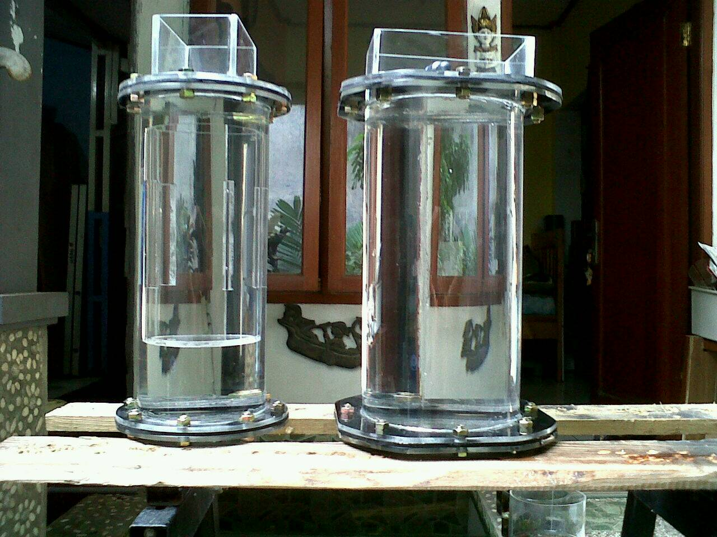

Gambar 5. *Reactor Tube* dan *Bubbler Tube*

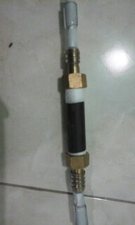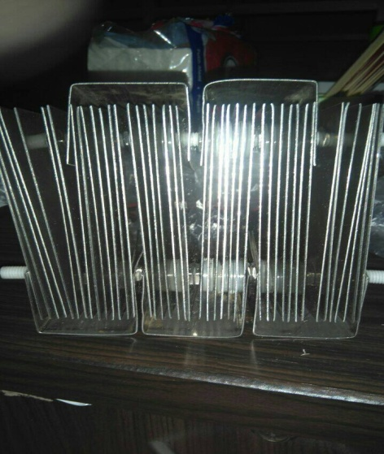

Gambar 6. *Stainless Steel Electrode* Gambar 7 *. Anti-Flashback Arrestor*

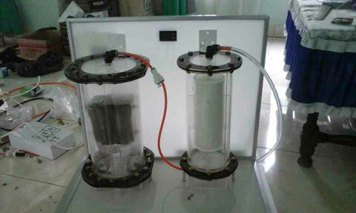

Gambar 8 . Tampak Depan

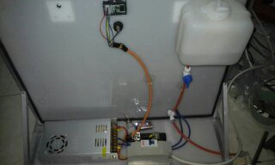

Gambar 9. Tampak Belakang

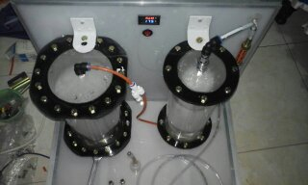

Gambar 10. Tampak Atas