FOTO HASIL AKHIR ALAT

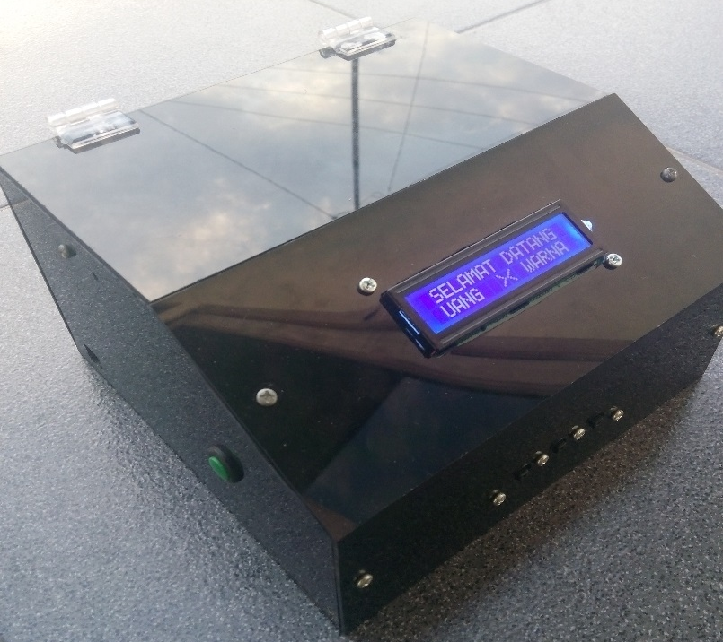

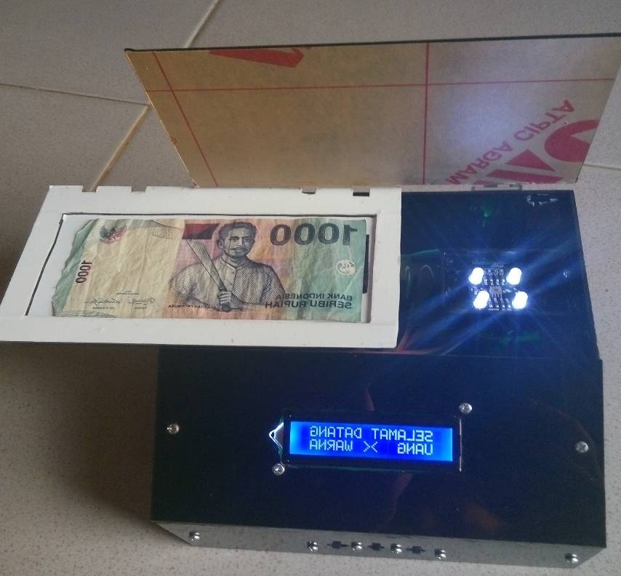

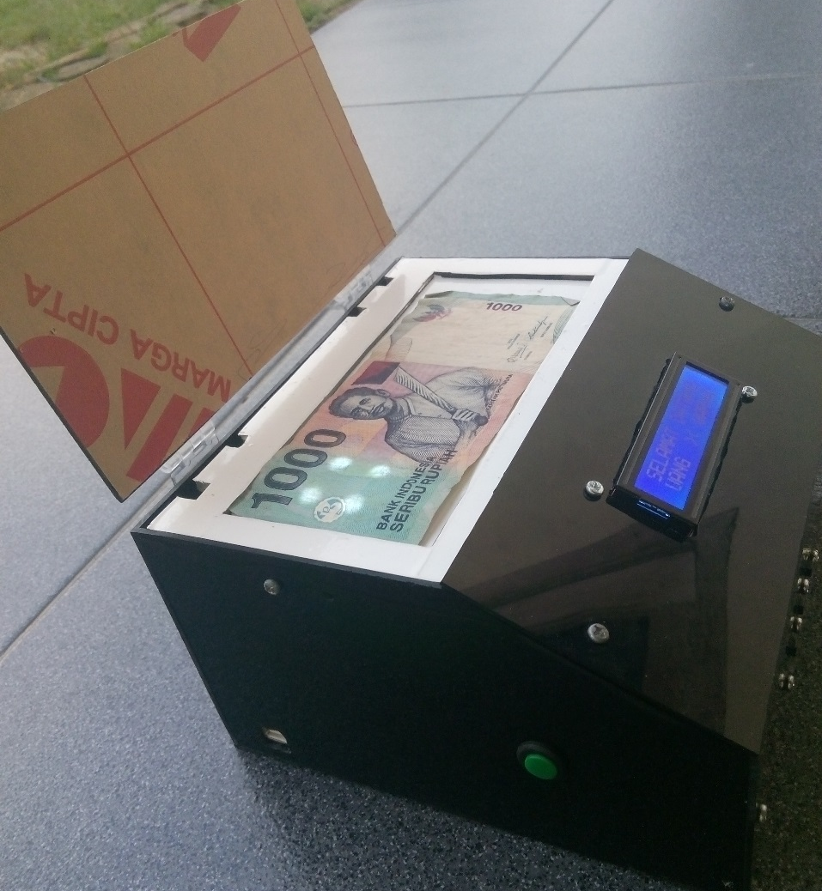

Program Alat

#include <LiquidCrystal.h>
#include <DFPlayer_Mini_Mp3.h>
#include <SoftwareSerial.h>

LiquidCrystal lcd(12, 11, 7, 9, A3, A4);
SoftwareSerial voice(5, 8); // RX, TX

#define s0 0
#define s1 1
#define s2 2
#define s3 3
#define out 4

#define button1 10
#define button2 6

unsigned long merah = 0;
unsigned long hijau = 0;
unsigned long biru = 0;
unsigned long putih = 0;

int volume = A5; // Volume pada Pin Nomor A5
int hasilPot;
int layar = 0;

void setup() {
voice.begin (9600);
mp3_set_serial (voice); //set softwareSerial for DFPlayer-mini mp3 module

lcd.begin(16, 2);
lcd.setCursor(0, 0);
lcd.print("ALAT PENDETEKSI");
lcd.setCursor(0, 1);
lcd.print("WARNA & NOM.UANG");
delay(1300);
lcd.clear();
lcd.setCursor(0, 0);
lcd.print("Widya Hurisantri");
lcd.setCursor(0, 1);
lcd.print(" TC 2013 - 2016 ");
delay(1300);
mp3_play (1);
pinMode(s0, OUTPUT);
pinMode(s1, OUTPUT);
pinMode(s2, OUTPUT);
pinMode(s3, OUTPUT);
pinMode(out, INPUT);
pinMode(button1, INPUT_PULLUP);
pinMode(button2, INPUT_PULLUP);

digitalWrite(s0, HIGH);
digitalWrite(s1, LOW);}

void loop() {
menu:
lcd.clear();
while (1) {
hasilPot = analogRead(5);
layar = map(hasilPot, 0, 1023, 0, 30);
mp3_set_volume(layar);
lcd.setCursor(0, 0);
lcd.print(" SELAMAT DATANG ");
lcd.setCursor(0, 1);
lcd.print(" UANG >< WARNA ");
if (digitalRead(button1) == LOW) {
if (digitalRead(button2) == LOW) {
goto scan;
} }
if (digitalRead(button1) == LOW) {
delay(200);
goto uang;
}
if (digitalRead(button2) == LOW) {
delay(200);
goto warna;
} }
uang:
lcd.clear();
while (1) {
RGB();
delay(1000);
if ( (merah > 33 && merah < 40) && (hijau > 35 && hijau < 44) && (biru > 26 && biru < 33)) {
lcd.clear();
lcd.print(" DUA RIBU ");
lcd.setCursor(0, 1);
lcd.print(" RUPIAH ");
mp3_play (13);
delay (4000);
goto menu;
} if ( (merah > 28 && merah < 37) && (hijau > 36 && hijau < 51) && (biru > 25 && biru < 37)) {
lcd.clear();
lcd.print(" SERATUS RIBU ");
lcd.setCursor(0, 1);
lcd.print(" RUPIAH ");
mp3_play (8);
delay (4000);
goto menu;
} if ( (merah > 42 && merah < 56) && (hijau > 42 && hijau < 62) && (biru > 34 && biru < 52)) {
lcd.clear();
lcd.print(" SERIBU ");
lcd.setCursor(0, 1);
lcd.print(" RUPIAH ");
mp3_play (14);
delay (4000);
goto menu;
} if ( (merah > 36 && merah < 47) && (hijau > 31 && hijau < 45) && (biru > 22 && biru < 37)) {
lcd.clear();
lcd.print(" DUA PULUH RIBU ");
lcd.setCursor(0, 1);
lcd.print(" RUPIAH ");
mp3_play (10);
delay (4000);
goto menu;
} if ( (merah > 38 && merah < 52) && (hijau > 43 && hijau < 55) && (biru > 29 && biru < 38)) {
lcd.clear();
lcd.print(" SEPULUH RIBU ");
lcd.setCursor(0, 1);
lcd.print(" RUPIAH ");
mp3_play (11);
delay (4000);
goto menu;
} if ( (merah > 40 && merah < 48) && (hijau > 42 && hijau < 52) && (biru > 30 && biru < 40)) {
lcd.clear();
lcd.print(" DUA RIBU ");
lcd.setCursor(0, 1);
lcd.print(" RUPIAH ");
mp3_play (13);
delay (4000);
goto menu;
} if ( (merah > 30 && merah < 39) && (hijau > 36 && hijau < 47) && (biru > 32 && biru < 42)) {
lcd.clear();
lcd.print(" LIMA RIBU ");
lcd.setCursor(0, 1);
lcd.print(" RUPIAH ");
mp3_play (12);
delay (4000);
goto menu;
} if ( (merah > 43 && merah < 54) && (hijau > 38 && hijau < 47) && (biru > 23 && biru < 30)) {
lcd.clear();
lcd.print(" LIMA PULUH RIBU");
lcd.setCursor(0, 1);
lcd.print(" RUPIAH ");
mp3_play (9);
delay (4000);
goto menu;
}
else {
lcd.clear();
lcd.print("TIDAK TERDETEKSI!!!");
mp3_play (19);
delay (4000);
delay(1000);
goto menu;
} }

warna:
lcd.clear();
while (1) {
RGB();
delay(1000);
if (merah > 45 && (merah < hijau && merah < biru)) {
lcd.clear();
lcd.print(" DETEKSI WARNA ");
lcd.setCursor(0, 1);
lcd.print(" WARNA MERAH ");
mp3_play (2);
delay (4000);
goto menu;
}
if ((biru > 30 && biru < 90) && (biru < merah && biru < hijau)) {
lcd.clear();
lcd.print(" DETEKSI WARNA ");
lcd.setCursor(0, 1);
lcd.print(" WARNA BIRU ");
mp3_play (4);
delay (4000);
goto menu; }
if (hijau > 40 && (hijau < merah && hijau < biru)) {
lcd.clear();
lcd.print(" DETEKSI WARNA ");
lcd.setCursor(0, 1);
lcd.print(" WARNA HIJAU ");
mp3_play (3);
delay (4000);
goto menu;
}
if (merah > 140 && hijau > 140 && biru > 90) {
lcd.clear();
lcd.print(" DETEKSI WARNA ");
lcd.setCursor(0, 1);
lcd.print(" WARNA HITAM ");
mp3_play (18);
delay (4000);
goto menu;
}
if (merah < 30 && hijau < 30 && biru < 30) {
lcd.clear();
lcd.print(" DETEKSI WARNA ");
lcd.setCursor(0, 1);
lcd.print(" WARNA PUTIH ");
mp3_play (17);
delay (4000);
goto menu;
}
else {
lcd.clear();
lcd.print("TIDAK TERDETEKSI!!!");
mp3_play (19);
delay (4000);
delay(1000);
goto menu;
} }
scan:
lcd.clear();
while (1) {
RGB();
lcd.clear();
lcd.setCursor(0, 0);
lcd.print("SC R G B ");
lcd.setCursor(0, 1);
lcd.print("AN ");
lcd.setCursor(4, 1);
lcd.print(merah); lcd.print(" ");
lcd.setCursor(8, 1);
lcd.print(hijau); lcd.print(" ");
lcd.setCursor(12, 1);
lcd.print(biru); lcd.print(" ");
delay(1000);
}}
scan_RGB:
digitalWrite(s0, HIGH);
digitalWrite(s1, HIGH);
lcd.clear();
while (1) {
RGB();
lcd.clear();
lcd.setCursor(0, 0);
lcd.print("SC R G B ");
lcd.setCursor(0, 1);
lcd.print("AN ");
lcd.setCursor(4, 1);
lcd.print(merah1); lcd.print(" ");
lcd.setCursor(8, 1);
lcd.print(hijau1); lcd.print(" ");
lcd.setCursor(12, 1);
lcd.print(biru1); lcd.print(" ");
delay(1000);
if (digitalRead(button1) == LOW) {
delay(200);
goto scan;
} }}
//========================================================//
void RGB() {
digitalWrite(s2, LOW);
digitalWrite(s3, LOW);
merah = pulseIn(out, HIGH);
merah1 = constrain(merah, 11, 19);
merah1 = map(merah1, 11, 19, 255, 0);
delay(10);
digitalWrite(s2, HIGH);
digitalWrite(s3, HIGH);
hijau = pulseIn(out, HIGH);
hijau1 = constrain(hijau, 14, 25);
hijau1 = map(hijau1, 14, 25, 255, 0);
delay(10);
digitalWrite(s2, LOW);
digitalWrite(s3, HIGH);
biru = pulseIn(out, HIGH);
biru1 = constrain(biru, 8, 16);
biru1 = map(biru1, 8, 16, 255, 0);
delay(10);}

