**PENGARUH PAJAK DAERAH, RETRIBUSI DAERAH, DANA ALOKASI UMUM DAN DANA BAGI HASIL TERHADAP BELANJA MODAL PADA KABUPATEN DAN KOTA**

**DI SUMATERA SELATAN**



**SKRIPSI**

Disusun Untuk Memenuhi Syarat Menyelesaikan Pendidikan Sarjana Terapan

(D-IV) Akuntansi Sektor Publik pada Jurusan Akuntansi

Politeknik Negeri Sriwijaya

**Oleh:**

**IKHSAN BUDIMAN**

**NIM 061440511774**

**POLITEKNIK NEGERI SRWIIJAYA**

**PALEMBANG**

**2018**

**PENGARUH PAJAK DAERAH, RETRIBUSI DAERAH, DANA ALOKASI UMUM DAN DANA BAGI HASIL TERHADAP BELANJA MODAL PADA KABUPATEN DAN KOTA**

**DI SUMATERA SELATAN**



**SKRIPSI**

Disusun Untuk Memenuhi Syarat Menyelesaikan Pendidikan Sarjana Terapan

(D-IV) Akuntansi Sektor Publik pada Jurusan Akuntansi

Politeknik Negeri Sriwijaya

**Oleh:**

**IKHSAN BUDIMAN**

**NIM 061440511774**

**POLITEKNIK NEGERI SRWIIJAYA**

**PALEMBANG**

**2018**

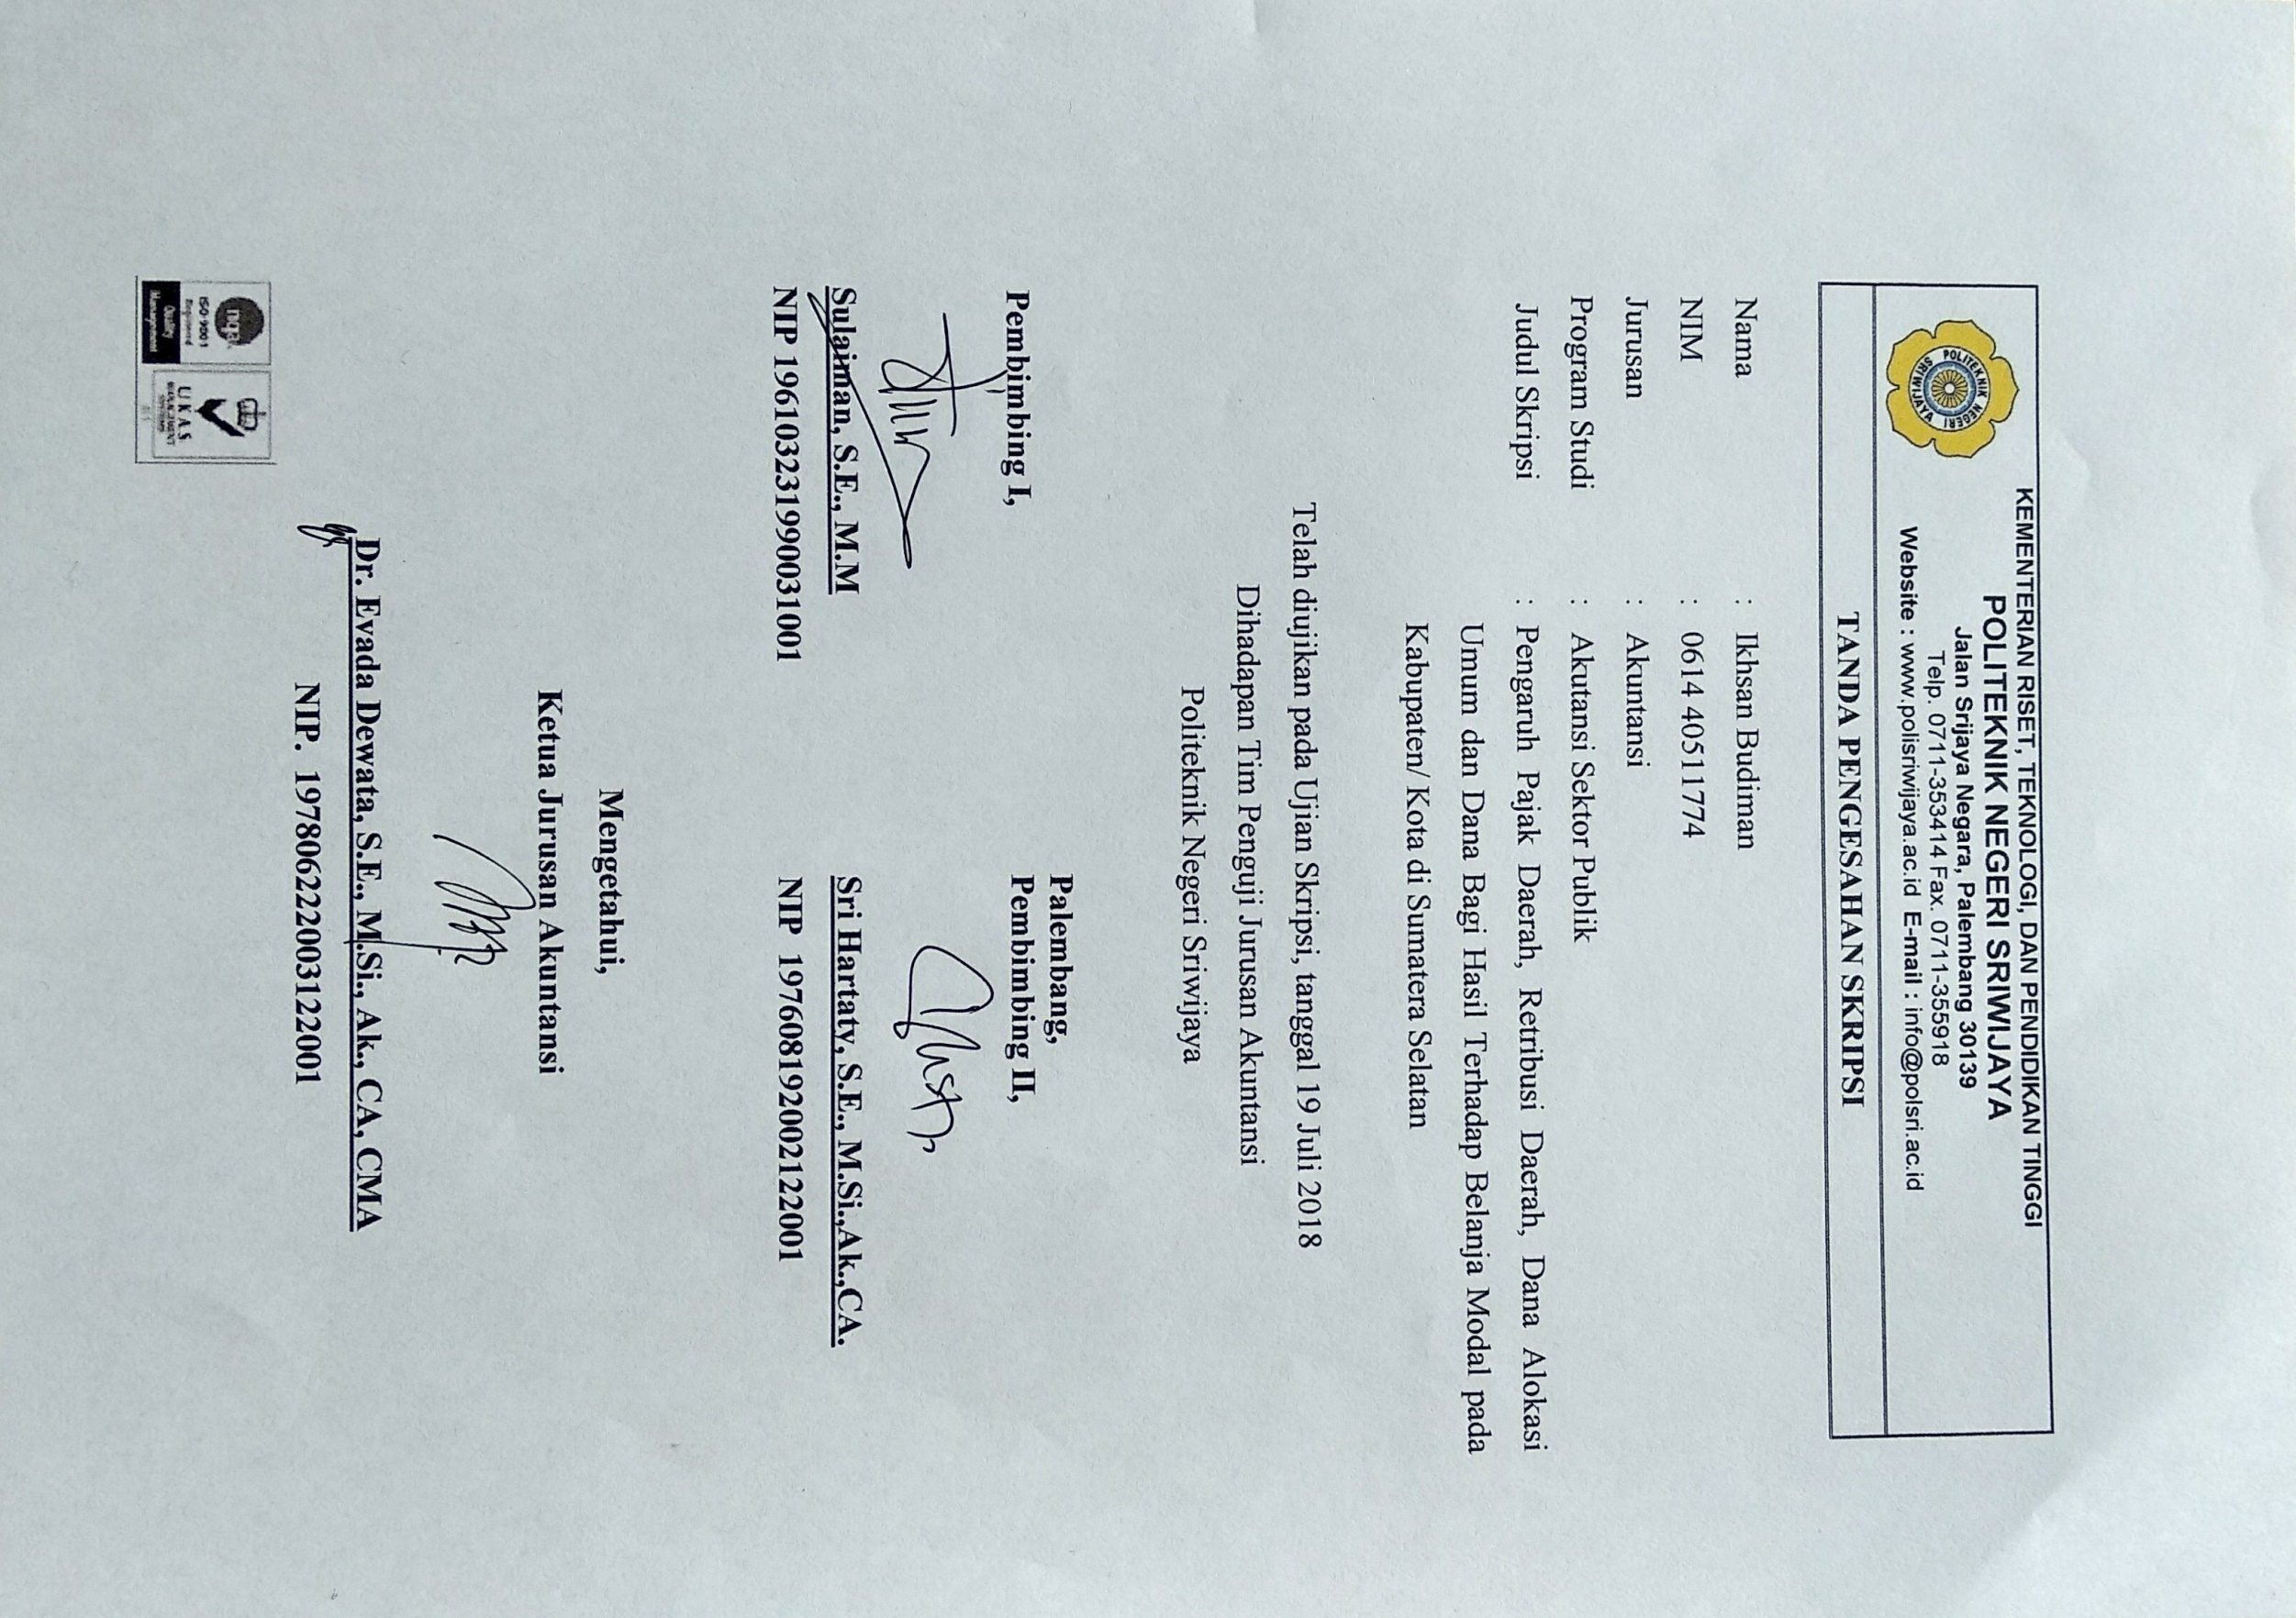

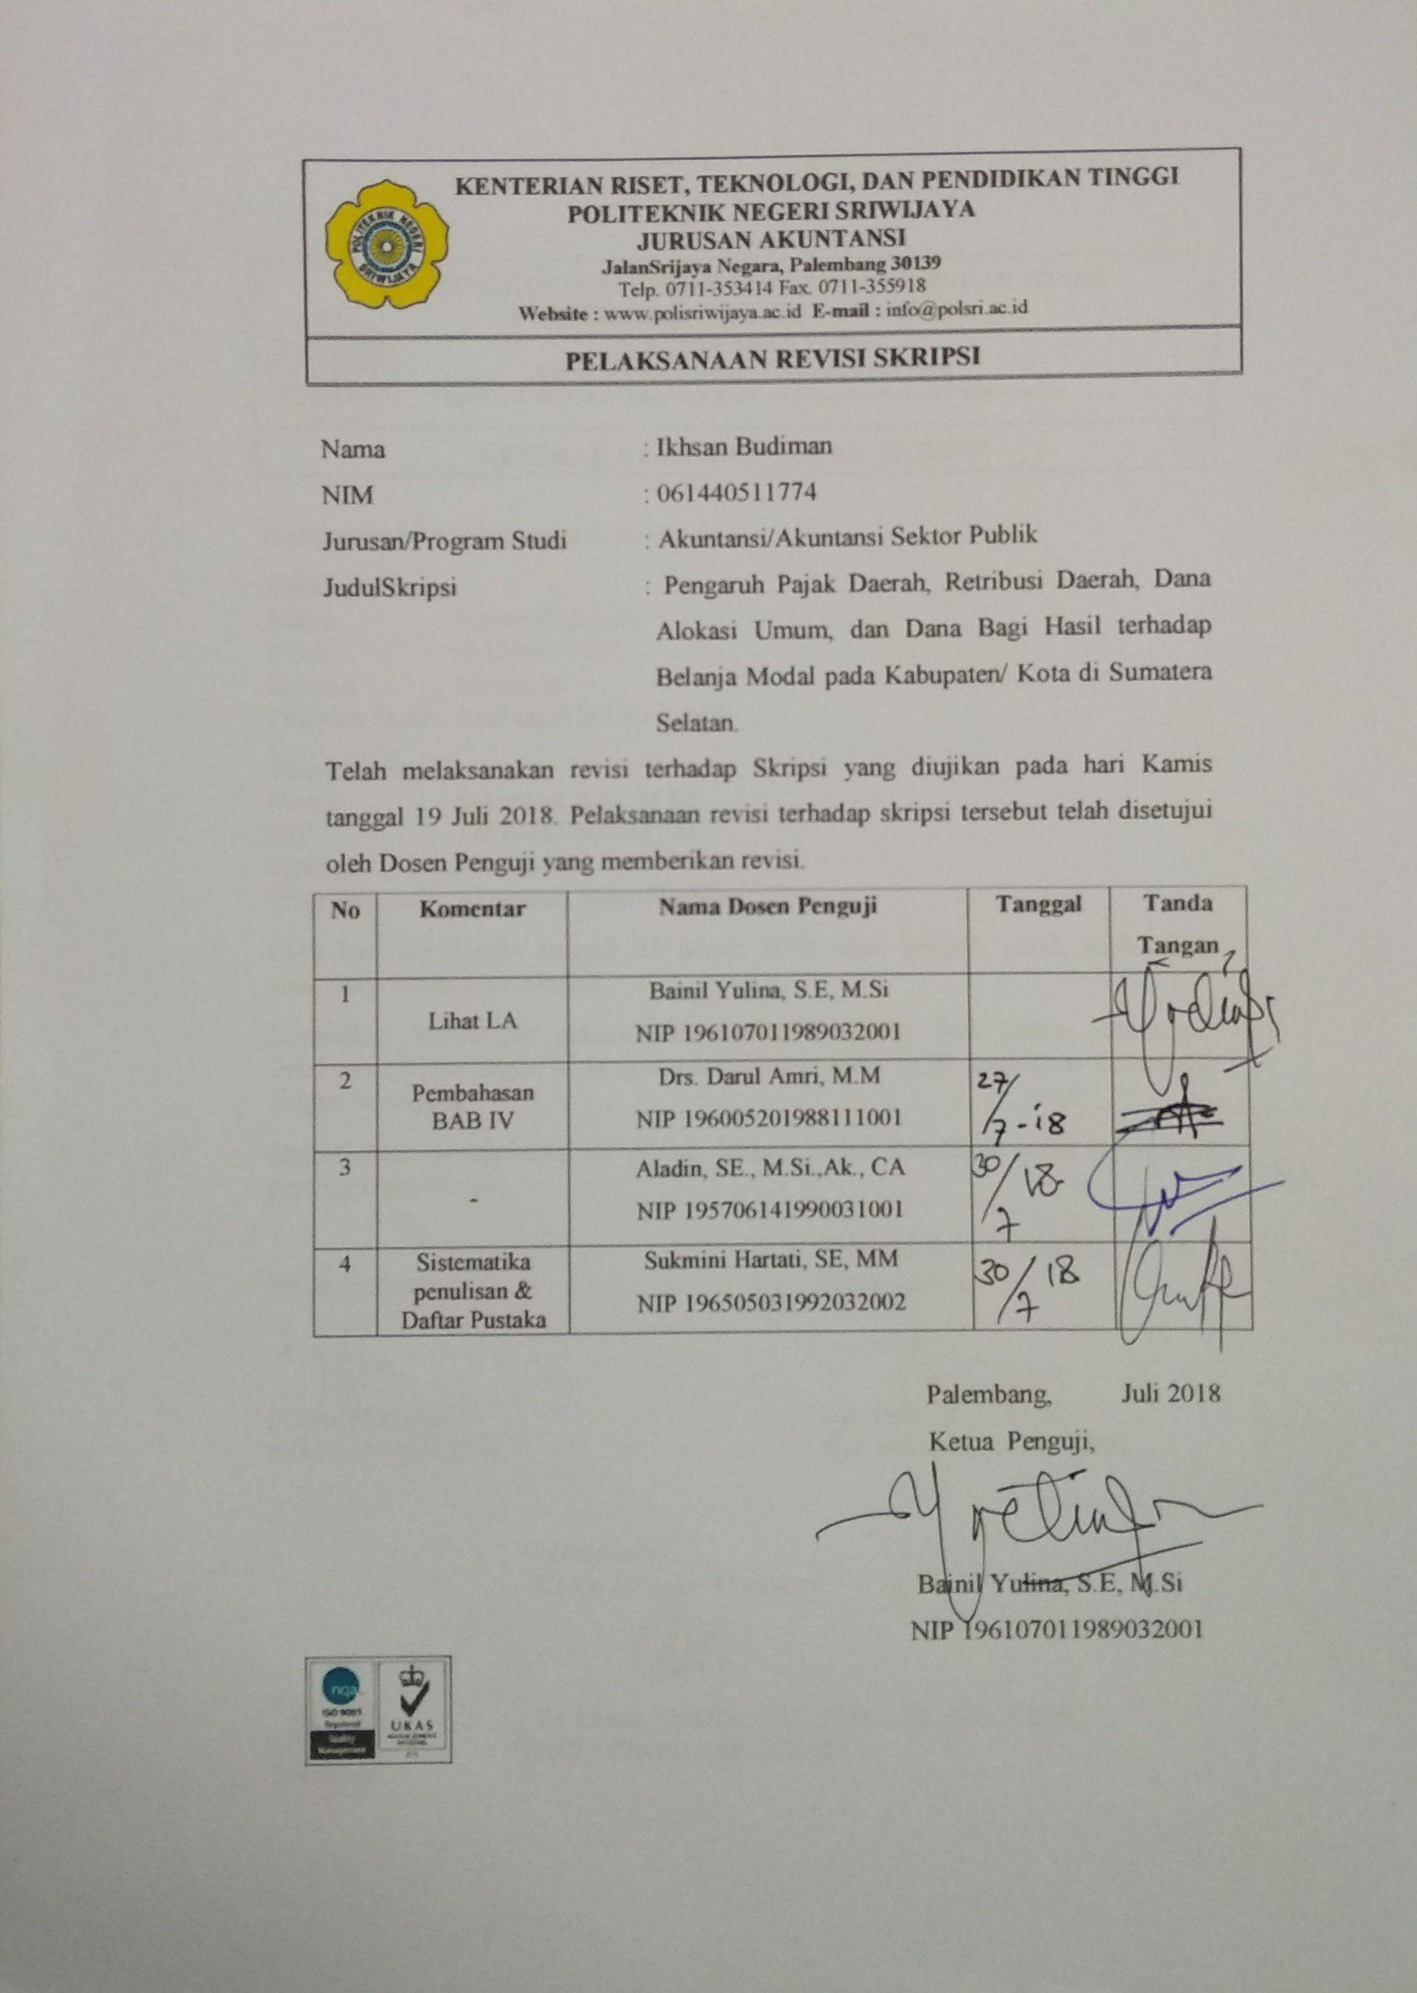

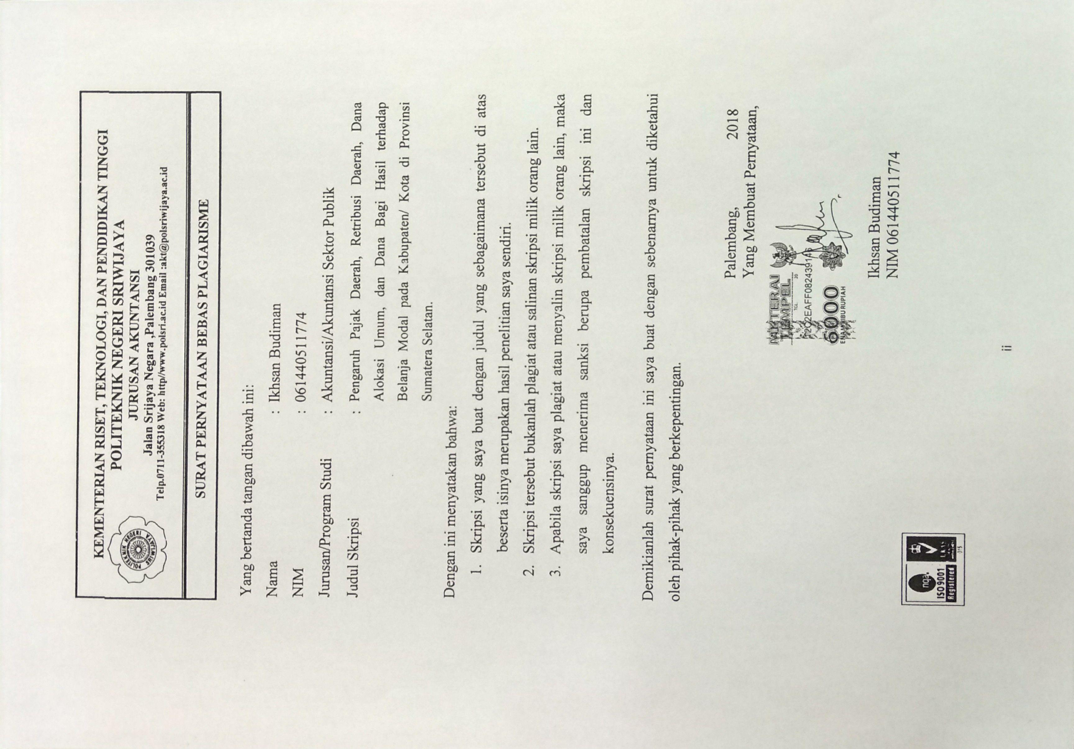

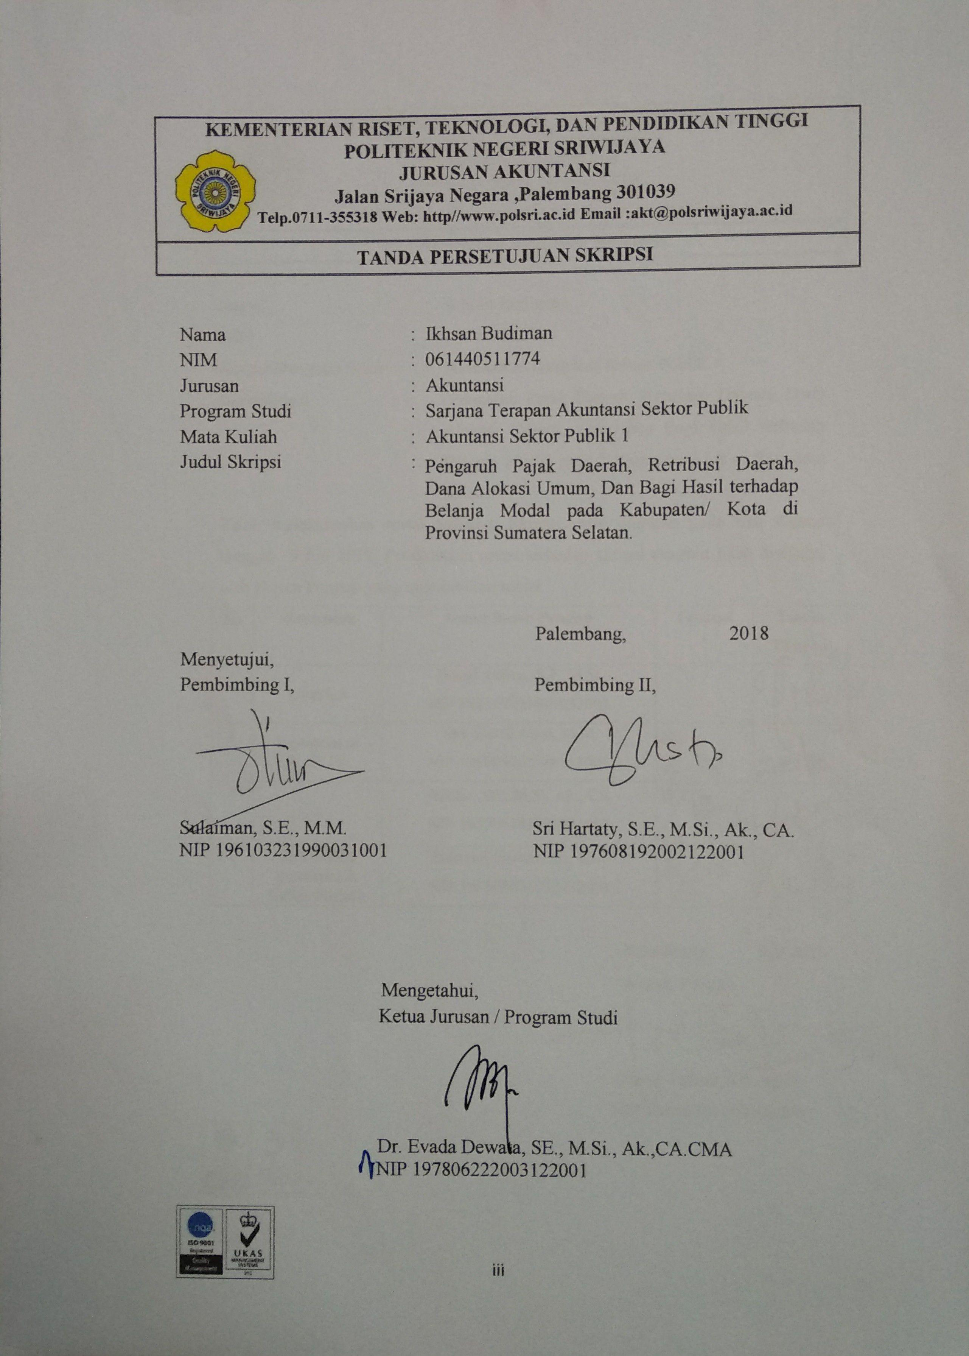

Motto

“Boleh jadi kamu membenci sesuatu, padahal ia amat baik bagimu, dan boleh jadi (pula) kamu menyukai sesuatu, padahal ia amat buruk bagimu. Allah mengetahui sedang kamu tidak mengetahui.”

(QS. Al-Baqarah: 216)

“Tiadanya keyakinanlah yang membuat orang takut menghadapi tantangan dan saya percaya pada diri saya sendiri”

( Muhammad Ali )

“Orang goblok itu gak banyak mikir, yang penting terus melangkah. Orang pinter kebanyakan mikir, akibatnya tidak pernah melangkah”

(Bob Sadino)

“Setiap langkah yang dilalui akan mendapatkan kenangan. Setiap usaha yang dijalani pasti akan mendapatkan hasil”

( Penulis)

“Seringkali kita membutuhkan lebih banyak keberanian untuk berani melakukan yang benar daripada takut berbuat salah.”

(Abraham Lincoln)

Kupersembahkan Untuk :

Orangtuaku tersayang

Kakakku tercinta

Teman Seperjuangan AP.C 2014

Sahabat yang selalu mendukung

Orang yang selalu memotivasi

Almamaterku

**KATA PENGANTAR**

Segala Puji dan syukur penulis panjatkan atas kehadirat Allah SWT, yang telah melimpahkan nikmat, rahmat dan berkah-Nya, sehingga penulis dapat menyelesaikan proposal skripsi ini dengan baik dan tepat waktu. Proposal skripsi ini berjudul **“Pengaruh Pajak Daerah, Retribusi Daerah, Dana Alokasi Umum dan Dana Bagi Hasil terhadap Belanja Modal pada Kabupaten/ Kota di Provinsi Sumatera Selatan.”** Sejalan penyusunan proposal skripsi ini, penulis telah banyak mendapat bantuan dari berbagai pihak. Untuk itu dalam kesempatan ini, penulis ingin menyampaikan rasa terima kasih yang sebesar-besarnya kepada:

1. Bapak Dr. Ing. Ahmad Taqwa, S.T., M.T. selaku Direktur Politeknik Negeri Sriwijaya.
2. Ibu Dr. Evada Dewata, S.E., M.Si., Ak., CA. selaku Ketua Jurusan Akuntansi Politeknik Negeri Sriwijaya.
3. Ibu Yuliana Sari, S.E., MBA., Ak. selaku Sekretaris Jurusan Akuntansi Politeknik Negeri Sriwijaya
4. Ibu Nelly Masnila, S.E., M.Si.,Ak., CA selaku Ketua Program Studi Akuntansi Sektor Publik Politeknik Negeri Sriwijaya.
5. Ibu Desi Indriasari, S.E., M.Si., Ak., CA. Selaku Dosen Pembimbing Akademik kelas 8 (delapan) AP.C yang selalu memberikan semangat dan motivasi kepada penulis dan teman-teman selama proses penyelesaian skripsi.
6. Bapak Sulaiman, S.E., M.M. selaku Dosen Pembimbing I (satu) yang telah berkenan untuk membantu dan membimbing penulis hingga selesai sesuai dengan kriteria yang diharapkan dalam menyelesaikan skripsi.
7. Ibu Sri Hartaty, S.E., M. Si., Ak., CA. selaku Dosen Pembimbing II (dua) yang telah berkenan untuk membantu dan membimbing penulis hingga selesai sesuai dengan kriteria yang diharapkan dalam menyelesaikan skripsi.
8. Bapak dan Ibu Dosen Jurusan Akuntansi Politeknik Negeri Sriwijaya, Program Studi Akuntansi Sektor Publik yang telah memberikan ilmu pengetahuan dan para staf akademik jurusan akuntansi yang telah membantu segala kepentingan perihal administrasi dan akademik selama proses penyusunan skripsi hingga selesai.
9. Kedua orang tua ( Buyung Faisal dan Karmila ) dan kakak tercinta ( Ferry Hidayat ) yang selalu mencurahkan semua kasih sayang, pengorbanan, dukungan, dan semua hal yang selalu diberikan untuk penulis hingga saat ini.
10. Bapak dan Ibu Bidang Kemahasiswaan Politeknik Negeri Sriwijaya serta para Senior, Teman-teman, *Manager*, Pelatih dan *Official Team* PORSENI Politeknik Sriwijaya yang telah memberikan ilmu pengetahuan dan membantu segala kepentingan perihal administrasi akademik dan non akademik selama proses kuliah hingga selesai.
11. Keluarga besar kelas AP.C 2014, Satria Putratama, Prasetyo Adi, Arbain, Alvin Syahrin, Dwi Syahputra, Ryanza, Heru, Lianda, Atika Putri, Deastya, Velisia, Metriani, Ranny dan teman-teman yang telah memberikan banyak kenangan indah selama kuliah dan selalu saling mengingatkan dalam hal kebaikan, saling memberikan semangat, doa serta motivasi.
12. Semua pihak yang tidak dapat disebutkan satu-persatu yang telah memberikan bantuan, doa, dan masukan selama penyusunan skripsi ini.

Penulis menyadari bahwa dalam penulisan skripsi ini masih banyak terdapat kekurangan. Oleh karena itu, penulis sangat mengharapkan kritik dan saran yang bersifat membangun demi kesempurnaan penulisan di masa yang akan datang. Semoga skripsi ini dapat bermanfaat bagi penulis khususnya dan para pembaca umumnya.

Palembang, 2018

Penulis

***ABSTRACT***

***The Effect of Local Taxes, Regional Retributions, General Allocation Funds, and Profit Sharing Funds on Capital Expenditures in Districts / Cities in the Province of South Sumatra***

**Ikhsan Budiman, 2018 (xiii + 62 *pages)***

**Email: ikhsanbudiman1881@gmail.com**

*This study aims to determine the effect of Local Taxes, Local Retributions, General Allocation Funds, and Revenue Sharing Funds on Capital Expenditures in Districts / Cities in the Province of South Sumatra in 2013-2016. The sample of this study includes 15 Districts / Cities in South Sumatra. Based on the results of tests conducted it can be seen that the Regional Tax, Local Retribution and General Allocation Fund partially have no effect and not significant to Capital Expenditure. While Revenue Sharing has a positive and significant effect on Capital Expenditures. The results show that the Regional Tax, Regional Retribution, General Allocation Fund and Profit Sharing Fund together or simultaneously have a positive and significant impact on Capital Expenditure. It can be concluded that Districts / Cities in South Sumatra are still very dependent on Revenue Sharing Funds.*

*Keywords:* PAD*, Balancing Fund, and Capital Expenditure*

**ABSTRAK**

**Pengaruh Pajak Daerah, Retribusi Daerah, Dana Alokasi Umum, dan Dana Bagi Hasil terhadap Belanja Modal pada Kabupaten/ Kota di Provinsi Sumatera Selatan**

**Ikhsan Budiman, 2018 (xiii + 62 halaman)**

**Email: ikhsanbudiman1881@gmail.com**

Penelitian ini bertujuan untuk mengetahui pengaruh Pajak Daerah, Retribusi Daerah, Dana Alokasi Umum, dan Dana Bagi Hasil terhadap Belanja Modal pada Kabupaten/ Kota di Provinsi Sumatera Selatan tahun 2013-2016. Sampel penelitian ini meliputi 15 Kabupaten / Kota di Sumatera Selatan. Berdasarkan hasil pengujian yang dilakukan dapat diketahui bahwa Pajak Daerah, Retribusi Daerah dan Dana Alokasi Umum secara parsial tidak berpengaruh dan tidak signifikan terhadap Belanja Modal. Sedangkan Dana Bagi Hasil berpengaruh positif dan signifikan terhadap Belanja Modal. Hasil penelitian menunjukkan Pajak Daerah, Retribusi Daerah, Dana Alokasi Umum dan Dana Bagi Hasil secara bersama-sama atau simultan berpengaruh positif dan signifikan terhadap Belanja Modal. Dapat disimpulkan Kabupaten/ Kota di Sumatera Selatan masih sangat tergantung terhadap Dana Bagi Hasil.

Kata Kunci : PAD, Dana Perimbangan, dan Belanja Modal

**DAFTAR ISI**

|  |  |  |  |  |  |  |  |  |  |  |  |  |  |  |  |  |  |  |  |  |  |  |  |  |  |  |  |  |  |  |  |  |  |  |  |  |  |  |  |  |  |  |  |  |  |  |  |  |  |  |  |  |  |  |  |  |  |  |
| --- | --- | --- | --- | --- | --- | --- | --- | --- | --- | --- | --- | --- | --- | --- | --- | --- | --- | --- | --- | --- | --- | --- | --- | --- | --- | --- | --- | --- | --- | --- | --- | --- | --- | --- | --- | --- | --- | --- | --- | --- | --- | --- | --- | --- | --- | --- | --- | --- | --- | --- | --- | --- | --- | --- | --- | --- | --- | --- |
|  | | | | | | | | | | | | | | | | | | | | | | | | | | | | | | | | | | | | | | | | |  | | | | | | | | | | | **Halaman** | | | | | | |
| **HALAMAN SAMPUL** | | | | | | | | | | | **. . . . . . .. . . . . . . . . . . . . . . . . . . . . . . . . . . . . . . .** | | | | | | | | | | | | | | | | | | | | | | | | | | | | | | | | | | | | | | | | | | | | | | | **i** |
| **HALAMAN PERNYATAAN BEBAS PLAGIARISME** | | | | | | | | | | | | | | | | | | | | | | | | | | | | | | | | | | | | | | | | | | | | | | **. . . . . . . . . . . .** | | | | | | | | | | | | **ii** |
| **SURAT PERSETUJUAN SKRIPSI** | | | | | | | | | | | | | | | | | | | | | | | | | | | | | | | | | **. . . . . . . . . . . . . . . . . . . . . . . . . . . . .** | | | | | | | | | | | | | | | | | | | | | | | | | **iii** |
| **HALAMAN MOTTO** | | | | | | | | **. . . . . . . . . . . . . . . . . . . . . . . . . . . . . . . . . . . . . . . . .** | | | | | | | | | | | | | | | | | | | | | | | | | | | | | | | | | | | | | | | | | | | | | | | | | | **iv** |
| **KATA PENGANTAR** | | | | | | | | **. . . . . . . . . . . . . . . . . . . . . . . . . . . . . . . . . . . . . . . . .** | | | | | | | | | | | | | | | | | | | | | | | | | | | | | | | | | | | | | | | | | | | | | | | | | | **v** |
| ***ABSTACT*** | | **. . . . . . . . . . . . . . . . . . . . . . . . . . . . . . . . . . . . . . . . . . . . . . . .. .** | | | | | | | | | | | | | | | | | | | | | | | | | | | | | | | | | | | | | | | | | | | | | | | | | | | | | | | | **vii** |
| **ABSTAK** | **. . . . . . . . . . . . . . . . . . . . . . . . . . . . . . . . . . . . . . . . . . . . . . . . . .** | | | | | | | | | | | | | | | | | | | | | | | | | | | | | | | | | | | | | | | | | | | | | | | | | | | | | | | | | **viii** |
| **DAFTAR ISI** | | | **. . . . . . . . . . . . . . . . . . . . . . . . . . . . . . . . . . . . . . . . . . . . . . . .** | | | | | | | | | | | | | | | | | | | | | | | | | | | | | | | | | | | | | | | | | | | | | | | | | | | | | | | **ix** |
| **DAFTAR TABEL** | | | | | **. . . . . . . . . . . . . . . . . . . . . . . . . . . . . . . . . . . . . . . . . . .** | | | | | | | | | | | | | | | | | | | | | | | | | | | | | | | | | | | | | | | | | | | | | | | | | | | | | **xi** |
| **DAFTAR GAMBAR** | | | | | | | **. . . . . . . . . . . . . . . . . . . . . . . . . . . . . . . . . . . . . . . .** | | | | | | | | | | | | | | | | | | | | | | | | | | | | | | | | | | | | | | | | | | | | | | | | | | | **xii** |
| **DAFTAR LAMPIRAN** | | | | | | | | | | | | | **. . . . . . . . . . . . . . . . . . . . . . . . . . . . . . . . . . . . . . .** | | | | | | | | | | | | | | | | | | | | | | | | | | | | | | | | | | | | | | | | | | | | | **xiii** |
|  | | | | | | | | | | | | |  | | | | | | | | | | | | | | | | | | | | | | | | | | | | | | | | | | | | | | | | | | | | |  |
| **Bab I Pendahuluan** | | | | | | . . . . . . . . . . . . . . . . . . . . . . . . . . . . . . . . . . . . . . . . . . | | | | | | | | | | | | | | | | | | | | | | | | | | | | | | | | | | | | | | | | | | | | | | | | | | | | **1** |
| 1.1 Latar Belakang Penelitian | | | | | | | | | | | | | | | | | | | | | | | | | | | | | | | | | | | . . . . . . . . . . . . . . . . . . . . . . . . . . . . | | | | | | | | | | | | | | | | | | | | | | | 1 |
| 1.2 Rumusan Masalah | | | | | | | | | | | | | | | | | | | | . . . . . . . . . . . . . . . . . . . . . . . . . . . . . . . . . . | | | | | | | | | | | | | | | | | | | | | | | | | | | | | | | | | | | | | | 4 |
| 1.3 Ruang Lingkup Pembahasan | | | | | | | | | | | | | | | | | | | | | | | | | | | | | | | | | | | | | . . . . . . . . . . . . . . . . . . . . . . . . . . . | | | | | | | | | | | | | | | | | | | | | 5 |
| 1.4 Tujuan Penelitian & Manfaat | | | | | | | | | | | | | | | | | | | | | | | | | | | | | | | | | | | | | | . . . . . . . . . . . . . . . . . . . . . . . . . | | | | | | | | | | | | | | | | | | | | 5 |
| 1.4.1 Tujuan Penelitian | | | | | | | | | | | | | | | | | | | | | | | | | . . . . . . . . . . . . . . . . . . . . . . . . . . . . . . . . . | | | | | | | | | | | | | | | | | | | | | | | | | | | | | | | | | 5 |
| 1.4.2 Manfaat Penelitian | | | | | | | | | | | | | | | | | | | | | | | | | | | | . . . . . . . . . . . . . . . . . . . . . . . . . . . . . . . . | | | | | | | | | | | | | | | | | | | | | | | | | | | | | | 6 |
|  | | | | | | | | | | | | | | | | | | | | | | | | | | |  | | | | | | | | | | | | | | | | | | | | | | | | | | | | | | |  |
| **Bab II Tinjauan Pustaka** | | | | | | | | | | | | | | . . . . . . . . . . . . . . . . . . . . . . . . . . . . . . . . . . . . . | | | | | | | | | | | | | | | | | | | | | | | | | | | | | | | | | | | | | | | | | | | | **7** |
| 2.1 Pengertian dan Konsep Variabel Penelitian | | | | | | | | | | | | | | | | | | | | | | | | | | | | | | | | | | | | | | | | | | | | . . . . . . . . . . . . . . . | | | | | | | | | | | | | | 7 |
| 2.1.1 Pajak Daerah | | | | | | | | | | | | | | | | | | . . . . . . . . . . . . . . . . . . . . . . . . . . . . . . . . . . . . | | | | | | | | | | | | | | | | | | | | | | | | | | | | | | | | | | | | | | | | 7 |
| 2.1.2 Retribusi Daerah | | | | | | | | | | | | | | | | | | | | | | | | . . . . . . . . . ... . . . . . . . . . . . . . . . . . . . . . . | | | | | | | | | | | | | | | | | | | | | | | | | | | | | | | | | | 10 |
| 2.1.3 Dana Alokasi Umum | | | | | | | | | | | | | | | | | | | | | | | | | | | | | | | | . . . . . . . . . . . . . . . . . . . . . . . . . . . . . . | | | | | | | | | | | | | | | | | | | | | | | | | | 13 |
| 2.1.4 Dana Bagi Hasil | | | | | | | | | | | | | | | | | | | | | | . . . . . . . . . . . . . . . . . . . . . . . . . . . . . . . . . | | | | | | | | | | | | | | | | | | | | | | | | | | | | | | | | | | | | 15 |
| 2.1.5 Belanja Modal | | | | | | | | | | | | | | | | | | | . . . . . . . . . . . . . . . . . . . . . . . . . . . . . . . . . . . | | | | | | | | | | | | | | | | | | | | | | | | | | | | | | | | | | | | | | | 18 |
| 2.2 Hubungan Antar Variabel | | | | | | | | | | | | | | | | | | | | | | | | | | | | | | | | | | . . . . . . . . . . . . . . . . . . . . . . . . . . . . . | | | | | | | | | | | | | | | | | | | | | | | | 20 |
| 2.1.1 Pengaruh Pajak Daerah Terhadap Belanja Modal | | | | | | | | | | | | | | | | | | | | | | | | | | | | | | | | | | | | | | | | | | | | | | | . . . . . . . . | | | | | | | | | | | 20 |
| 2.2.2 Pengaruh Retribusi Daerah Terhadap Belanja Modal | | | | | | | | | | | | | | | | | | | | | | | | | | | | | | | | | | | | | | | | | | | | | | | | | | . . . . . | | | | | | | | 20 |
| 2.2.3 Pengaruh Dana Alokasi Umum Terhadap Belanja Modal | | | | | | | | | | | | | | | | | | | | | | | | | | | | | | | | | | | | | | | | | | | | | | | | | | | | | | | . . | | | 21 |
| 2.2.4 Pengaruh Dana Bagi Hasil Terhadap Belanja Modal | | | | | | | | | | | | | | | | | | | | | | | | | | | | | | | | | | | | | | | | | | | | | | | | | . . . . . . | | | | | | | | | 21 |
| 2.2.5 Pengaruh Pajak Daerah, Retribusi Daerah, Dana Alokasi | | | | | | | | | | | | | | | | | | | | | | | | | | | | | | | | | | | | | | | | | | | | | | | | | | | | | | | | |  | 22 |
| Umum, Dana Bagi Hasil Terhadap Belanja Modal | | | | | | | | | | | | | | | | | | | | | | | | | | | | | | | | | | | | | | | | | | | | | | | | | . . . . . . | | | | | | | | |
| 2.3 Penelitian Terdahulu | | | | | | | | | | | | | | | | | | | | | | | | | | . . . . . . . . . ... . . . . . . . . . . . . . . . . . . . . . . | | | | | | | | | | | | | | | | | | | | | | | | | | | | | | | | 23 |
| 2.4 Kerangka Pemikiran | | | | | | | | | | | | | | | | | | | | | | | | . . . . . . . . . . . . . . . . . . . . . . . . . . . . . . . . . | | | | | | | | | | | | | | | | | | | | | | | | | | | | | | | | | | 26 |
| 2.5 Hipotesis | | | | | | | | | | | . . . . . . . . . . . . . . . . . . . . . . . . . . . . . . . . . . . . . . . . | | | | | | | | | | | | | | | | | | | | | | | | | | | | | | | | | | | | | | | | | | | | | | | 27 |
|  | | | | | | | | | | |  | | | | | | | | | | | | | | | | | | | | | | | | | | | | | | | | | | | | | | | | | | | | | | |  |
| **Bab III Metode Penelitian** | | | | | | | | | | | | | | | . . . . . . . . . . . . . . . . . . . . . . . . . . . . . . . . . . . . | | | | | | | | | | | | | | | | | | | | | | | | | | | | | | | | | | | | | | | | | | | **29** |
| 3.1 Jenis Penelitian | | | | | | | | | | | | | | | | | | | | | | | | | | | | | | | | | | | . . . . . . . . . . . . . . . . . . . . . . . . . . . .. | | | | | | | | | | | | | | | | | | | | | | | 29 |
| 3.2 Jenis & Sumber Data | | | | | | | | | | | | | | | | | | | | | | | | . . . . . . . . . . . . . . . . . . . . . . . . . . . . . . . . . | | | | | | | | | | | | | | | | | | | | | | | | | | | | | | | | | | 29 |
| 3.3 Teknik Pengumpulan Data | | | | | | | | | | | | | | | | | | | | | | | | | | | | | | | | | | | | . . . . . . . . . . . . . . . . . . . . . . . . . . . . . | | | | | | | | | | | | | | | | | | | | | | 29 |
| 3.4 Populasi dan Sampel Penelitian | | | | | | | | | | | | | | | | | | | | | | | | | | | | | | | | | | | | | | | . . . . . . . . . . . . . . . . . . . . . . . . | | | | | | | | | | | | | | | | | | | 30 |
| 3.4.1 Populasi | | | | | | | | | | | | . . . . . . . . . . . . . . . . . . . . . . . . . . . . . . . . . . . . . . . . | | | | | | | | | | | | | | | | | | | | | | | | | | | | | | | | | | | | | | | | | | | | | | 30 |
| 3.4.2 Sampel | | | | | | | | | . . . . . . . . . . . . . . . . . . . . . . . . . . . . . . . . . . . . . . . . . | | | | | | | | | | | | | | | | | | | | | | | | | | | | | | | | | | | | | | | | | | | | | | | | | 31 |
| 3.5 Variabel Penelitian | | | | | | | | | | | | | | | | | | | | | | . . . . . . . . . . . . . . . . . . . . . . . . . . . . . . . . . . | | | | | | | | | | | | | | | | | | | | | | | | | | | | | | | | | | | | 32 |
| 3.5.1 Klasifikasi Variabel | | | | | | | | | | | | | | | | | | | | | | | | | | | | | | | . . . . . . . . . . . . . . . . . . . . . . . . . . . . . . . | | | | | | | | | | | | | | | | | | | | | | | | | | | 32 |
| 3.5.2 Definisi Operasional Variabel Penelitian | | | | | | | | | | | | | | | | | | | | | | | | | | | | | | | | | | | | | | | | | | | | | . . . . . . . . . . . . . . | | | | | | | | | | | | | 33 |
| 3.6 Teknik Analisis Data | | | | | | | | | | | | | | | | | | | | | | | | | | | . . . . . . . . . . . . . . . . . . . . . . . . . . . . . . . . | | | | | | | | | | | | | | | | | | | | | | | | | | | | | | | 35 |
| 3.6.1 Model Regresi Linear Berganda | | | | | | | | | | | | | | | | | | | | | | | | | | | | | | | | | | | | | | | | . . . . . . . . . . . . . . . . . . . . . | | | | | | | | | | | | | | | | | | 35 |
| 3.6.2 Uji Asumsi Klasik | | | | | | | | | | | | | | | | | | | | | | | | | | | | | | | | . . . . . . . . . . . . . . . . . . . . . . . . . . . . . . | | | | | | | | | | | | | | | | | | | | | | | | | | 36 |
| 3.6.3 Uji Hipotesis | | | | | | | | | | | | | | | | | . . . . . . . . . . . . . . . . . . . . . . . . . . . . . . . . . . . . | | | | | | | | | | | | | | | | | | | | | | | | | | | | | | | | | | | | | | | | | 37 |
|  | | | | | | | | | | | | | | | | | | | | | | | | | | | | | | | | | | |  | | | | | | | | | | | | | | | | | | | | | | |  |
| **Bab IV Hasil Dan Pembahasan** | | | | | | | | | | | | | | | | | | | | | | | | | | | | | . . . . . . . . . . . . . . . . . . . . . . . . . . . . . . . . | | | | | | | | | | | | | | | | | | | | | | | | | | | | | **40** |
| 4.1 Hasil Penelitian | | | | | | | | | | | | | | | | . . . . . . . . . . . . . . . . . . . . . . . . . . . . . . . . . . . . . | | | | | | | | | | | | | | | | | | | | | | | | | | | | | | | | | | | | | | | | | | 40 |
| 4.1.1 Gambaran Umum Kabupaten/Kota Sumatera Selatan | | | | | | | | | | | | | | | | | | | | | | | | | | | | | | | | | | | | | | | | | | | | | | | | | | | | . . . . . | | | | | | 40 |
| 4.1.2 Analisis Statistik Deskriptif | | | | | | | | | | | | | | | | | | | | | | | | | | | | | | | | | | | | | | | . . . . . . . . . . . . . . . . . . . . . . . . | | | | | | | | | | | | | | | | | | | 42 |
| 4.1.3 Uji Asumsi Klasik | | | | | | | | | | | | | | | | | | | | | | | | | | | | | | . . . . . . . . . . . . . . . . . . . . . . . . . . . . . . . | | | | | | | | | | | | | | | | | | | | | | | | | | | | 43 |
| 4.1.4 Analisis Regresi Linear Berganda | | | | | | | | | | | | | | | | | | | | | | | | | | | | | | | | | | | | | | | | | | . . . . . . . . . . . . . . . . . . . | | | | | | | | | | | | | | | | 48 |
| 4.1.5 Koefisien Determinasi (*Adjusted* R2) | | | | | | | | | | | | | | | | | | | | | | | | | | | | | | | | | | | | | | | | | | | . . . . . . . . . . . . . . . . . | | | | | | | | | | | | | | | 50 |
| 4.1.6 Uji Parsial (t-Test) | | | | | | | | | | | | | | | | | | | | | | | | | | | | | | . . . . . . . . . . . . . . . . . . . . . . . . . . . . . . . | | | | | | | | | | | | | | | | | | | | | | | | | | | | 51 |
| 4.1.7 Uji F (Simultan) | | | | | | | | | | | | | | | | | | | | | | | . . . . . . . . . . . . . . . . . . . . . . . . . . . . . . . . . | | | | | | | | | | | | | | | | | | | | | | | | | | | | | | | | | | | 52 |
| 4.2 Pembahasan | | | | | | | | | | . . . . . . . . . . . . . . . . . . . . . . . . . . . . . . . . . . . . . . . . | | | | | | | | | | | | | | | | | | | | | | | | | | | | | | | | | | | | | | | | | | | | | | | | 53 |
| 4.2.1 Pengaruh Pajak Daerah Terhadap Belanja Modal | | | | | | | | | | | | | | | | | | | | | | | | | | | | | | | | | | | | | | | | | | | | | | | | . . . . . . . | | | | | | | | | | 53 |
| 4.2.2 Pengaruh Retribusi Daerah Terhadap Belanja Modal | | | | | | | | | | | | | | | | | | | | | | | | | | | | | | | | | | | | | | | | | | | | | | | | | | | | | . . . . | | | | | 55 |
| 4.2.3 Pengaruh Dana Alokasi Umum Terhadap Belanja Modal | | | | | | | | | | | | | | | | | | | | | | | | | | | | | | | | | | | | | | | | | | | | | | | | | | | | | | | | . | | 56 |
| 4.2.4 Pengaruh Dana Bagi Hasil Terhadap Belanja Modal | | | | | | | | | | | | | | | | | | | | | | | | | | | | | | | | | | | | | | | | | | | | | | | | | | | . . . . . | | | | | | | 58 |
| 4.2.5 Pengaruh Pajak Daerah, Retribusi Daerah, Dana Alokasi | | | | | | | | | | | | | | | | | | | | | | | | | | | | | | | | | | | | | | | | | | | | | | | | | | | | | | | | |  | 59 |
| Umum dan Dana Bagi Hasil Terhadap Belanja Modal | | | | | | | | | | | | | | | | | | | | | | | | | | | | | | | | | | | | | | | | | | | | | | | | | | | | | | . . . . | | | |
|  | | | | | | | | | | | | | | | | | | | | | | | | | | | | | | | | | | | | | | | | | | | | | | | | | | | | | |  | | | |  |
| **Bab 5 Kesimpulan Dan Saran** | | | | | | | | | | | | | | | | | | | | | . . . . . . . . . . . . . . . . . . . . . . . . . . . . . . . . . . | | | | | | | | | | | | | | | | | | | | | | | | | | | | | | | | | | | | | **61** |
| 5.1 Kesimpulan | | | | | | | | | | . . . . . . . . . . . . . . . . . . . . . . . . . . . . . . . . . . . . . . . . | | | | | | | | | | | | | | | | | | | | | | | | | | | | | | | | | | | | | | | | | | | | | | | | 61 |
| 5.2 Saran | | | | . . . . . . . . . . . . . . . . . . . . . . . . . . . . . . . . . . . . . . . . . . . . . . | | | | | | | | | | | | | | | | | | | | | | | | | | | | | | | | | | | | | | | | | | | | | | | | | | | | | | 62 |
|  | | | | | | | | | | | | | | | | | | | | | | | | | | | | | | | | | | | | | | | | | | |  | | | | | | | | | | | | | | |  |

**Daftar Pustaka**

**Lampiran**

**DAFTAR TABEL**

|  |  |  |  |  |  |  |  |  |  |  |  |  |  |  |  |  |  |  |
| --- | --- | --- | --- | --- | --- | --- | --- | --- | --- | --- | --- | --- | --- | --- | --- | --- | --- | --- |
|  | | | | | | | | | |  | | | | | | | Halaman | |
| Tabel 2.1 Penelitian Terdahulu | | | | | | . . . . . . . . . . . . . . . . . . . . . . . . . . . . . . . . . . | | | | | | | | | | | | 23 |
| Tabel 3.1 Daftar Populasi Kabupaten dan Kota di Provinsi | | | | | | | | | | | | | | | |  | |  |
| Sumatera Selatan | | | . . . . . . . . . . . . . . . . . . . . . . . . . . . . . . . . . . . . . | | | | | | | | | | | | | | | 30 |
| Tabel 3.2 Daftar Sampel Kabupaten dan Kota di Provinsi | | | | | | | | | | | | | | |  | | | 32 |
| Sumatera Selatan | | | | . . . . . . . . . . . . . . . . . . . . . . .. . . . . . . . . . . . . . | | | | | | | | | | | | | |
| Tabel 4.1 Statistik Deskriptif | | | | | . . . . . . . . . . . . . . . . . . . . . . . . . . . . . . . . . . | | | | | | | | | | | | | 42 |
| Tabel 4.2 Uji Statistik One-Sample Kolmogorov Smirnov | | | | | | | | | | | | | | . . . . . . . . . . . . | | | | 44 |
| Tabel 4.3 Hasil Uji Multikolinearitas | | | | | | | | . . . . . . . . . . . . . . . . . . . . . . . . . . . . . | | | | | | | | | | 46 |
| Tabel 4.4 Hasil Uji Autokorelasi | | | | | | | . . . . . . . . . . . . . . . . . . . . . . . . . . . . . . . | | | | | | | | | | | 48 |
| Tabel 4.5 Hasil Analisis Regresi Linear Berganda | | | | | | | | | | | . . . . . . . . . . . . . . . . . . . | | | | | | | 49 |
| Tabel 4.6 Hasil *Adjusted R Square* (R2) | | | | | | | | | . . . . . . . . . . . . . . . . . . . . . . . . . . . | | | | | | | | | 50 |
| Tabel 4.7 Uji-statistik t | . . . . . . . . . . . . . . . . . . . . . . . . . . . . . . . . . . . . . . . | | | | | | | | | | | | | | | | | 51 |
| Tabel 4.8 Uji-statistik F | . . . . . . . . . . . . . . . . . . . . . . . . . . . . . . . . . . . . . . | | | | | | | | | | | | | | | | | 52 |
| Lampiran | | | | | | | | | | | | |  | | | | |  |
|  | | | | | | | | | | | |  | | | | | |  |
|  | |  | | | | | | | | | | | | | | | |  |

**DAFTAR GAMBAR**

Halaman

Gambar 2.1 Hubungan Antara Variabel-variabel Independen Dengan Variabel Dependen. . . . . . . . . . . . . . . . . . . . . . . . . . . .. . . . . . . . . . . . . . . . . .27

Gambar 4.1 Analisis Grafik *Normal Probability Plot*. . . . . . . . . . . . . . . . . . . . . 45

Gambar 4.2 Hasil Uji ScatterPlots Regresi. . . . . . . . . . . . . . . . . . . . . . . . . . . . . .47

**DAFTAR LAMPIRAN**

1. Data Pajak Daerah, Retribusi Daerah, DAU dan DBH Kabupaten/ Kota di Sumatera Selatan Tahun 2013-2016
2. Kesepakatan bimbingan skripsi
3. Kartu konsultasi bimbingan skripsi
4. Rekomendasi Ujian Laporan Akhir
5. Tabel *Durbin Watson*
6. t- Tabel
7. F- Tabel