FINAL REPORT
DESIGNING PALEMBANG TRADITIONAL FOOD VIDEO:
A CULINARY TOURISM PROGRAM

This report is written to fulfill requirement for subject of final report subject
at State Polytechnic Of Sriwijaya

BY

PUTRI ANNA
061530900703

ENGLISH DEPARTMENT
STATE POLYTECHNIC OF SRIWIJAYA

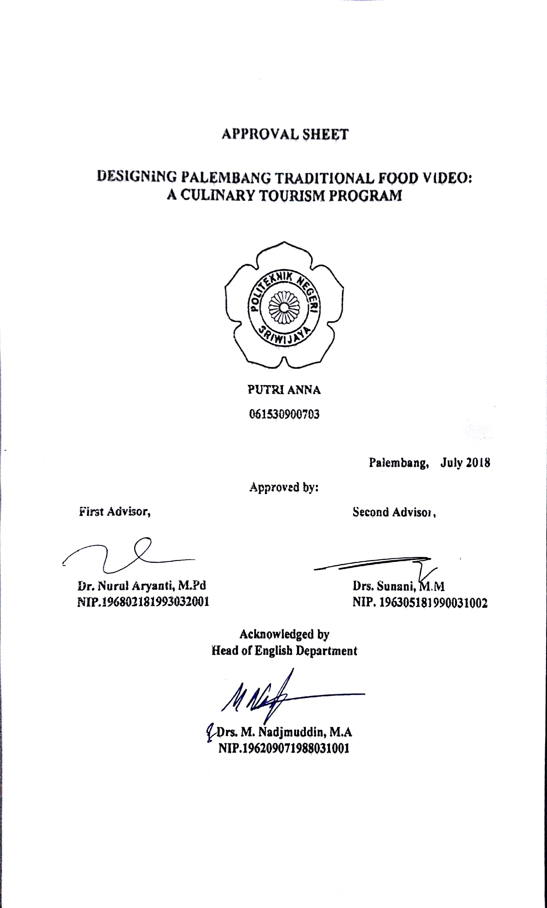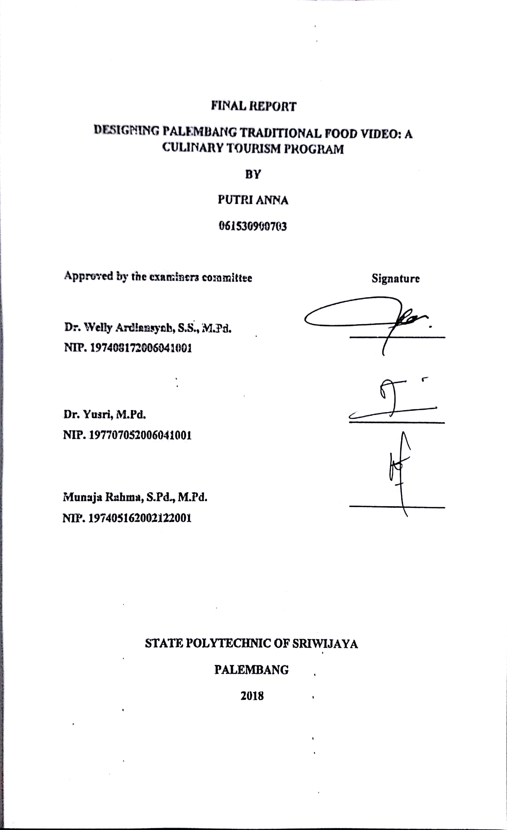
PREFACE

First of all, the writer would like to thank to Allah swt who has beeen given the blessing, oppurtunity, and health to finish this final report. The writer would like to perform His deepest gratitude to the noble prophet, Rasulullah saw for warning and reminding every fault occured. This final report is written to fulfill the requirement of Diploma III curriculum of State Polytechnic of Sriwijaya with the title “ Designing Palembang Traditional Food Video: A Culinary Tourism Program.” Comments and suggestions from all sources about this final report are welcome.

Palembang, July 2018

The writer,

ABSTRACT
Designing Palembang Traditional Food Video: A Culinary Tourism Program
(Putri Anna, 2018: 87 Pages, 3 Charts, 174 Pictures)
Palembang has many traditional foods but some of Palembang traditional foods are less known by the public. Therefore, a medium to provide information about Palembang traditional foods is needed in order to promote and preserve the traditional foods. The medium is a video. A video is powerful tool for promotion. The purpose of this research is to design Palembang traditional food video as a culinary tourism program. The writer used the modification of research and development by Sukmadinata. The writter collected the data by doing interview and observation. In limited field testing, the result showed that scripts and contents of videos should be revised and it must be fixed. In wider field testing, videos were still getting a little comments and suggestions. The final report product was conducted based on the limited and wider field testing. It is concluded that videos can be used to promote and preserve Palembang traditional food. The writer suggests the readers develop the videos and to love and preserve Palembang traditional foods.
Keyword: Design, Video, Palembang Ttraditional Food, Culinary Tourism

MOTTO AND DEDICATION

Motto
“No Limits”

This final report is dedicated to:
- My parents
- My brothers
- Drs. Zakaria, M.Pd

TABLE OF CONTENT

TITTLE SHEET
APPROVAL SHEET
APPROVAL SHEET EXAMINERS
PREFACE.....................................................................................................................i
ABSTRACT.................................................................................................................ii
ACKNOWLEDGMENT............................................................................................iii
MOTTO & DEDICATION........................................................................................iv
TABLE OF CONTENT..............................................................................................v
LIST OF CHART......................................................................................................vii
LIST OF PICTURE.................................................................................................viii
CHAPTER I: INTRODUCTION
  - Background..................................................................................................1
1.2. Problem Formulation..................................................................................2
1.3. Research Purpose........................................................................................2
1.4. Research Benefits.......................................................................................2
CHAPTER II: LITERARTURE REVIEW
2.1. Tourism
2.1.1. Definition of Tourism..................................................................4
2.1.2. Types of Tourism.........................................................................5
2.2. Culinary Tourism
2.2.1. Definition of Culinary Tourism...................................................6
2.3. Traditional Food
2.3.1. Definition of Traditional Food.....................................................7
2.4. Designing
2.4.1. Definition oof Designing.............................................................8
2.5. Video
2.5.1. Definition of Video......................................................................8
2.5.2. Advantages of Video...................................................................9
2.5.3. Components of Video..................................................................9
2.5.4. Steps of Designing Video..........................................................10
2.5.5. Narrator or Voice Over..............................................................11
2.6. Program
2.6.1 Definition of Program.................................................................12
2.6.2 Types of Program.......................................................................12
CHAPTER III: RESEARCH METHODOLOGY
3.1. Research Method......................................................................................18
3.2. Techniques of Collecting Data.................................................................22
3.3. Techniques of Analyzing Data.................................................................23
CHAPTER IV: FINDINGS AND DISCUSSION
4.1. Findings....................................................................................................24
4.1.1. Prelimanary Study.....................................................................24
4.1.2. Model Development..................................................................49
4.1.3. Final Product..............................................................................59
4.2. Discussion.................................................................................................85
CHAPTER V: CONLUSION AND SUGGESTIONS
5.1. Conclusion................................................................................................88
5.2. Suggestions...............................................................................................88
REFERENCES
APPENDICES

LIST OF CHART

Chart 3.1. Steps of R&D by Borg and Gall (1983)....................................................20
Chart 3.2. Steps of R&D by Sukmadinata (2005)......................................................20
Chart 3.3. Steps of R&D by the writer.......................................................................21

LIST OF PICTURE

Picture 2.1. Straight News......................................................................................13
Picture 2.2. Feature.................................................................................................14
Picture 2.3. Infotainment........................................................................................14
Picture 2.4. Magazine.............................................................................................15
Picture 2.5. Documentary.......................................................................................15
Picture 2.6. Talkshow.............................................................................................15
Picture 2.7. Music Program....................................................................................16
Picture 2.8. Drama Stories.....................................................................................16
Picture 2.9. Games.................................................................................................17
Picture 4.1. Adobe Premiere..................................................................................26
Picture 4.2. Opening Adobe Premiere....................................................................27
Picture 4.3 Adobe Premiere...................................................................................27
Picture 4.4. The scene of Opening Program (1).....................................................27
Picture 4.5. The scene of Opening Program (2).....................................................28
Picture 4.6. The scene of Opening Program (3).....................................................28
Picture 4.7. The scene of Opening Program (4).....................................................28
Picture 4.8. The scene of Opening Program (5).....................................................29
Picture 4.9. The scene of Opening Program (6).....................................................29
Picture 4.10. The scene of Episode 1 (1)...............................................................29
Picture 4.11. The scene of Episode 1 (2)...............................................................30
Picture 4.12. The scene of Episode 1 (3)...............................................................30
Picture 4.13. The scene of Episode 1 (4)...............................................................30
Picture 4.14. The scene of Episode 1 (5)...............................................................31
Picture 4.15. The scene of Episode 1 (6)...............................................................31
Picture 4.16. The scene of Episode 1 (7)...............................................................31
Picture 4.17. The scene of Episode 1 (8)...............................................................32
Picture 4.18. The scene of Episode 1 (9)...............................................................32
Picture 4.19. The scene of Episode 1 (10).............................................................32
Picture 4.20. The scene of Episode 1 (11).............................................................33
Picture 4.21. The scene of Episode 1 (12).............................................................33
Picture 4.22. The scene of Episode 1 (13).............................................................33
Picture 4.23. The scene of Episode 1 (14).............................................................34
Picture 4.24. The scene of Episode 1 (15).............................................................34
Picture 4.25. The scene of Episode 1 (16).............................................................34
Picture 4.26. The scene of Episode 1 (17).............................................................35
Picture 4.27. The scene of Episode 1 (18).............................................................35
Picture 4.28. The scene of Episode 1 (19).............................................................35
Picture 4.29. The scene of Episode 1 (20).............................................................36
Picture 4.30. The scene of Episode 2 (1)...............................................................36
Picture 4.31. The scene of Episode 2 (2)...............................................................37
Picture 4.32. The scene of Episode 2 (3)...............................................................37
Picture 4.33. The scene of Episode 2 (4)...............................................................37
Picture 4.34. The scene of Episode 2 (5)...............................................................38
Picture 4.35. The scene of Episode 2 (6)...............................................................38
Picture 4.36. The scene of Episode 2 (7)...............................................................38
Picture 4.37. The scene of Episode 2 (8)...............................................................39
Picture 4.38. The scene of Episode 2 (9)...............................................................39
Picture 4.39. The scene of Episode 2 (10).............................................................39
Picture 4.40. The scene of Episode 2 (11).............................................................40
Picture 4.41. The scene of Episode 2 (12).............................................................40
Picture 4.42. The scene of Episode 2 (13).............................................................40
Picture 4.43. The scene of Episode 2 (14).............................................................41
Picture 4.44. The scene of Episode 2 (15).............................................................41
Picture 4.45. The scene of Episode 2 (16).............................................................41
Picture 4.46. The scene of Episode 2 (17).............................................................42
Picture 4.47. The scene of Episode 2 (18).............................................................42
Picture 4.48. The scene of Episode 2 (19).............................................................42
Picture 4.49. The scene of Episode 2 (20).............................................................43
Picture 4.50. The scene of Episode 2 (21).............................................................43
Picture 4.51. The scene of Episode 3 (1)...............................................................44
Picture 4.52. The scene of Episode 3 (2)...............................................................44
Picture 4.53. The scene of Episode 3 (3)...............................................................44
Picture 4.54. The scene of Episode 3 (4)...............................................................45
Picture 4.55. The scene of Episode 3 (5)...............................................................45
Picture 4.56. The scene of Episode 3 (6)...............................................................45
Picture 4.57. The scene of Episode 3 (7)...............................................................46
Picture 4.58. The scene of Episode 3 (8)...............................................................46
Picture 4.59. The scene of Episode 3 (9)...............................................................46
Picture 4.60. The scene of Episode 3 (10).............................................................47
Picture 4.61. The scene of Episode 3 (1)...............................................................47
Picture 4.62. The scene of Episode 3 (1)...............................................................47
Picture 4.63. The scene of Episode 3 (1)...............................................................48
Picture 4.64. The scene of Episode 3 (1)...............................................................48
Picture 4.65. The scene of Episode 3 (1)...............................................................48
Picture 4.66. The scene of Episode 3 (1)...............................................................49
Picture 4.67. The scene of Episode 3 (1)...............................................................49
Picture 4.68. The scene of Episode 3 (1)...............................................................49
Picture 4.69. The scene of Episode 1 (before).......................................................55
Picture 4.70. The scene of Episode 1 (after)..........................................................55
Picture 4.71. The scene of Episode 1 (before).......................................................55
Picture 4.72. The scene of Episode 1 (after)..........................................................56
Picture 4.73. The scene of Episode 1 (before).......................................................56
Picture 4.74. The scene of Episode 1 (after)..........................................................56
Picture 4.75. The scene of Episode 1 (before).......................................................57
Picture 4.76. The scene of Episode 1 (after)..........................................................57
Picture 4.77. The scene of Episode 1 (before).......................................................57
Picture 4.78. The scene of Episode 1 (after)..........................................................57
Picture 4.79. The scene of Episode 2 (before).......................................................57
Picture 4.80. The scene of Episode 2 (after)..........................................................58
Picture 4.81. The scene of Episode 2 (after)..........................................................58
Picture 4.82. The scene of Episode 2 (after added scene)......................................58
Picture 4.83. The scene of Episode 3 (before).......................................................59
Picture 4.84. The scene of Episode 3 (after)..........................................................59
Picture 4.85. The scene of Episode 3 (after added scene)......................................59
Picture 4.86. The scene of Opening Program Episode 1 (final product)..............60
Picture 4.87. The scene of Opening Program Episode 1 (final product)...............61
Picture 4.88. The scene of Opening Program Episode 1 (final product)...............61
Picture 4.89. The scene of Opening Program Episode 1 (final product)..............61
Picture 4.90. The scene of Opening Program Episode 1 (final product)..............61
Picture 4.91. The scene of Opening Program Episode 1 (final product)...............62
Picture 4.92. The scene of Opening Program Episode 1 (final product)..............62
Picture 4.93. The scene of Episode 1 (final product).............................................62
Picture 4.94. The scene of Episode 1 (final product).............................................63
Picture 4.95. The scene of Episode 1 (final product).............................................63
Picture 4.96. The scene of Episode 1 (final product).............................................63
Picture 4.97. The scene of Episode 1 (final product).............................................64
Picture 4.98. The scene of Episode 1 (final product).............................................64
Picture 4.99. The scene of Episode 1 (final product).............................................64
Picture 4.100. The scene of Episode 1 (final product)...........................................65
Picture 4.101. The scene of Episode 1 (final product)...........................................65
Picture 4.102. The scene of Episode 1 (final product)...........................................65
Picture 4.103. The scene of Episode 1 (final product)...........................................66
Picture 4.104. The scene of Episode 1 (final product)...........................................66
Picture 4.105. The scene of Episode 1 (final product)...........................................66
Picture 4.106. The scene of Episode 1 (final product)...........................................67
Picture 4.107. The scene of Episode 1 (final product)...........................................67
Picture 4.108. The scene of Episode 1 (final product)...........................................67
Picture 4.109. The scene of Episode 1 (final product)...........................................68
Picture 4.110. The scene of Episode 1 (final product)...........................................68
Picture 4.111. The scene of Episode 1 (final product)...........................................68
Picture 4.112. The scene of Opening Program Episode 2 (final product).............69
Picture 4.113. The scene of Opening Program Episode 2 (final product).............69
Picture 4.114. The scene of Opening Program Episode 2 (final product).............69
Picture 4.115. The scene of Opening Program Episode 2 (final product).............69
Picture 4.116. The scene of Opening Program Episode 2 (final product).............70
Picture 4.117. The scene of Opening Program Episode 2 (final product).............70
Picture 4.118. The scene of Episode 2 (final product)...........................................70
Picture 4.119. The scene of Episode 2 (final product)...........................................71
Picture 4.120. The scene of Episode 2 (final product)...........................................71
Picture 4.121. The scene of Episode 2 (final product)...........................................71
Picture 4.122. The scene of Episode 2 (final product)...........................................72
Picture 4.123. The scene of Episode 2 (final product)...........................................72
Picture 4.124. The scene of Episode 2 (final product)...........................................72
Picture 4.125. The scene of Episode 2 (final product)...........................................73
Picture 4.126. The scene of Episode 2 (final product)...........................................73
Picture 4.127. The scene of Episode 2 (final product)...........................................73
Picture 4.128. The scene of Episode 2 (final product)...........................................74
Picture 4.129. The scene of Episode 2 (final product)...........................................74
Picture 4.130. The scene of Episode 2 (final product)...........................................74
Picture 4.131. The scene of Episode 2 (final product)...........................................74
Picture 4.132. The scene of Episode 2 (final product)...........................................75
Picture 4.133. The scene of Episode 2 (final product)...........................................75
Picture 4.134. The scene of Episode 2 (final product)...........................................75
Picture 4.135. The scene of Episode 2 (final product)...........................................75
Picture 4.136. The scene of Episode 2 (final product)...........................................76
Picture 4.137. The scene of Episode 2 (final product)...........................................76
Picture 4.138. The scene of Episode 2 (final product)...........................................76
Picture 4.139. The scene of Episode 2 (final product)...........................................77
Picture 4.140. The scene of Episode 2 (final product)...........................................77
Picture 4.141. The scene of Opening Program Episode 3 (final product).............78
Picture 4.142. The scene of Opening Program Episode 3 (final product).............78
Picture 4.143. The scene of Opening Program Episode 3 (final product).............78
Picture 4.144. The scene of Opening Program Episode 3 (final product).............79
Picture 4.145. The scene of Opening Program Episode 3 (final product).............79
Picture 4.146. The scene of Opening Program Episode 3 (final product).............79
Picture 4.147. The scene of Episode 3 (final product)...........................................79
Picture 4.148. The scene of Episode 3 (final product)...........................................80
Picture 4.149. The scene of Episode 3 (final product)...........................................80
Picture 4.150. The scene of Episode 3 (final product)...........................................80
Picture 4.151. The scene of Episode 3 (final product)...........................................81
Picture 4.152. The scene of Episode 3 (final product)...........................................81
Picture 4.153. The scene of Episode 3 (final product)...........................................81
Picture 4.154. The scene of Episode 3 (final product)...........................................82
Picture 4.155. The scene of Episode 3 (final product)...........................................82
Picture 4.156. The scene of Episode 3 (final product)...........................................82
Picture 4.157. The scene of Episode 3 (final product)...........................................83
Picture 4.158. The scene of Episode 3 (final product)...........................................83
Picture 4.159. The scene of Episode 3 (final product)...........................................83
Picture 4.160. The scene of Episode 3 (final product)...........................................84
Picture 4.161. The scene of Episode 3 (final product)...........................................84
Picture 4.162. The scene of Episode 3 (final product)...........................................84
Picture 4.163. The scene of Episode 3 (final product)...........................................85
Picture 4.164. The scene of Episode 3 (final product)...........................................85
Picture 4.165. The scene of Episode 3 (final product)...........................................85

