CHAPTER II
LITERATURE REVIEW

2.1 Tourism
2.1.1 Definition of Tourism
According to Gulden in Kurniawan (2010), tourism contains travel elements. It means transitional places by person or group to obtain services and intended for tourism. Tourism as a temporary undertaking, conducted from one place to another place in order to enjoy an excursion and recreation (Musanef in Primadany et al., 2013).
Rismiyanto and Danangdjojo (2015), stated that tourism contains temporary elements. Te journey is wholly or partially in order to enjoy the tourist attraction. The most important element in tourism activities is not aimed at earning money.
In addition, Norval in Primadany et al. (2013), tourism is the whole activity that related to the entry, residence, and movement of foreign residents within or outside a particular country, city, or region.
From the explanation above, the writer concludes that tourism is an activity from one place to another place temporary in order to enjoy the excursion and attraction by an individual or group.

2.1.2 Types of Tourism
According to Wardhani (2008), there are 7 types of tourism. They are:
- Ecotourism
Ecotourism is tourism that directed toward exotic, often threatened, natural environments, especially to support conservation efforts and observe wildlife.
- Cultural tourism
Cultural tourism is the subset of tourism which is concerned with a traveler's engagement with a country or region's culture, specifically the lifestyle of the people in those geographical areas, the history of those people, their art, architecture, religion(s), and other elements that helped shape their way of life.
- Heritage tourism
Heritage tourism is traveling in order to experience the places, artifacts, and activities that authentically represent the stories and people of the past.
- Religious tourism
Religious tourism is a type of tourism, where people travel individually or in groups for pilgrimage, missionary, or leisure (fellowship) purposes.
- Culinary tourism
Culinary tourism or food tourism is the exploration of food as the purpose of tourism.

- Shopping tourism
Shopping tourism is a tourist trip that makes shopping as the reason tourists travel.
- Agritourism
Agritourism is defined most broadly, involving any agriculturally-based operation or activity that brings visitors to a farm or ranch.
- Adventure travel
Adventure travel is a type of niche tourism, which inlvolves exploration or travel with a certain risk. It may require special skills and physical exertion.
2.2 Culinary Tourism
2.2.1 Definition of Culinary Tourism
According to Kurniawan (2010), culinary tourism is a program that raised the theme of a variety of food. It usually presents the street food and cheap food. The places visited are spread across the corner of the city, district, provincial or the capital of a city.
Based on Suryadana in Rismiyanto and Danangdjojo (2015), culinary tourism is defined as a tour that provides a variety of services and activities suitable to meet the needs of tourists built for recreation, relaxation, education and health
Furthermore, Harsana in Akbar (2014), culinary tourism is a travel activity or part of the activity is done voluntarily and temporary to enjoy a type of food or drink. It also means human activities that travel with a destination to somewhere to obtain or enjoy a type of food or drink that can only be found in the area.
From the explanation above, the writer concludes that culinary tourism is a part of tourist activities which tourists have a goal to enjoy traditional food that only exists in the area.

2.3 Traditional Food
2.3.1 Definition of Traditional Food
Traditional food is a hereditary food and it has been cultured in a concentrated Indonesian society with local traditions (Winarno in Adiasih and Brahmana, 2015). Traditional food is food that consumed by ethnic and specific ethnic groups. It processed on the basis of a hereditary recipe. The materials used in the local area and the taste of food are based on local society (Adiasih and Brahmana, 2015).
According to Nurhalimah (2016), traditional foods are snacks and beverages. Traditional food is generally consumed by local people then it is introduced to foreign people or immigrants.
Based on Setiabudi (2016), traditional food is everything that can be eaten. Traditional food comes from an area and only exist in that area. So, it can be a hallmark for an area. Traditional food is processed based on recipes of foods that have been known with techniques and cooking tools passed down from generation to generation.
Furthermore, Kumala in Rahmalianti (2016), traditional food is a cultural phenomenon that is increasingly in the precise of its existence. The culture can determine the food can be eaten or not, as well as to stamp or legalize it to the uniqueness of an area. Thus, food is not just to survive, but also to preserve the culture.
The writer concludes that traditional foods are including snacks and beverages that only exist in an area. It is derived from certain areas and passed down from generation to generation. The ingredients and technique of cooking are based on the local society. Traditional food is usually consumed by local people then it is introduced to foreign people or immigrants.

2.4 Designing
2.4.1 Definition of Designing
Based on Sachari (2005), regarding the definition of design contains the sense as an artist's creations to meet the certain needs in a certain way. Design is to design a design to produce a design. The design as a noun is a concept or science. The design as a verb is an idea and the last design as a verb is a final product (Heskett, 2002),
Furthermore, Anggraini and Nathalia (2014), a design is the art of conveying information or messages by using a visual language that is conveyed through the media in the form of design. The purpose of designing is to inform, influence, and to change the target behavior (audience). The design process takes into account aspects of functionality, aesthetics, and various other aspects, and the data is usually derived from research, thought, brainstorming, and pre-existing design. The principles of composition are unity, balance, rhythm, contrast, focus, and proportion.

2.5 Video
2.5.1 Definition of Video
According to Yurikhe (2015), a video is a technology for capturing, recording, processing and rearranging moving images. Video as an audio-visual media that displays motion, the longer the more popular in our society. Messages which is presented can be factual or fictive, and it can be informative, educative and instructional. Most movie tasks can be replaced by videos. But it does not mean that the video will replace the movie position. Video media is one type of audio-visual media, in addition to films that are widely developed for learning purposes (Ibtida, 2016).
Similar to Sudirman (1990) stated that nowadays, video as a audio visual media that displays motion, more popular in our society. Messages presented facts (events or important events, news) or fictive, and it can be informative, educative and instructional.
The writer concludes, a video is a technology for capturing, recording, processing and rearranging moving images. Nowadays, video as an audio-visual media that displays motion, more popular in our society. Messages presented facts and fictive, and it can be informative, educative and instructional
2.5.2 Advantages of Video
According to MacFarland (2014) video is a powerful tool for promotion, he mentions several advantages of video. They are:
1. A video has become so easy to use that a person can simply use a smartphone, tablet or computer to record a video.
2. A Video is an impeccable storytelling medium that allows the viewer to look and listen to the content, using multiple senses that have the ability to transport your mind from the environment you are in and place you inside the environment of the video.
3. A video is being watched online more and more every year including an 800% increase in online video consumption over the past six years, a 55% majority of video news viewers among Internet users and 2 billion video views per week are monetized on YouTube.

2.5.3 Componenst of Video
According to Ciampa et al (2016) there are four components that make a good video, they are :
  - Good lighting
Good lighting (as opposed to merely adequate lighting) needs to bathe the subject in a flattering way, as shown. It doesn’t matter if using a sophisticated light kit or depending on the sun, as long as the final product looks good.
  - Top quality audio
The better a video sounds, the better it looks. Visual elements can easily be accepted when the sound is clear.
  - Steady camera
Steady camera will produce a steady shots as well. Steady shots will ease the editor when selecting the best shots. The result of video will look professional if the display do not shake or move too much. Therefore, using of a tripod is highly recommended.
  - Shot Structure
A good video display the object in different shot types and angles. The editor should strive for a nice selection of shot types and angles in order to keep the viewers engaged.

2.5.4 Steps of Desiging Video
The steps of designing a video according to Budiyono (2017), as follows:
- Making script and storyboard
Make the script based on topics you like, figure out what topic you are interested to discuss in your video , write down everything that you need to talk during the video. You can also use code like to show something, could be pictures to be shown in the video. Make sure that you put detail information about the topic you want to discuss in your video. After you write all the necessary information, it is time to type the script and make storyboard. Storyboard is an important foundation to make a video because it is the reference for the director in making video. Storyboard is an activity to transfer your words into draws. To make a storyboard you need a plain paper and divide your paper into some square by lining it up with pen or pencil. Then you can go to scene I, draw everything you want to show during the video, make sure it is related with the script you have made before. Continue until all scenes are connected with the scripts.

- Recording
After making script and storyboard, then you can continue to record the video. To record the video you need camera or smartphone, tripod for holding the camera if necessary, and audio recorder from your smartphone. Before you record the video , you need to prepare the location where you want to record the video and set the camera setting. Do not forget to record your voice using audio recorder while you were recording the video. If you need to talk in front of the camera you have to remember the script and talk as if you are talking with the viewers. After all sets are ready you can begin to record your video and check the scenes that you have recorded on the storyboard.

- Editing
Move all the files that you want to edit from your camera or smartphone to your computer. Make a new folder and put all the files you want to edit there, you also can rename your files to ease you, such as changing the audio record title as the same title as the video. You can edit the video using adobe premiere pro or others application. Edit your video based on the storyboard you have made before.

2.5.5 Narrator or Voice Over
Ayawaila (2017), says the main key that is required from a narrator is the flexibility in adapting to the tempo and storyline rhythm and also theme in general. The followings are several criteria for a narrator given by Ayawaila.
- Having a dramatic sensitivity and timing (based on the tempo and rhythm of speech).
- Able to master and animate the meaning and the purpose of every words and/senteces when processing the speech.
- Able to give action and reaction to visual elements.
- Able to use the sense in applying dramatic elements to the speech, in accordence with the understanding of the content and theme of the video, so there is harmonization and mutual support between the narrative and the visual sequence.
- Able to understand quickly and precisely when the narrative serves as a supporter, and when as a main information, especially if the visual ability is rather week in providing information to the audience.
2.6 Program
2.6.1 Definition of Program
According to Sholichah (2014), a program is a material that has been prepared in a single format with video elements supported by an audio element that technically meets the feasible broadcasting requirements and meets the prevailing aesthetic and artistic standards. Programs can be equated or analogous to products or goods or services sold to other parties, in this, case the audience and advertising (Nisa, 2008).
Furthertmore, Kuswita (2014) stated that a program is the result of voice and image coverage compiled into an audio visual program and disseminated to audiences through media with audio visual form or event format.
The writer concludes that a program is a video format as the result of image coverage supported by audio-visual which made based on the standards and deserve to be disseminated.

2.6.2 Types of Program
According to Morissan (2009), the various types of programs that can be grouped into two parts they are:
- Information program
An information program on television, as the name implies, provides a wealth of information to satisfy the audience's curiosity about something. An information program is any kind of broadcast that aims to provide additional knowledge. Information programs are not always about news, but all the forms of information presentation include talk shows, such as interviews with artists. The information program can be divided into two major parts, they are:
- Hard News
Hard News is all the important and interesting information that must be broadcasted by the broadcasting media because of its nature that must be immediately aired in order to be known to the audience as soon as possible. Hard news can be straight news, features, infotainment.
- Straight news is a direct news, it means a short news with only containing or presenting the most important information included 5w + h to a reported event.
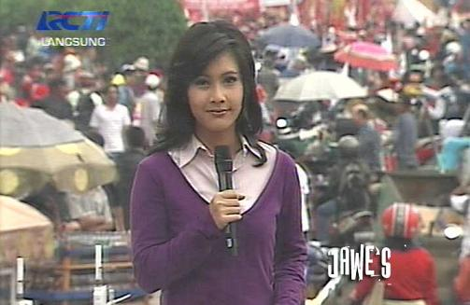
Picture 2.1. Straight News
source www.google.com

- Feature is a news or topic that can be about lifestyle, household, family, art, entertainment, or who have a weekly section such as culinary, health, education, and so on.

Picture 2.2. Feature
source www.google.com

- Infotainment is one of events that presents a program about entertainment world information.

Picture 2.3. Infotainment
source www.google.com

- Soft News
Soft news is all the important and interesting information that is submitted in depth but not necessarily be aired. Programs included in this category are current affairs, magazines, documentaries and talk shows.
Picture 2.4. Magazine
source www.google.com

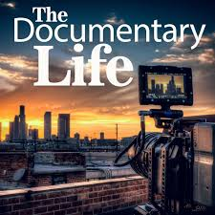
Picture 2.5. Documentary
source www.google.com

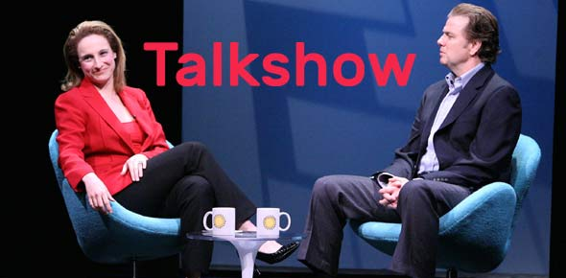
Picture 2.6. Talkshow
source www.google.com

- Entertaint Program
An entertainment program is any form that aims to entertain an audience in the form of music, songs, drama stories, and game.

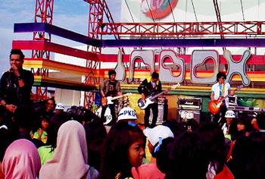
Picture 2.7. Music Program
source www.google.com

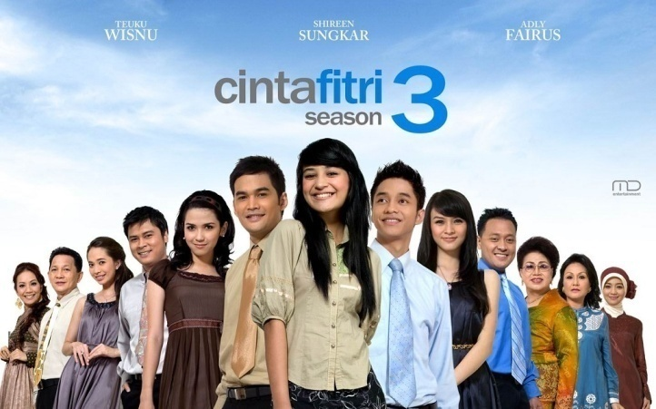
Picture 2.8. Drama stories
source www.google.com

Picture 2.9. Games
source www.google.com

