FINAL REPORT
DESIGNING A GUIDEBOOK OF LORONG BASAH NIGHT CULINARY IN PROMOTING PALEMBANG TOURISM
This report is written to fulfill requirement for subject of final report subject at State Polytechnic of Sriwijaya

BY:
MELLA LORENSA
0615 3090 0699

ENGLISH DEPARTMENT
STATE POLYTECHNIC OF SRIWIJAY
2018
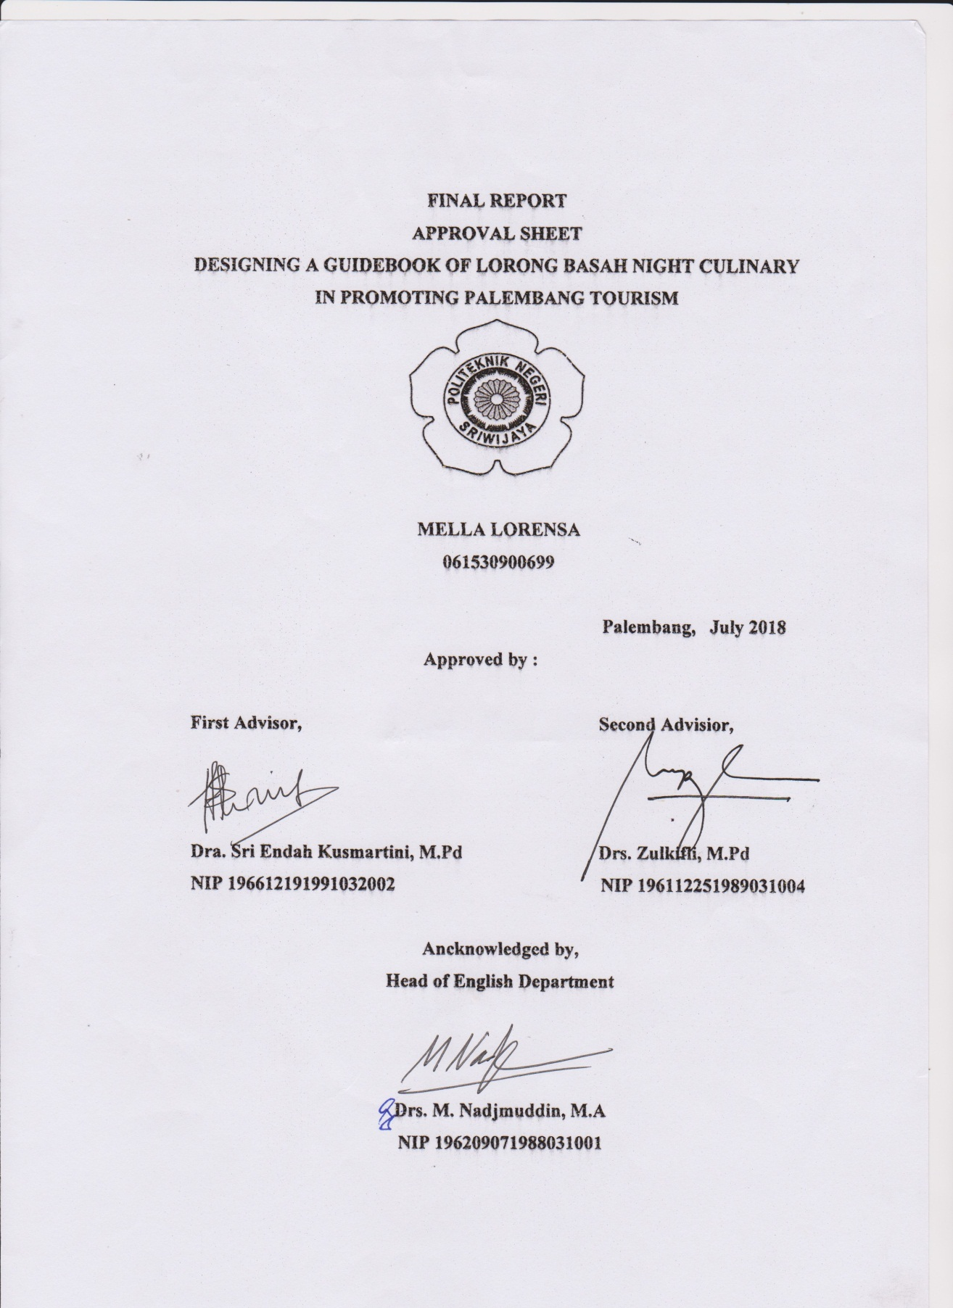
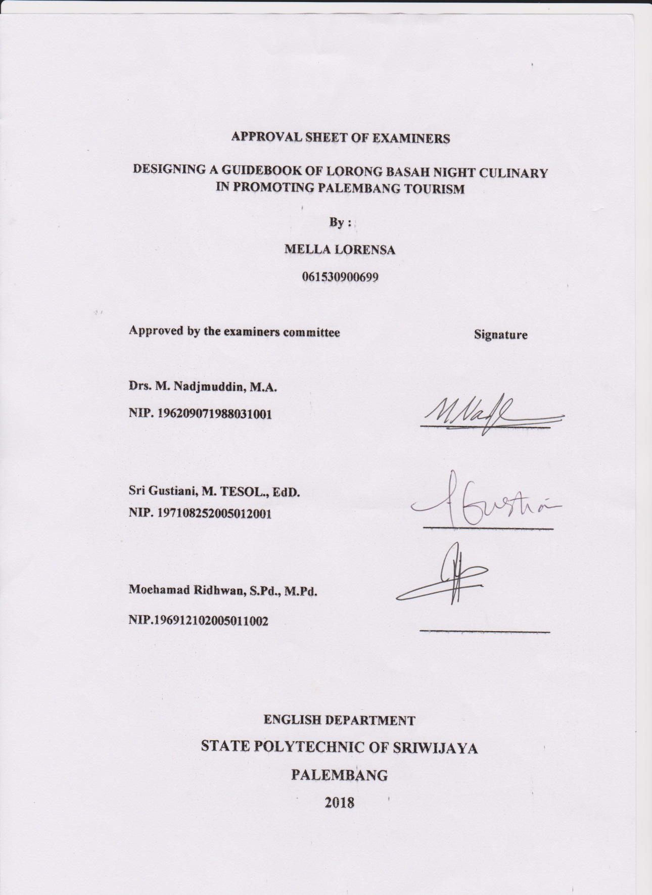
ABSTRACT
Designing a Guidebook of Lorong Basah Night Culinary in Promoting Palembang Tourism
(Mella Lorensa, 2018: 121 Pages, 82 Figures, 4 Tables)
Lorong Basah Night Culinary is one of tourism destinations especially culinary tourism in Palembang. In fact, the information about Lorong Basah Night Culinary is still very limited. Therefore, it needs a media that provides lot of information about Lorong Basah Night Culinary to promote it. The media is a guidebook. The purpose of the research is to design guidebook of Lorong Basah Night Culinary in promoting tourism destination. The writer used research and development method modified by Sukmadinata, the writer collected the data by doing observation and interview. In limited field testing, the result showed that the guidebook should be revised. The experts give the comments and suggestions that there were some design and the content of guidebook should be revised. The experts give the comments some mistakes in the language used so that it must be fixed. In wider field testing, the guidebook was still getting a little comments and suggestions after that it can be accepted. The final product must be conducted based on the limited and wider field testing comments. The writer suggested the reader that the guidebook can as one of references to search the information about Lorong Basah Night Culinary. The writer also suggested to the government that as references for media promotion about tourism destination in Palembang.
Keyword: Design, Guidebook, Palembang Tourism, Lorong Basah Night Culinary

ABSTRACT
Mendesign Sebuah Buku Panduan di Lorong Basah Night Culinary dalam Mempromosikan Destinasi Pariwisata Palembang
(Mella Lorensa, 2018: 121 Halaman, 82 Gambar, 4 Tabel)
Lorong Basah Night Culinary adalah salah satu tujuan wisata khususnya wisata kuliner di Palembang. Faktanya, informasi tentang Lorong Basah Night Culinary masih sangat terbatas. Oleh karena itu, dibutuhkan media yang menyediakan banyak informasi tentang Lorong Basah Night Culinary untuk mempromosikan itu. Media tersebut adalah buku panduan. Tujuan dari penelitian ini adalah untuk mendesign buku panduan Lorong Basah Night Culinary dalam mempromosikan destinasi pariwisata Palembang. Penulis menggunakan metode penelitian dan pengembangan yang dimodifikasi oleh Sukmadinata, Penulis mengumpulkan data dengan melakukan observasi dan wawancara. Dalam pengujian lapangan terbatas, hasilnya menunjukkan bahwa buku panduan harus direvisi. Para ahli memberikan komentar dan saran bahwa ada beberapa desain dan isi buku panduan harus direvisi. Para ahli memberikan komentar bahwa ada beberapa kesalahan dalam bahasa yang digunakan sehingga harus diperbaiki. Dalam pengujian lapangan yang lebih luas, buku panduan masih mendapatkan sedikit komentar dan saran setelah itu dapat diterima. Produk akhir harus dilakukan berdasarkan komentar pengujian lapangan yang terbatas dan lebih luas. Penulis menyarankan kepada pembaca bahwa buku panduan dapat menjadi salah satu referensi untuk mencari informasi tentang Lorong Basah Night Culinary. Penulis juga menyarankan kepada pemerintah bahwa sebagai referensi untuk media promosi tentang destinasi pariwisata di Palembang.
Kata Kunci : Design, Buku Panduan, Destinasi Pariwisata Palembang, Lorong Basah Night Culinary

PREFACE
First of all the writer would like to thank to Allah SWT and Prophet of Muhammad SAW for the mercy that has been given to the writer so that the writer could finish the final report. Eventually, this report is written to fulfill the requirement of final report at State Polytechnic of Sriwijaya Palembang entitled “Designing Guidebook of Lorong Basah Night Culinary in Promoting Palembang Tourism”.
The writer would also like to thank all people who had helped finishing this report because without their helps, motivation, and advices, this report would not be finished. Therefore, any suggestions and critics always welcome. The writer also expects that this report along with the product could give advantages for the readers.

Palembang, 13 July 2018

The Writer

ACKNOWLEDGMENT
First of all, the writer would like to express the gratitude to Allah SWT and the prophet of Muhammad SAW. In this moment, the writer would like to say thanks to everyone who has given many contributions in this final report:
- My family, My mother, father, sister and brother. Thank you for always support and pray for me.
- Mr. Nadjmuddin as the Head of English Department.
- Mrs. Sri EndahKusmartini as the first advisor and Mr. Zulkifli as the second advisor. I would like to say thank you for both of you for your time, suggestions, advices, critics, correction, new knowledge, supports, and guiding patiently during the consultation.
- Deby, Habibah, KakCia and Dimas. Thank you for always helping me.
- The experts, thank you for all the comments and suggestions that you give to me in order to finish my final report.
- All my beloved friends in BB Class 2015-2018. Thank you for all the moments that we spend together in these past three years and thank you for each of you supports.

Palembang, 13 July 2018

The Writer
I just say Thank you

MOTTO

“Without being grateful,
you will never know the meaning of life”

- MellaLorensa-

TABLE OF CONTENTS
TITLE SHEET
APPROVAL SHEET
APPROVAL SHEET OF EXAMINERS
ABSTRACT i
PREFACE ii
ACKNOWLEDGEMENT. iii
MOTTO. iv
TABLE OF CONTENT v
LIST OF FIGURES viii
LIST OF TABLES xii
CHAPTER I INTRODUCTION
1.1 Background 1
1.2 Problem Formulation 3
1.3 Research Purposes 3
1.4 Research Benefits 3
CHAPTER II LITERATURE REVIEW
2.1 Tourism
2.1.1 Definition Tourism 5
2.1.2 Type of tourism 5
2.2 Culinary Tourism 6
2.3 LorongBasah Night Culinary 7
2.4 Promotion
2.4.1 Definition Promotion 8
2.4.2 The Type of Promotion Media 8
2.5 Guidebook 9
2.6 Tips for Writing A Guide Book 10
2.7 Design
2.7.1 Definition of Design 11
2.7.2 The Element of Design 12
2.7.3 The Principle of Design 13
CHAPTER III RESEARCH METHODOLOGY
3.1 Qualitative of Research 18
3.2 Method of Research 18
3.3 Places of Research 21
3.4 Participant of Research 22
3.5 Technique of Collecting The Data
3.4.1 Literature Study 23
3.4.2 Field Survey 23
3.6 Technique of Analyzing The Data
3.5.1 Literature Study 24
3.5.2 Field Survey 24
CHAPTER IV FINDINGS AND DISCUSSIONS
4.1 Findings 26
4.2 Discussions 74
CHAPTER V CONCLUSION
5.1 Conclusion 78
5.2 Suggestion 78
REFERENCES 80

APPENDINCES
Appendix 1 : Recommendation Sheet 87
Appendix 2 : Letter of Implementation of the Final Report Revision 88
Appendix 3 : Letter of Final Report Guidance Agreement 92
Appendix 4 : Final Report Guidance Sheet 94
Appendix 5 : List of Tenants 98
Appendix 6 : Interview Questions 104
Appendix7 : Letter of Statement 105
Appendix 8 : Interview Journal 114

LIST OF FIGURES
Figure 2.1 Line of Design Principles 14
Figure 2.2 Colour of Design Principles 14
Figure 2.3 Negative Space of Design Principles 15
Figure 2.4 Texture of Design Principles 15
Figure 2.5 Contrast of Design Principles 16
Figure 2.6 Framing of Design Principles 16
Figure 2.7 Typography of Design Principles 17
Figure 3.1 The Steps of R&D Modified by Sukmadinata 19
Figure 4.1 Step 1 of Cover Design 27
Figure 4.2 Step 2 of Cover Design 27
Figure 4.3 Step 3 of Cover Design 28
Figure 4.4 Step 4 of Cover Design 28
Figure 4.5 Step 5 of Cover Design 29
Figure 4.6 Step 6 of Cover Design 29
Figure 4.7 Step 7 of Cover Design 30
Figure 4.8 Step 8 of Cover Design 30
Figure 4.9 Step 9 of Cover Design 31
Figure 4.10 Step 10 of Cover Design 31
Figure 4.11 Step 1 of Content Design 32
Figure 4.12 Step 2 of Content Design 32
Figure 4.13 Step 3 of Content Design 32
Figure 4.14 Table of Content 33
Figure 4.15 Palembang and Lorong Basah Night Culinary 33
Figure 4.16 Maps of Lorong Basah Night Culinary ..34
Figure 4.17 The Background of The Content 34
Figure 4.18 Mommy Corner 35
Figure 4.19 Waroeng Gokar 35
Figure 4.20 Kedai Oncak 36
Figure 4.21 Nasi Bakar Bu’Lies 36
Figure 4.22 Julie Ammar 37
Figure 4.23 Warung Cilamaya 37
Figure 4.24 Pangsit Mayo 38
Figure 4.25 Tea Tea Thai 38
Figure 4.26 Siomay Nyonya Lani 39
Figure 4.27 Te Teh 39
Figure 4.28 Sate Taichan Pf 40
Figure 4.29 Bakso 40
Figure 4.30 Pokat Kocok 41
Figure 4.31 Pempek Panggang 41
Figure 4.32 Ice Milo Kepal Bunda Joice 42
Figure 4.33 Pisang Rindu 42
Figure 4.34 Aneka pempek Udang Sungsang 43
Figure 4.35 Pempek Crispy Ummi 43
Figure 4.36 Martabak Iki 44
Figure 4.37 Kerak Telor Khas Betawi 44
Figure 4.38 Cillor Jolly 45
Figure 4.39 Vip Place 45
Figure 4.40 List of Hotel 46
Figure 4.41 The Background of Palembang and Lorong Basah Night Culinary (Before the revision) 47
Figure 4.42 The Background of Palembang and Lorong Basah Night Culinary (After the revision) 47
Figure 4.43 The Text and Font of Nasi Bakar Bu’Lies (Before the revision) 48
Figure 4.44 The Text and Font of Nasi Bakar Bu’ Lies (After the revision) 48
Figure 4.45 The Map Page of Lorong Basah Night Culinary (Before the revision) 51
Figure 4.46 The Maps Page of Lorong Basah Night Culinary (After the revision) 51
Figure 4.47 The Profile 52
Figure 4.48 The Cover of Guidebook (Before the revision) 52
Figure 4.49 (The cover of Guidebook (After the revision) 53
Figure 4.50 The Location of Tenant ( Before the revision) 62
Figure 4.51 The Location of Tenant ( After the revision) 62
Figure 4.52 The Maps of Lorong Basah Night Culinary (Before the revision) 63
Figure 4.53 The Maps of Lorong Basah Night Culinary (After the revision) 63
Figure 4.54 The Front and Back Cover (After the Revision) 64
Figure 4.55 TheProfile 64
Figure 4.56 The Table of Content (After the revision) 65
Figure 4.57 Page 1 and 2 65
Figure 4.58 Page 3 and 4 65
Figure4.59 Page 5 and 6 66
Figure 4.60 Page 7 and 8 66
Figure 4.61 Page 9 and 10 66
Figure 4.62 Page 11 and 12 67
Figure 4.63 Page 13 and 14 67
Figure 4.64 Page 15 and 16 67
Figure 4.65 Page 17 and 18 68
Figure 4.66 Page 19 and 20 68
Figure 4.67 Page 21 and 22 68
Figure 4.68 Page 23 and 24 69
Figure 4.69 Page 25 and 26 69
Figure 4.70 Page 27 and 28 69
Figure 4.71 Page 29 and 30 70
Figure 4.72 Page 31 and 32 70
Figure 4.73 Page 33 and 34 70
Figure 4.74 Page 35 and 36 71
Figure 4.75 Page 37 and 38 71
Figure 4.76 Page 39 and 40 71
Figure 4.77 Page 41 and 42 72
Figure 4.78 Page 43 and 44 72
Figure 4.79 Page 45 and 46 72
Figure 4.80 Page 47 and 48 73
Figure 4.81 Page 49 and 50 73
Figure 4.82 Page 51 and 52 73

LIST OF TABLES
Table 4.1 The list of Waroeng Gokar Content 49
Table 4.2 The list of Julie Ammar Content 50
Table 4.3 Revision in term of language aspect 53
Table 4.4 The information of Pokat Kocok (before and after the revision) 60

