THE INNOVATION OF A NEW VARIANT OF INSTANT CEREALS THROUGH THE USE OF PUMPKINS

This report is written to fulfill the requirement of Diploma III in English Department at State Polytechnic of Sriwijaya

By:
Nadya Simatupang
0615 3090 0675

ENGLISH DEPARTMENT
STATE POLYTECHNIC OF SRIWIJAYA
PALEMBANG
2018

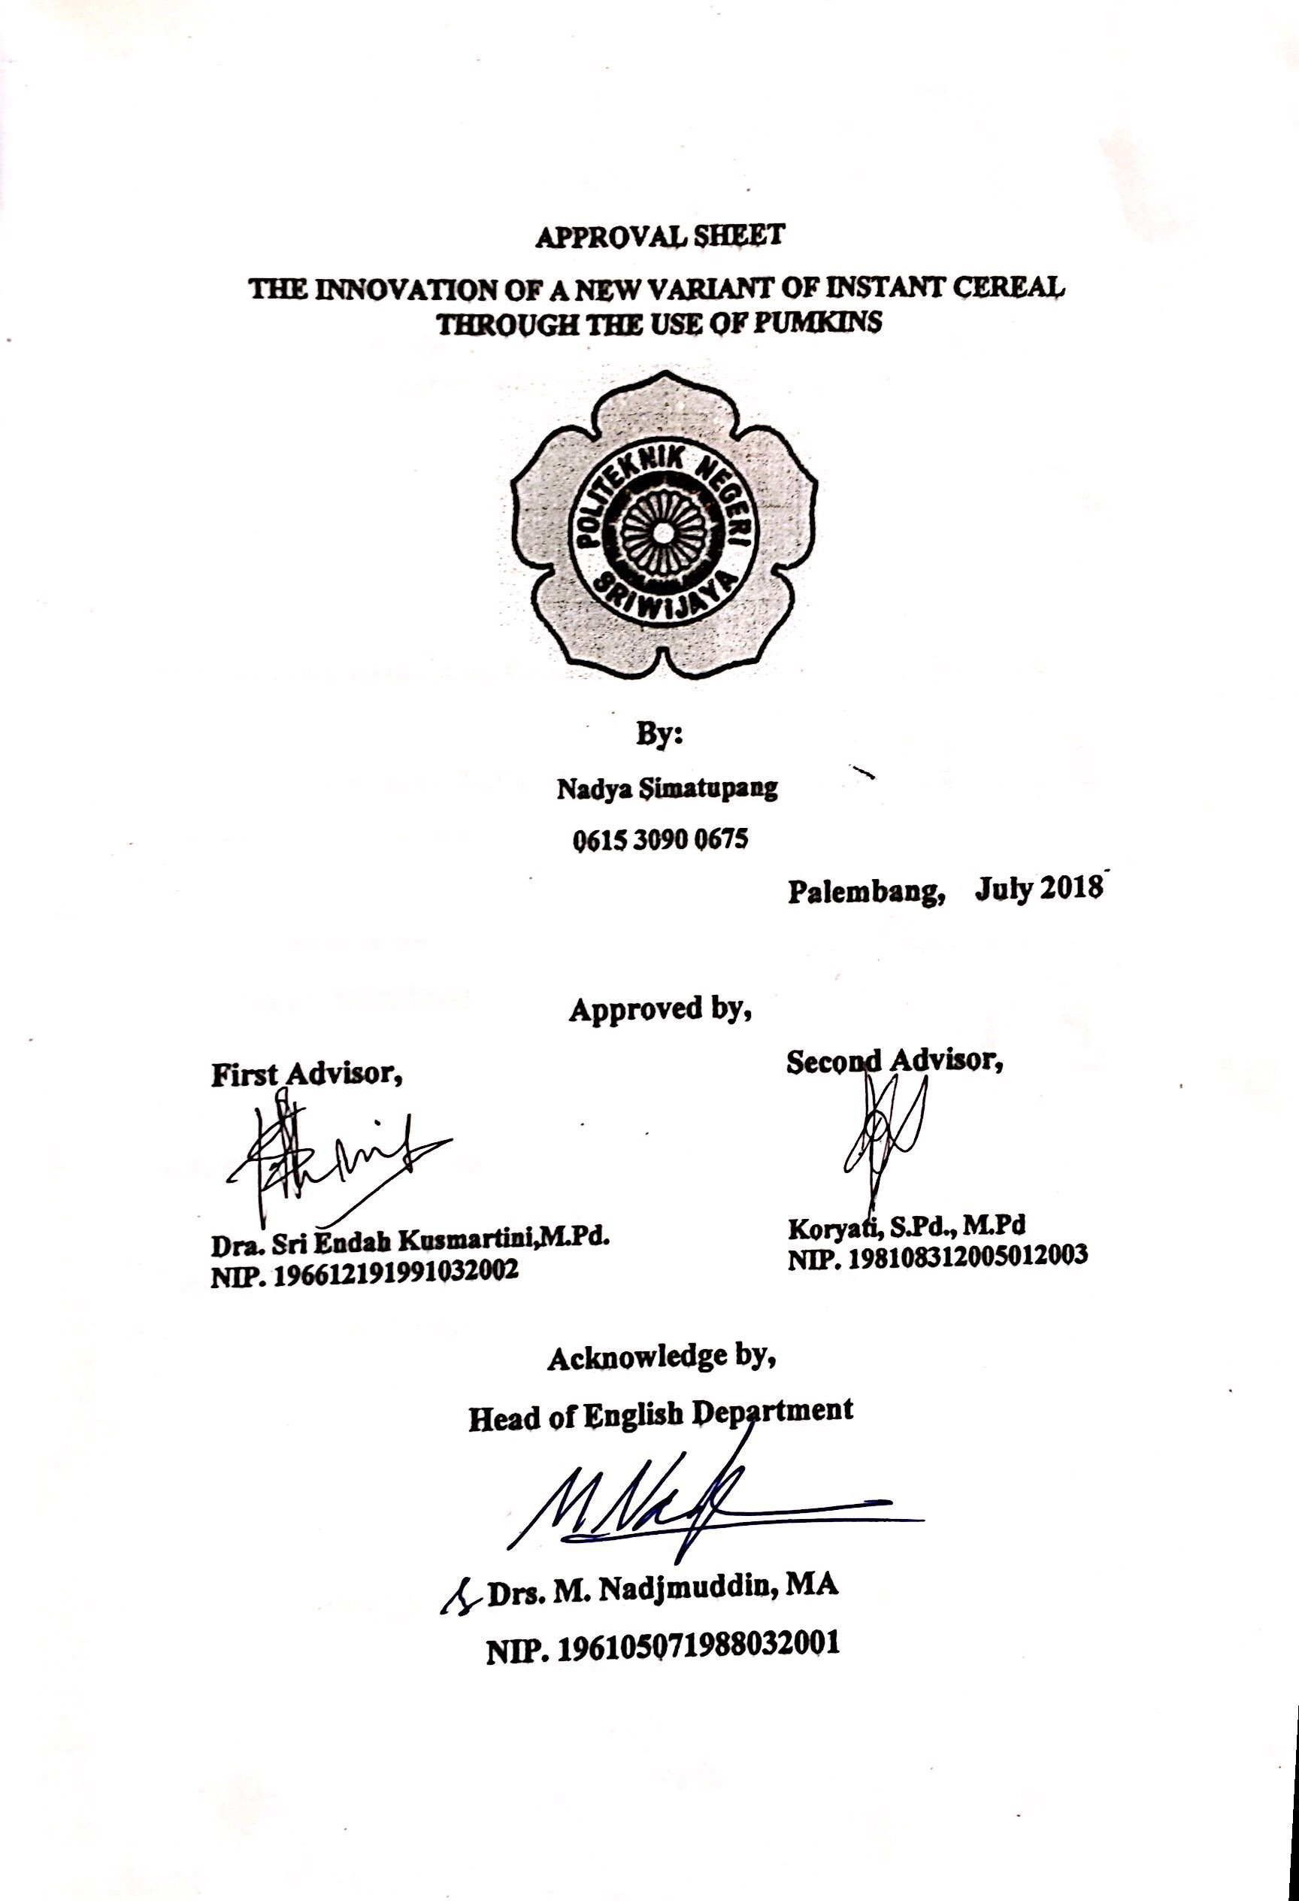
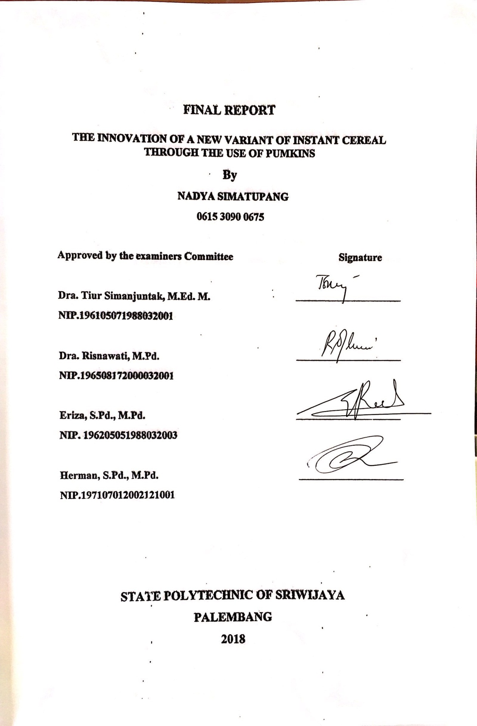

MOTTO AND DEDICATION

MOTTO:
“Kill them with your success, and then bury them with a smile”
DEDICATION:
I dedicate this final report to: My beloved parents, my beloved brother and sister, my beloved friends, my beloved advisor, and my beloved major of English Department POLSRI.

PREFACE

First of all, the writer would like to say thank to Allah SWT for the mercy and blessing that Allah SWT has been given to the writer. Therefore, the writer could finish the final report. The writer also would like to express the warm east gratitude to the noble prophet Muhammad SAW. Eventually, this report is written as one of the requirements to finish diploma III at English Department, which entitled “The Innovation of New Variant of Instant Cereals Through the Use of Pumpkins”.
The writer considers that in writing this final report still has many insufficiencies and unintended mistakes. Therefore, constructive criticism and suggestion are expected for the improvement. Finally, the writer expects that this report provide benefits to other people who might need the information especially for the students of English Department.

Palembang, July 2018

The writer

ACKNOWLEDGEMENT
In this moment, the writer would like to express deep gratitude to the entire participants for their advices and valuable guidance during writing this final report. First of all, the writer would like to thank to ALLAH SWT for his mercy and guidance in giving me strength to complete this final report. In this chance, the writer would like to thank to:
- Head of English Department, Mr. Drs. M. Nadjmuddin, MA and Mrs. Sri Gustiani, S.Pd.,M TESOL., EdD as the secretary of English Department
- Thank to my advisors, Mrs. Dra. Sri Endah Kusmartini,M.Pd. and Mrs. Koryati, S.Pd., M.Pd. for giving invaluable assistance, guidance and valuable suggestions during the writing of this final report.
- My third respect and thanks goes to all lecturers and staff in English Department
- My beloved family especially for my beloved parents for the prayers and financial support
- My beloved friends in 6BA class thank you for your support, help, and togetherness in this almost three years
- All of students in English Department at State Polytechnic of Sriwijaya who never give up in giving their support.

ABSTRACT

The Innovation of a New Variant of Instant Cereals Through The Use of Pumpkins

(Nadya Simatupang, 2018, i-ix, 1-45)
This research focused on the innovation of a new variant of instant cereals through the use of pumpkins. The purpose of this research was how to make the innovation of a new variant of instant cereals through the use of pumpkins. The method of the research was Research and Development Method which modified by Sugiono. The data were collected through the interview and documents analysis. Based on the finding, the writer found that pumpkins can be as main ingredient of instant cereals. The writer did three times to get proportional ingredients and steps. The conclusion was the innovation of a new variant of instant cereals through the use of pumpkins can be the options to diversify food variations. The writer hopes that pumpkin could be innovated in other variations of food in order the purpose of food diversification could run well.
Keywords: Innovation of Pumpkins, Food Diversification, Research and
Development, and Instant Cereals.

TABLE OF CONTENT

MOTTO AND DEDICATION …………………………………………………… i
PREFACE …………………………………..………………………………….….. ii
ACKNOWLEDGEMENT …………………………………..…………………… iii
ABSTRACT …………………………………..………………………………..….. iv
TABLE OF CONTENT …………………………………..……………………….. v
LIST OF FINGURES …………………………………..………………………… vii
LIST OF TABLES …………………………………..………..……………….…. viii
LIST OF CHART …………………………………….……………..………….…. ix
CHAPTER I: INTRODUCTION
  - Background ………………………..……………………….……..………….. 1
  - Problem Limitation ………………………..…………………………………. 2
  - Problem Formulation ………………………..……………….………………. 3
  - Research Purpose ………………………..…………………..……………….. 3
  - Research Benefit ………………………..…………………...……………….. 3

CHAPTER II: LITERATURE REVIEW
- Food Diversification …………………..………………………………….. 4
- The Definition of Innovations ………………..…………………………… 4
- Cereals ………………..……………..…………………………………….. 5
- Kind of Cereals ………………….…………………………………… 5
- Ingredients of Instant Cereals ………………..……………..………… 8
- Process Technology of Instant Cereals ………………..……………… 9
- Characteristic of Cereals …………………………………………….. 10
- Pumpkins ………………..………………………………..……….…….. 12
- Nutrient of Pumpkins ………………..…………………………….... 13
- Benefit of Pumpkins ………………..……………………………….. 14
- Previous Study ………………..………………...……………………….. 16

CHAPTER III: RESEARCH METHODOLOGY
- Method of Research ………………..……………..……………………….. 19
- Place of Research ………………..…………………………………….….. 22
- Subject of the Research ………………..………………………………….. 22
- Technique of Collecting Data ………………..…………………………… 23
- Techniques of Analyzing the Data ………………..……………….……… 24
CHAPTER IV: FINDING AND DISCUSSION
- Finding ……………..………………………………………..…………… 23
- Discussions ……………..………………………………………..…….… 36
CHAPTER V: CONCLUSION AND SUGGESTIONS
- Conclusion ……………..………………………………..……..………… 41
- Suggestions ……………..………………………………………...……… 41
REFERENCES ……………………………………………………….…………... 42
APPENDECIS

LIST OF FINGURES

Figure 2.1 Traditional Cereals …………………………………………..………….. 6
Figure 2.2 Traditional Ready-made Cereals ……………………………..………… 6
Figure 2.3 Ready-to-eat Breakfast Cereal ………………………………..………… 7
Figure 2.4 Ready-to-eat mix cereal ………………………………………………… 7
Figure 2.5 Weaning Food …………………………………………….…………….. 8
Figure 2.6 Pumpkins ……………………………………………………………….. 12
Figure 4.1 Instant Cereals through the use of pumpkins (Revision of Validation) ... 30
Figure 4.2 Instant Cereals through the use of pumpkins (Revision of Product
Testing) ………….............................................................................…… 33

LIST OF TABLES

Table 2.1 Nutrition Fact of Pumpkins per 100g ……………………………..…….. 13
Table 2.2 Hanawati’s Recipe …………………………………………………...….. 16
Table 2.3 Iriyanti‘s Recipe …………………………………………………..…….. 17
Table 2.4 Agustina‘s Recipe ………………………………………………..……… 17
Table 4.1 Ingredients in Making Cereal in Product Design ………………..……… 26
Table 4.3 Steps in Making Cereal in Product Design …………….………..……… 27
Table 4.3 The Ingredients of Product Design and its Revision …………….……… 29
Table 4.4 The Steps of Product Design and its Revision …………………..……… 29
Table 4.5 Ingredients of Product Testing and its Revisions ……………....………. 32
Table 4.6 Steps of Product Testing and its Revisions …………………..…………. 33
Table 4.7 The Ingredients of Final Product …………...…..……………………….. 34
Table 4.8 Steps of Final Product …………...…..………………………………….. 35

LIST OF CHART

Chart 1 the steps of R&D Modified by Sugiono ………………………………….. 19

