CHAPTER II
LITERATURE REVIEW

2.1 Food Diversification
Yuli et al. (2015) mention that food diversification is a program that encourages people to vary their staple foods so they do not focus on one main food item. Similar to Yuli, Riyadi (2003) (as stated in Fasak 2011, p.31) mentions food diversification is a process of choosing food which does not depend on just one kind of food, but it has many kinds of alternative food.
Meanwhile, Budiarto (2013) states that food diversification can be defined as kinds of food that are consumed, so that the more kinds of food that human is consumed, the more various the food will be. In the line with Tjiptono (2008) (as stated in Wijaya and Karneli, 2017) mentions that diversification is an effort to find and develop new products or markets, or both, in order to pursue growth, increased sales, profitability, and flexibility.
Moreover, the Government Regulation Number 68 of 2002 about Food Sovereignty mentions that food diversification is to increase the consumption of a variety of foods with the balance principles nutrition. It means that for choosing the type of food not only considering the elements of nutrition cause body needs the content of energy, proteins, carbohydrates, fats, vitamins and minerals but also considering the food with a role as a functional food.
In short, Diversification food is the act of turning food. So, as do not stick to one staple food, and people do not monotonous to consume one food. It could maintain health because people can get other nutrients in different foods.

2.2 The Definition of Innovations
According to Kotler and Keller (2009) (as stated in Fatkhurohman, 2017), innovation is a new product, service, idea, and perception of a person. Innovation is a product or service perceived by consumers as a new product or service. Innovation can be interpreted as a breakthrough associated with new products. In same line, Manual (2005) ( as cited in Tiwari 2008, p.1) says that the definition of innovation is the implementation of a new or significantly improved product (good or service), or process, a new marketing method, or a new organizational method in business practices, workplace organization or external relations.
From the definition above, the writer concludes that the innovation is the implementation of the mining of a product, method or organization to achieve a new breakthrough.

2.3 Cereals
Cereal is one of breakfast menu in the morning. Albertson et al. (2008) (as cited in Pangestika, 2014) mention that cereals are foods made from processed grains that are often, but not always, eaten in the morning. Cereals are often eaten cold, usually mixed with milk (cow's milk, soy milk, rice milk or almond milk), water or yogurt and fruit. Some cereals such as oatmeal can be served hot as porridge.
To sum up, Sukasih and Setyadjit (2012) argue that cereal is one of the most popular food products. Breakfast foods can be made from tubers as a source of carbohydrates, mixed with beans as a source of protein, or it can be mixed with fruit as a source of fiber and vitamins.

2.3.1 Kinds of Cereals
There are some kinds of cereals. Alvita, et al. (2007) (as cited in Setyo (2015), cereals on the market today are classified into 5 (five) types. They are:
- Traditional Cereals
Traditional cereals usually sold in the market in raw and processed form. This form of cereal requires cooking before consumption and is generally served while hot.
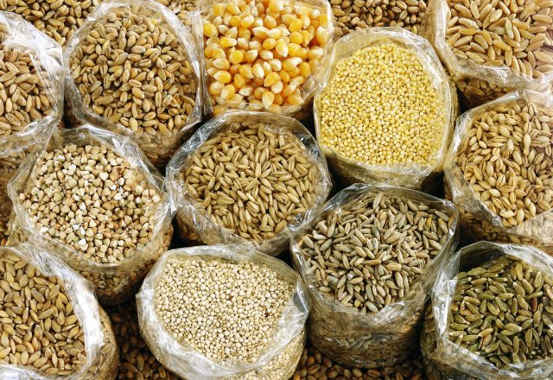
Figure 2.1 Traditional Cereals

- Traditional Ready-made Cereals
It is cereal that is cooked in the form of grain or cooked powder and requires that only boiling water for preparation.
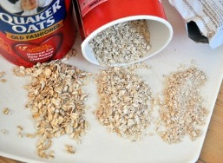
Figure 2.2 Traditional Ready-made Cereals

- Ready-to-eat or Instant Breakfast Cereals
Ready to eat breakfast or Instant cereal products have been processed and engineered by type and shape, such as flakes, puffed, and shredded.
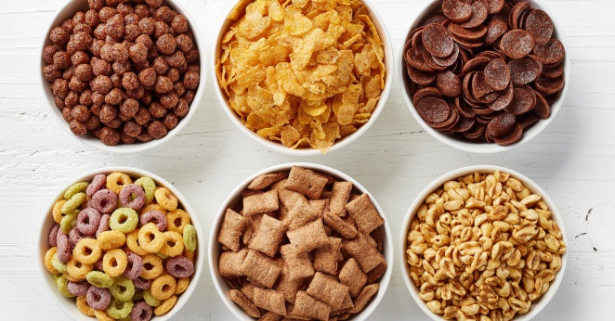
Figure 2.3 Ready-to-eat Breakfast Cereal

- Ready-to-eat Mix Cereal
Ready-to-eat mix cereal is cereal products are processed with other products, such as grains, nuts, and or dried fruit.
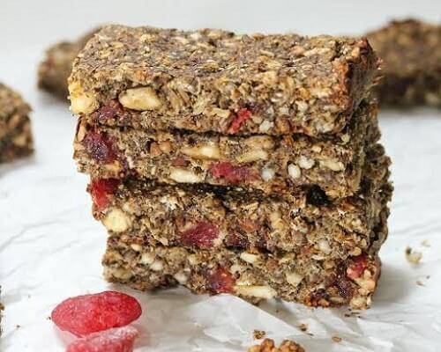
Figure 2.4 Ready-to-eat mix cereal

- Weaning Food
Other variant of breakfast cereal products cannot be categorized into the four types of over due to special process or ultimate usefulness. An example of this type is food for baby.
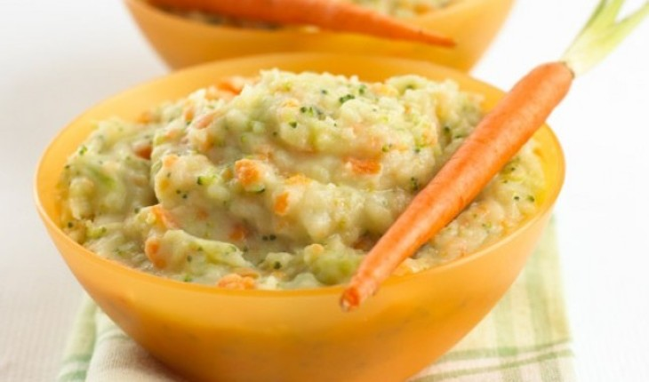
Figure 2.5 Weaning Food

2.3.2 Ingredients of Instant Cereals
According to Syamsir (2012), Breakfast cereal products are based on the formulation of materials with high starch content. The three basic components in product formulation are cereals, sweeteners and flavor-formers. Other commonly used ingredients are salt, yeast, food coloring, vitamins, minerals and preservatives.
- Cereals
Cereals are widely used as raw materials of this product are corn, wheat, rice, oats and barley. This cereal can be used in the form of whole, crushed or flour. Whole or cracked forms are commonly used to make flake, shredded and puffed products, while flour forms are commonly used to make baked and extruded products.

- Sweetener
Sweeteners used in breakfast cereal products are sucrose, honey and corn syrup. Some products use fruit juice concentrate as a sweetener. Sweeteners can be formulated into the product or added to the product surface as a coating. In addition to sweeteners, the addition of sugar in the product also serves to help binding between the particles of the material and help to form the desired brown color. To form a stronger color and sweetness, can be used invert syrup such as honey and corn syrup.
As a coating material on the surface of the product, sugars not only serve as a sweet giver but also maintain product crispness by inhibiting excessive water absorption. In addition, sucrose also readily crystallizes and does not cause browning of the product when it is dried after the coating process.
- Flavor Formers
Commonly added ingredients for flavor-forming products are malt (made from barley germinated), chocolate, cinnamon and other spices and fruit essence. For the purpose of providing flavor to the product, malt should be used from a non-diastatic malt type to prevent texture softening due to enzyme activity. Some other ingredients that can also be functioned as a flavor maker are nuts and dried fruit.
- Other Materials
Vitamins and minerals are often added to breakfast cereals to replace natural vitamins and minerals from lost cereals during processing. The fortification process needs to be taken care not to damage the vitamins and minerals. For heat-resistant nutrients such as minerals, riboflavin and niacin, additions and also may be made in the base formula. However, if the nutrients to be added are heat sensitive, such as vitamin A and thiamine, the addition can be done by spraying it on the final product.

2.3.3 Process Technology of Instant Cereals
According to Syamsir (2012), In general, the process of processing breakfast cereals is the preparation of raw materials, the formation of dough (cooking), the formation of breakfast cereals, the addition of coating materials (optional) and packaging.
- Raw Material Preparation
In the early stages inspection and analysis of cereals raw materials will be needed. Cereals can be used in the form of whole seeds or require further processing. Often whole seeds are destroyed by using an iron grinder to remove the outermost layer of skin. Furthermore, the cereals that have been crushed and removed from the outer shell can be ground into flour.

- The formation of dough (cooking)
(1) Pressure cooking
Cooking is done with high temperatures and pressures, for raw materials of large or broken sharps or sized pieces (e.g. grits)
(2) Cooking with cooking extruder
Cooking with cooking extruder is done for cereal-shaped raw material smaller than grits and flour

- Breakfast Cereal Formation
The stage of breakfast cereal formation is a process stages that distinguishes the resulting product form. The following will explain the stages of forming breakfast cereals flake shape, shred and puff.
- Addition of Coating Material
The addition of coating materials is an additional process. The process of coating the sugar is done by spraying the thickened and hot syrup onto the cereal surface in a rotary drum that produces a layer of sugar crystals at the time of drying

2.3.4 Characteristic of Cereals
According to Iriyani (2011), the characteristic of cereal could be measured from the organoleptic tests or sensory tests, means of testing using the human senses as the primary means of measuring the acceptability of a product.
- Appearance
Color plays an important role in food products, because if the color of a food is unattractive or prevalent, although its complete nutritional content will reduce consumer acceptance of the product. In organoleptic test, the first time a product is assessed by using the eye is to see the color that is owned, because the color visually appears first in the determination of food products. If a product has a color that is less attractive to look at though it has excellent taste, texture, and aroma, everyone will consider consuming it. This is because color is the most rapid response and easy to give a good impression.
- Aroma
Aroma is one of the determinants of product quality. The smell of a food usually shows the delicacy of the food. In the food industry the aroma test is considered important because it can quickly provide an assessment of the product about whether or not the product is received. The emergence of this aroma because the substance is volatile (yawning), slightly soluble in water and fat.
- Texture
Texture is a description of the attributes of foodstuffs generated through a combination of physical and chemical properties, widely accepted by touch, sight and hearing. The resulting cereals are dry and have a crunchy, hard texture. The hard texture of cereal can be caused by an increase in protein, fat, and crude fiber from the raw material and the decrease in the amount of starch contained in the raw material
- Taste
Taste of a food is a combination of the various flavors of ingredients used in the food. Flavors are defined as the stimuli generated by the ingredients eaten, especially those perceived by the taste bud. Pain is an important factor in determining decisions for consumers to accept or reject a food. Although other parameters are good, if the taste is uncomfortable or disliked, the product will be rejected. There are four basic types of known flavors: sweet, salty, sour, and bitter. The other sense is a fusion of the basic flavor.

2.4 Pumpkins

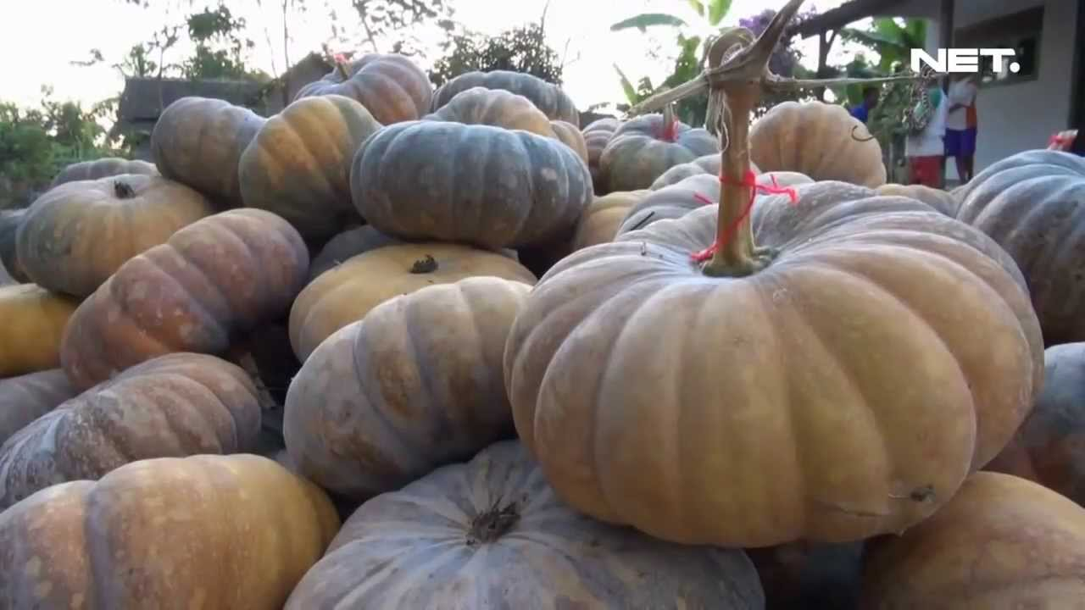
Figure 2.6 Pumpkins

According to Wiryo (2002) (as cited in Arisandi, 2013, p. 2), pumpkin is one of the fruit with high fiber content, so it is very good to serve as a substitute for rice. While, Ranonto et.al (2015) mention that Pumpkin (Cucurbitamoschata Durch) is a type of vegetable which has quite complete nutrition of carbohydrates, proteins, minerals such as calcium, phosphorus, iron, and vitamins; Vitamin B and C and fiber. The yellow or orange color of the flesh signals the beta carotene content very high.
In addition, Hamdi (2017) mention that pumpkin is a kind of plant that grows in Indonesia with high adaptation ability in various environmental conditions. Pumpkin fruit has a high durability advantage and has a distinctive aroma and flavor. Besides, still according to Hamdi, pumpkin has a very thick and hard rind, which can act as a barrier to respiration rate, the release of water through the evaporation process, as well as the entry of the air causing the oxidation process. This causes the pumpkin relatively durable compared to other fruits. Durability can be up to 6 months or more, depending on the storage.

    - Nutrient of Pumpkins
Meanwhile, Dalimartha (2011) (as cited in Arisandi, 2013, p. 2) states that pumpkin contains 34 calories, 0.8 g fat, 45 mg calcium, and 0.8 g of mineral so pumpkin is very good consumed by youngster to oldster , because the nutrient content is very good for the health of the body. While Hamdi (2017) states that pumpkin is a type of plant that contains a high enough and complete nutrition so often used to make medicine and health supplements. Nutritional content consists of protein, fat, carbohydrates, vitamins A, B, C, magnesium, iron, phosphorus, calcium and water. Nutritional content as listed in the Table 2.1.

Table 2.1 Nutrition Fact of Pumpkins per 100g
Sumber : https://www.fatsecret.co.id/kalori-gizi/umum/labu

    - Benefit of Pumpkin
According to Wiryo (2002) (as cited in Arisandi, 2013, p. 2), In terms of health pumpkins also have a myriad of benefits. The pumpkin contains mostly beta carotene, which protects the eyes from cataracts, cancer, heart, dysentery, kidney, diarrhea and other diseases.
Pumpkin has many benefits for human body. Siswanto (2014) says that there are 8 benefits of Pumpkins. They are helps lower cholesterol levels, for diabetes, prevent cancer, maintain heart health, prevent cancer, maintaining eye health, and other benefits. The explanations can be described as follows:
- Helps Lower Cholesterol Levels
Eating pumpkin can help lower cholesterol in your body. Pumpkin itself does not contain any cholesterol, but contain phytosterols that have been known to lower LDL cholesterol (up to about 75%) and increase HDL cholesterol (up to 15%). Phytosterols inhibit the absorption of cholesterol in the body and make it directly expelled from the body.
- Helping Diabetes Patients
Pumpkin has a low glycemic index so it can be one of the diabetic diets. Pumpkin can help the production of insulin and help the healing process of pancreatic tissue. Omega 3 found in pumpkins are also good consumed by diabetics.
- Prevent Cancer
Pumpkin contains many antioxidants, especially carotenoids. These antioxidants can help inhibit the metabolism of cancer cells. Eating pumpkin can help prevent the occurrence of breast cancer, cervical cancer, lung cancer, colon cancer, and skin cancer.
- Helps Maintain Heart Health
The content of folate, carotenoids, and magnesium in yellow squash makes it very good for your heart health. Magnesium will work as relaxant blood vessels that can lower blood pressure and prevent the occurrence of stroke and heart attacks. In addition, the yellow squash can also prevent the occurrence of atherosclerosis is a condition in which the walls of arterial blood vessels to harden due to the accumulation of fat on the inside walls.
- Maintaining Eye Health
Pumpkin consumption can prevent macular degeneration from aging. Zeaxanthin in the yellow squash can help protect the eye's retina from harmful UV radiation and other oxidative stresses.
Carotenoids, both alpha and beta in the yellow squash are also good for eye health and can prevent night blindness (night blindness). Lutein and zeaxanthin in the flask are also good for preventing cataracts.
- Other Benefits
Other benefits of pumpkin for your health are:
• Reduce stress. Pumpkins are rich in amino acids, tryptophan, which will be converted into serotonin. Serotonin is a neurotransmitter that can reduce anxiety and stress so it can improve your mood
• Prevent constipation (rich in fiber)
• Helps maintain prostate health and prevent the occurrence of benign prostate enlargement (zinc)
• Helps prevent the formation of kidney stones and various diseases associated with bile content and can prevent the occurrence of ulcers due to stomach acid irritation (pumpkin juice)
• Helps to strengthen bones and tooth enamel and prevent osteoporosis (zinc and magnesium)
• Prevent arthritis (anti-inflammatory agents)

  - Previous Study
The innovation of new variant of instant cereals has been conducted by some researchers. This study is also presented by student in the final project in Fakultas Pertanian Universitas Sebelas Maret Surakarta. The research has been done by Hanawati (2011). The title is “Flakes Kaya Antioksidan Sebagai Alternatif Diversifikasi Ubi Jalar Ungu”. She was made the flakes through the use of purplr sweet potatoes. Following are the ingredients and steps.

Table 2.2 Hanawati’s Recipe
No. | Ingredients | No. | Steps
1. | Purple sweet potato | 1. | Mix purple sweet potato flour, wheat flour, and cornstarch.
2. | Cornstarch | 2. | Add refined sugar and salt.
3. | Wheat flour | 3. | Add water.
4. | Sugar | 4. | Prepare the baking brass, spread out margarine and sprinkled with flour.
5. | Salt | 5. | Shape the dough
6. | Margarine | 6. | Bake the dough in temperature 120° C for ± 30 minutes.
7. | Water | 7. | Chill after cooking.
 |  | 8. | Package the cereals.

Another research has been done by Iriyanti (2011). The title is “Sereal dengan Subsitusi Bakatul Tinggi Anti Oksidan”. This research is conducted research articles in Fakultas Kedokteran Universitas Diponegoro. She was made the cereals through the use of bran. Following are the ingredients and steps.

Table 2.3 Iriyanti‘s Recipe
No. | Ingredients | No. | Steps
1. | Corn | 1. | Combine corn and bran according to the percentage of formulation.
2. | Bran | 2. | Add water and vegetable oil.
3. | Water: 200 ml | 3. | Mix well.
4. | Coconut oils: 200 ml | 4. | Insert the material mixture into the extruder machine.

Another research entitled “Substitusi Tepung Kacang Merah Dalam Pembuatan Sereal Yang Kaya Akan Serat” was done by Agustina (2011). This research is conducted the final project in Fakultas Teknik Universitas Negeri Yogyakarta. She was made the cereals through the use of red beans powder. Following are the ingredient and steps.

Table 2.4 Agustina‘s Recipe
No. | Ingredients | No. | Steps
1. | Red bean flour: 125 gr | 1. | Melted margarine and eggs are whipped until mixed
2. | Rice flour: 125 gr | 2. | Add Wheat Flour, Rice Flour, Sugar, and Vanilla.
3. | Margarine: 50 gr | 3. | Add milk and water.
4. | Eggs: 5 | 4. | Shape of dough.
5. | Sugar: 175 gr | 5. | Bake until browned.
6. | Water: 200 ml
7. | Milk: 200 ml
8. | Vanilla extract : 3 gr

