FINAL REPORT

WRITING HORROR FOLKTALE POCKET BOOK OF ANTU BANYU IN SUNGAI MUSI

This report is written to fulfill the requirements for Diploma III final report project in Majoring English Department

By :

Meise Rinanda Aprialisca
061530900674

STATE POLYTECHNIC OF SRIWIJAYA
2018

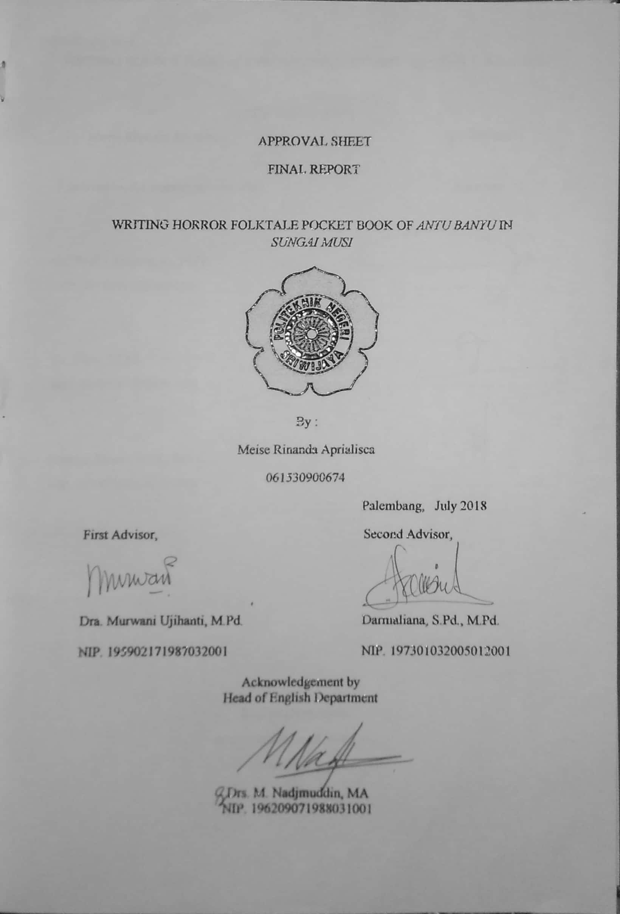

PREFACE
From all graces which has been descended, the writer would like to perform gratitude to Allah SWT for the lived whose the writer possessed and blessing to the researchers so that the writer able to finish the final report on time. The writer also want to express great gratitude to my beloved prophet, Rasulullah SAW, as a great leader of religion. This report is written to fulfill the requirement of Final Report subject at State Polytechnic of Sriwijaya which title is “Writing Horror Folktale Pocket Book of Antu Banyu in Sungai Musi”.
The writer realizes this report is still far from being perfect because of limited resources, funds, time, references, and knowledge. Therefore, the writer would like to have any suggestios and comments to make this report better.

Palembang, July 2018

Writer
MOTTO
Thoughts give birth to actions, actions spawned a habit, habit bore the character, and the character created fate.
-Aristoteles-

ACKNOWLEDGEMENT
Finally, this report is completed. Therefore, the writer would like to thank to the Almighty God for the mercy that has been given to me in finishing the report on time. The purpose of writing this report is to fulfill one of requirements to get the Diploma Degree at English Department at State Polytechnic of Sriwijaya. In this opportunity, I would like to express deep fratitude to their supports of many people during writing this final report.
Next, the writer would like to express my deepest appreciation to :
- Allah SWT.
- My prophet Muhammad SAW.
- My beloved parents for the pray and support to my work this whole time.
- Dra. Murwani Ujihanti, M.Pd, and Darmaliana, S.Pd, M.Pd as my beloved advisors for all the advice, help and support in finishing this report.
- Siti saodah as the illustrator of horror folktale pocket book.
- Ranti Octavia who helped me to check the grammar of the horror folktale pocket book.
- Our lovely friends in english Department especially in 6 BA class who support me with all condition and give me the sweetest moment.
- All the interviewees to support the final report and make the valid data.

I hope this could give some benefits and contributions. However, this report is still being perfect. Therefore, some comments and suggestions are always welcomed to make my final report better.

ABSTRACT

WRITING HORROR FOLKTALE POCKET BOOK OF ANTU BANYU IN SUNGAI MUSI

(Meise Rinanda Aprialisca, 2018, 38 pages, 1 chart)
This research is about writing horror folktale pocket book with the title of Antu Banyu in Sungai Musi. The purpose of writing this final report is to find out the steps in writing horror folktale pocket book. To get the purpose, the writer used Research and Development (R&D) method by Sukmadinata (2005). The result show that, there are 3 steps to made the horror folktale pocket book. They are : preliminary study, development of the product, and final testing. Based on the result, the writer expected that the Tourism Office of Palembang would provide a horror folktale pocket book of Antu Banyu in Sungai Musi because it can increase the interest of tourists and visitors to come to Palembang city.
Keywords : Folktale, horror

Table of Contents
TITLE.....................................................................................................................i
APPROVAL SHEET.............................................................................................ii
PREFACE..............................................................................................................iii
MOTTO.................................................................................................................iv
ACKNOWLEDGEMENT......................................................................................v
ABSTRACT...........................................................................................................vi
TABLE OF CONTENT.........................................................................................vii
CHAPTER I INTRODUCTION 1
1.1 Background 1
1.2 Problem Limitation 3
1.3 Problem Formulation 3
1.4 Purposes 3
1.5 Benefits 3
CHAPTER II LITERATURE REVIEW 4
2.1 Folktale 4
2.2 Pocket Book 4
2.2.1 Definition of Book 4
2.2.2 Definition of Pocket Book 5
2.3 Horror Genre 5
2.4 Antu Banyu 5
2.5 Steps in Writing Process 5
2.6 Writing Paragraph 6
2.7 Verb Tense Consistency 6
CHAPTER III RESEARCH METHODOLOGY 8
3.1 Method of research 8
3.1.1 Preliminary Study 8
3.1.2 Development of the Product 9
3.1.3 Final Testing 9
CHAPTER IV FINDINGS AND DISCUSSIONS 11
4.1 Findings 11
4.2 Discussions 11
4.2.1 Preliminary Study 11
4.2.2 Development of Product 20
4.2.3 Final Testing 26
CHAPTER V CONCLUSION AND SUGGESTION 38
5.1 Conclusion 38
5.2 Suggestion 38
REFERENCES 39
APPENDICES........................................................................................................41

LIST OF CHART

Chart 1 The steps of Research and Development Method.......................................8

