**LAMPIRAN A**

**VALIDASI DATA**

Berikut ini merupakan data hasil penelitian mahasiswa semester akhir Program Studi Sarjana Terapan Teknologi Kimia Industri

Nama : Tasya Athira Makaminan

NPM : 0615 4042 2264

Dosen Pembimbing I : Ir. Selastia Yuliati, M.Si.

Dosen Pembimbing II : Ir. Fadarina., M.T.

Judul Tugas Akhir : Waktu dan Laju pengeringan Alat *Tray Dryer* dari Hasil Pembuatan Silika gel Berbasis Ampas Tebu

Penelitian dilakukan di Laboratorium Satuan Operasi Jurusan Teknik Kimia Politeknik Negeri Sriwijaya. Data – data yang didapat dari hasil penelitian antara lain:

**Tabel 1. Hasil Pengamatan Massa Bahan, Temperatur Bola Basah dan Temperatur Bola Kering**

|  |  |  |  |  |  |  |
| --- | --- | --- | --- | --- | --- | --- |
| **Waktu Pengeringan**  **(menit)** | **Massa**  **Bahan**  **(gr)** | **Temperatur**  **Pengeringan**  **(oC)** | **Temperatur (oC)** | | | |
| **Input** | | **Output** | |
| **Tbb** | **Tbk** | **Tbb** | **Tbk** |
| 0 | 125,42 | 80 | 25 | 33 | 32 | 40 |
| 60 | 112,05 | 80 | 25 | 33 | 29 | 39 |
| 120 | 100,26 | 80 | 25 | 33 | 30 | 36 |
| 180 | 88,14 | 80 | 25 | 33 | 28 | 35 |
| 240 | 71,79 | 80 | 25 | 33 | 28 | 35 |
| 300 | 52,33 | 80 | 25 | 33 | 25 | 35 |
| 360 | 20,51 | 80 | 25 | 33 | 28 | 34 |
| 420 | 6,54 | 80 | 25 | 33 | 28 | 34 |

**Tabel 2. Data Pengamatan Laju Udara, *Humidity* dan Temperatur Bahan**

|  |  |  |  |  |  |  |
| --- | --- | --- | --- | --- | --- | --- |
| **Waktu Pengeringan**  **(menit)** | **Temperatur**  **Pengeringan**  **(oC)** | **Laju Udara** | | **Humidity**  **(kg H2O/kg Udara Kering)** | | **Temperatur**  **Bahan**  **(oC)** |
| **In (L/m)** | **Out (m/s)** | **In** | **Out** |
| 0 | 80 | 10 | 0,84 | 62 | 65 | 32 |
| 60 | 80 | 11 | 0,925 | 44 | 48 | 38 |
| 120 | 80 | 12 | 1 | 44 | 46 | 41 |
| 180 | 80 | 11,93 | 1 | 43 | 45 | 42 |
| 240 | 80 | 11,98 | 1 | 42 | 41 | 43 |
| 300 | 80 | 12 | 1 | 41 | 35 | 44 |
| 360 | 80 | 12 | 1 | 41 | 35 | 43 |
| 420 | 80 | 12 | 1 | 41 | 35 | 43 |

Palembang, Juli 209

Kasie Laboraturium Satuan Operasi,

Ir. Selastia Yuliati, M.Si.

NIP. 1961070419890320

**LAMPIRAN B**

**PERHITUNGAN**

1. **Perhitungan Desain Alat**

udara out

TRAY DRYER

Silika in Silika out

Udara in

Kapasitas = 2 kg

Kandungan air awal = 96%

Kandungan air akhir = 2 % (max)

Cp silika = 0,76 kJ/kg K ( T = 30 0C), (T = 40, Cp = 0,78)

Temperatur awal padatan = 32 0C (Ts1)

Temperatur akhir padatan = 44 0C (Ts2)

Temperatur awal udara = 80 0C (TG1)

Temperatur akhir udara = 50 0C (TG2 )

Basis 1 jam operasi

Massa padatan kering (Silika, out) = 2 kg ( 1-0,96) = 0,08 kg (Ms)

Kandungan air pada *wet solid* (X1) = = 24 kg/kg dry solid

Kandungan air di *dry solid* (X2) = = = 0,02 kg2/kg dry solid

Air yang teruapkan = Ms (X1 – X2) = 0,08 (24-0,02) = 1,918

* Menghitung Entalpi Padatan

Hs1 = [Cpsilika + Cpair. X1] [Ts1 – Tref]

= [0,76 + 4,12 (24)] (32-0)

= 3188,48 kJ/kg dry solid

Hs2 = [Cpsilika + Cpair. X1] [Ts1 – Tref]

= [0,78 + 4,12 (0,02)] (44-0)

= 37,94 kJ/kg dry solid

* Menghitung Entalpi untuk Gas, (Y1 = 0,015)

HG1 = [1,005 + 1,008.Y1] (TG1 – 0) + 2500 Y1

= [1,005 + 1,008 (0,015)] (80 – 0) + 2500 (0,015)

= 99,492 kJ/kg dry air

HG2 = [1,005 + 1,008.Y2] (TG2 – Tref) + 2500 Y2

= [1,005 + 1,008.Y2] (50 – 0) + 2500 Y2

= 40,2 + 2575,2 T2 ... (1)

* Neraca Massa

Ms (X2 – X1 ) = Gs (Y2 –Y1)

Gs = (40,2 + 2575,2. Y2 – 99,492)

-252,04 =

-252,04 (Y2 – 0,015) = 2685,2 Y2 – 113,72

-252,04 Y2 + 3,7806 = 2685,2 Y2 – 113,72

(-252,04 Y2 + 2685,5 Y2) = -113,72 – 3,7806

Y2 = = 0,0488 kg H2O/kg dry air

* Menghitung Volume Humid (Tout = 50 0C)

VH = 22,41 x

= 22,41 x

= 0,0025 m3/kg dry air

* Menghitung laju udara

Gs = $\frac{1,918}{(0,048-0,015)}$ = 58,12 kg/jam

Volume udara = G2.VH

= 58,12 kg/jam (0,0025 m3/kg)

= 0,1453 m3

* Menghitung Nilai Ntu di Stage III

Dengan mengasumsikan TSA = TSB  = 40 ˚C (313 K)

HSB = [Cp silika + Cp air . X2] × (TS2 – Tref)

= [0,77 + 4,12 (0,02)] × (313 – 273)

= 34,096

CHSB = 1,005 + 1,88 Y

= 1,005 + 1,88 (0,015)

= 1,0332

* Neraca Panas Stage I

MS (HS1 – HSB) = GS.CHB (TG2 – TGB)

0,08 (3188,48 – 34,096) = 58,12 (1,0332) (50 – TGB)

50 - TGB =

50 - TGB = 4,2

TGB = 45,79 ˚C

ΔT1 = (TG2 - TS2) = (50 - 44) = 6˚C

ΔT2 = (TGB - TSB) = (45,79 - 40) = 5,79˚C

Mencari nilai $∆_{Tm}$

$$∆_{Tm}=\frac{Δ_{T1}- Δ_{T2}}{\ln{\frac{Δ_{T1}}{Δ_{T2}}}}$$

$$∆_{Tm}=\frac{6- 5,79}{\ln{\frac{6}{5,79}}}$$

$$∆_{Tm}=5,89$$

$NTu=\frac{T_{G2}- T_{GB}}{∆_{Tm}}$

$NTu=\frac{50- 45,79}{5,89}$

$$NTu=0,614$$

* Menghitung Nilai Ntu di Stage II

TSA = 40˚C, TGB = 45,79

HAS = [Cp silika + Cp air . X1] × (TSA – Tref)

= [0,77 + 4,12 (24)] × (40 – 0)

= 3986 kJ/kg dry solid

CHSB = 1,005 + 1,88 Y × (TGB – Tref) + 2500 Y

= 1,005 + 1,88 (0,015) × (45,79 – 0) + 2500 (0,015)

= 84,81 kJ/kg dry air

* Neraca Panas Stage II

MS (HSA – HSB) = GS (HGB – HGA)

0,08 (39860 – 34,096) = 58,12 (84,81 - HGA)

84,81 - HGA =

84,81 - HGA = 5,43

HGA = 84,81 – 5,43

HGA = 79,37

HGA = 1,005 + 1,88 Y × (TGA – Tref) + 2500 Y

79,37 = 1,005 + 1,88 (0,015) × (TGA – 0) + 2500 (0,015)

79,37 = 1,0332 TGA + 37,5

1,0332 TGA = 79,37 - 37,5

TGA =

TGA = 41,62˚C

ΔT1 = (TGB - TSB) = (45,79 - 40) = 5,79˚C

ΔT2 = (TGA - TSA) = (41,62 - 40) = 1,62˚C

$$∆_{Tm}=\frac{Δ_{T1}- Δ_{T2}}{\ln{\frac{Δ_{T1}}{Δ_{T2}}}}$$

$$∆_{Tm}=\frac{5,79- 1,62}{\ln{\frac{5,79}{1,62}}}$$

$$∆_{Tm}=2,92$$

$NTu=\frac{T_{G2}- T_{GB}}{∆_{Tm}}$

$NTu=\frac{45,79 - 41,62}{2,92}$

$$NTu=1,42$$

* Menghitung Nila Ntu di Stage I

∆T1 = (TG1 – Ts1) = (80 – 32) oC = 48 oC

∆T2 = (TGA – TsA) = (41,62 – 40) oC =1,62 oC

∆Tm = = = 13, 82

Ntu (I) = $\frac{TG1-TGA }{∆Tm}$ = $\frac{80-41,62 }{13,82}$ = 0,21

Ntu = Nt(I) + Nt(II) + Nt(III)

= 0,61 + 1,22 + 0,21

= 2,04

* Menghitung nilai Heat Transfer Coeficient

QT = Uo V ………(Mc Cabe, 5thEd)

QT = Q sensible + Q lateen

Qsensibel = m . Cp . $∆T$

= 2 . 0,78 (44-32)

= 18,72 kJ

Qlaten = m . λ

= 2 . 0,78 (44-32) = (2 . 0,96) (2568)

= 4930,56 kJ

**QT = Qsensible + Qlaten**

QT = 18,72 + 4930,56

QT = 4972,28 kJ

QT = UA .V. $∆Tm$

4949,28 = UA (0,1453)(20,19)

UA = = 1687,097 kJ/Jam.m3.oC

* Menghitung Nilai Ltu

Laju Alir rata-rata = 58,12 kg

G = $\frac{58,12 }{0,1453}$ = 400 kg/jam.m3

CH = 1,0332 Kj/kgoC

Ltu = = = = 0,244

* Menghitung Panjang *Tray Dryer* (T)

Z = Ltu . Ntu

Z = 0,244 (2,04) = 0,4896 m

* Menghitung tinggi *Tray Dryer*

V = p . l . t

V = s . s . t

V = s2 . t

**t =**

t =

t = 0,6072 m

1. **Menghitung Laju Pengeringan**

|  |  |
| --- | --- |
| RH  =  62% =  62% =  Y1 =  = 0,0892 kgH2O/kg dry air | 65% =  65% =  Y2 =  = 0,0936 kgH2O/kg dry air |

**Diketahui :**

T udara = 80 oC

T plat = 44 oC

Trata-rata = =62 oC = 335 oK

Karena T = 62 oC maka,

V = 18,97 x 10-6 m3/s

Cp = 1005 J/kgK

µ = 20,1 x 10-6 Ns/m2/s

k = 0,02966 W/mk

L = 40 cm = 0,4 m

g = 9,8

β = 1/T

= 1/335 oK

= 2,985 x 10-3 oK

* Mencari nilai Gr (Gross off number)

Gr = $\frac{g.β\left(T-Tplat\right)L^{3}}{\left(V\right)^2}$

Gr = $\frac{9,8 . 2,985 x 10-3 \left(80-44\right)(0,4)^3}{\left(18,97 x {10}^{-6}\right)^2}$

Gr = 187.296.249,8

* Mencari nilai Pr (Prandlt Number)

Pr = $\frac{Cp.µ}{k}$

Pr = $\frac{(1005)(20,1x{10}^{-6})}{0,02966}$

Pr =0,68106

* Mencari nilai Ra (Ray leigh Number)

|  |  |  |
| --- | --- | --- |
| Gr.Pr | C | M |
| 104-109 | 0.59 | ¼ |
| 109-1013 | 0.1 | 1/3 |

Ra = Gr . Pr

= 187.296.249,8 x 0,68106

= 127.561.628,2 (karena, nilai Ra berada pada range 109 – 1013  maka, nilai C = 0,1 dan m = 1/3

* Mencari nilai Nu (Nusselt Number)

Nu = C (Gr . Pr $)^{m}$

= 0,1 (127.561.628,2 $)^{1/3}$

= 50,3392

* Mencari nilai koefisien film perpindahan panas (hc)

hc = $\frac{Nu . k}{L}$

hc = $\frac{\left(50,3392 \right).( 0,02966) }{0,4}$

hc = 3,7327 kJ/m2K

* Mencari nilai A

$$A=2 \left[pl+pt+lt\right]$$

$$A=2 \left[\left(0,4×0,4\right)+\left(0,4×0,33x{10}^{-3}\right)+(0,4×0,33x{10}^{-3})\right]$$

$$A=2 \left[0,16+1,32x{10}^{-4}+1,32x{10}^{-4}\right]$$

$$A=2 (0,160264)$$

$$A=0,3205 m^{2}$$

Qc = hc (T-Ts) A

= 3,7327 (80-44) ($0,3205$)

= 43,07 Kj

* **Menghitung Panas Konduksi**

Qk = Uk (T-Ts)A

zM =

kM = 58,67 W/m

zs =

ks = 0,75 W/cm.K

= 73,086 kcal/jam.m.K

= 265,86 kJ/jam.m.K

$$U_{k}= \frac{1}{1/{hc}+{z_{m}}/{k_{m}}+{z_{s}}/{k_{s}}}$$

$$U_{k}= \frac{1}{1/{3,7327}+{{0,33×10}^{-3}}/{58,67}+{{0,35×10}^{-3}}/{265,86}}$$

$$U_{k}= 3,7326 kJ/k.m^{2}$$

A = 2 [pl+pt+lt]

A = 2 [(40x40)+(40x60)+(40x60)]

A = 12.800 cm2

A = 1,28 m2

* **Menghitung Laju Pengeringan**

Diketahui :

hc = 4,647 kJ/m2K

T = 80 oC

Ts = 38 oC

Zm = 0,33 mm = 0,33 x 10-3 m

Km = 58,67

Zs = 0,35 mm = 0,35 x 10-3 m

Ks = 0,75 W/cm.K

= 73,086 kcal/jam.m.K

= 265,86 kJ/jam.m.K

λs = (1,005 + 1,88 Y2)Ts + 2500 Ts

= ( 1,005 + 1,88 (0,0936) 38 + 2500 (38)

= 95.044,87

Rc = $\frac{q}{A.λs}$ = $\frac{qc+qk+qr}{A.λs}$…….. (Gean Koplis)

= $\frac{\left(hc+Uk\right)\left(T-Ts\right)}{λs}$ (3600)

qr = 0 (karena hanya terdapat konduksi dan konveksi)

Rc = $\frac{q}{A.λs}$ = $\frac{qc+qk+qr}{A.λs}$ = $\frac{hc\left(T-Ts\right)A+Uk\left(T-Ts\right)+0}{A.λs}$ (3600)

Rc = $\frac{A(hc+ Uk)\left(T-Ts\right)}{A.λs}$ (3600)

Rc = $\frac{(hc+ Uk)\left(T-Ts\right)}{λs}$

= $\frac{(3,7326 + 3,7326)\left(80-44\right)}{110.002,6 }$

= 0.002443 kg/jam.m2

Dengan menggunakan cara yang sama seperti waktu pengeringan 0menit didapat data Laju pengeringan pada waktu pengeringan 60 menit, 120 menit, 180 menit, 240 menit, 300 menit, 360 menit, 420 menit sebagai berikut:

**Tabel. Pengamatan Hasil Perhitungan Laju Pengeringan**

|  |  |
| --- | --- |
| **Waktu** | **Laju Pengeringan** |
| **(menit)** | **(Kg/jam m2)** |
| 0 | 0.017719 |
| 60 | 0.01446 |
| 120 | 0.01584 |
| 180 | 0.01584 |
| 240 | 0.01668 |
| 300 | 0.01941 |
| 360 | 0.01941 |

**LAMPIRAN C**

**DOKUMENTASI**

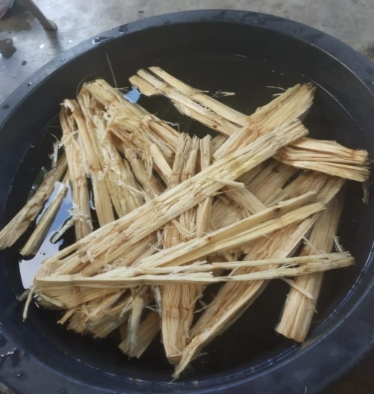 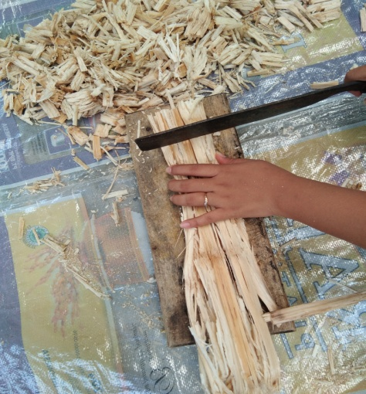

Pencucian Ampas Tebu Pengeringan dan Dicacah

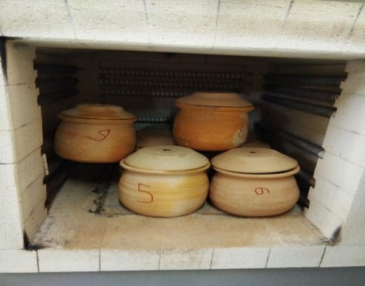 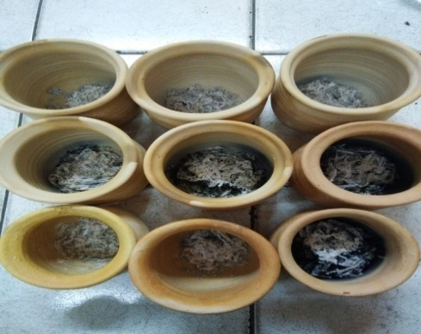

Memfurnace Ampas Tebu Hasil Furnace Ampas Tebu

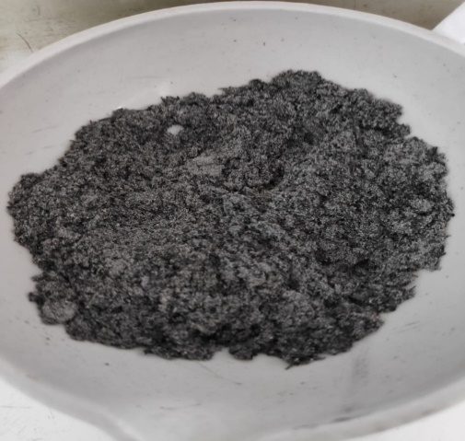 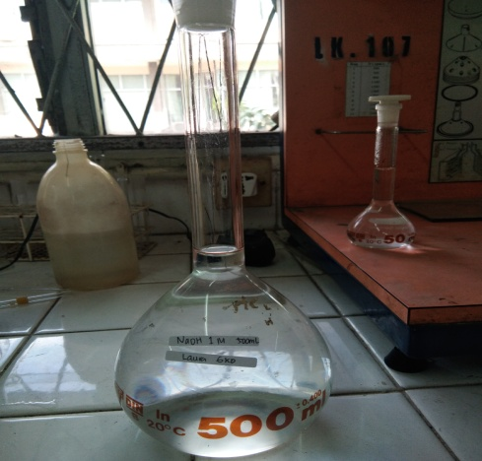

Menyiapkan Sampel Abu Pembuatan Larutan NaOH

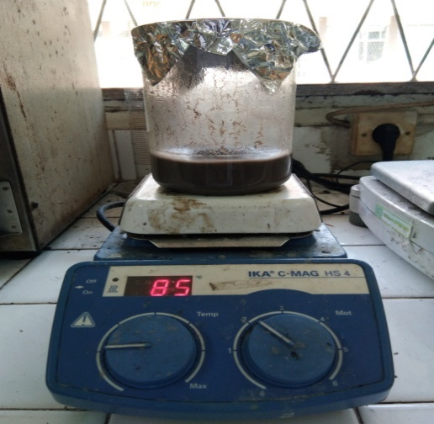 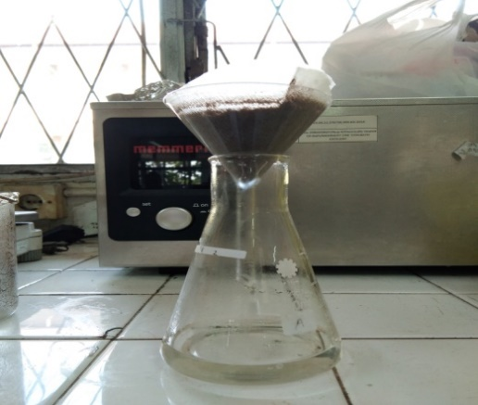

Pembuatan Larutan Natrium Silikat Penyaringan Larutan Natrium Silikat

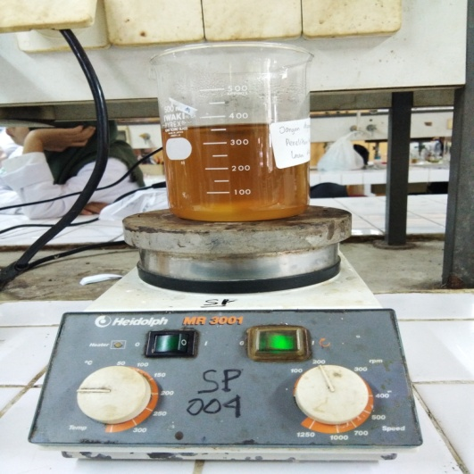 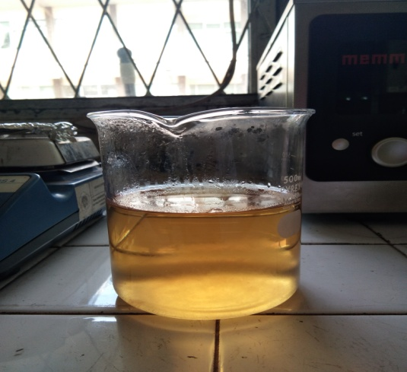

Presipitasi Larutan Natrium Silikat Proses Pembentukan Gel

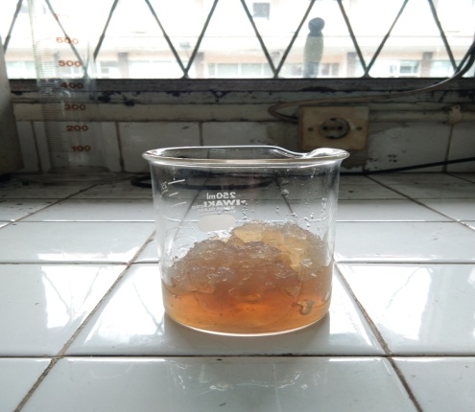 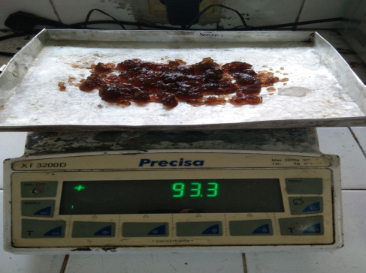

Gel yang sudah dipisahkan dari filtrat Penimbangan Silika Gel

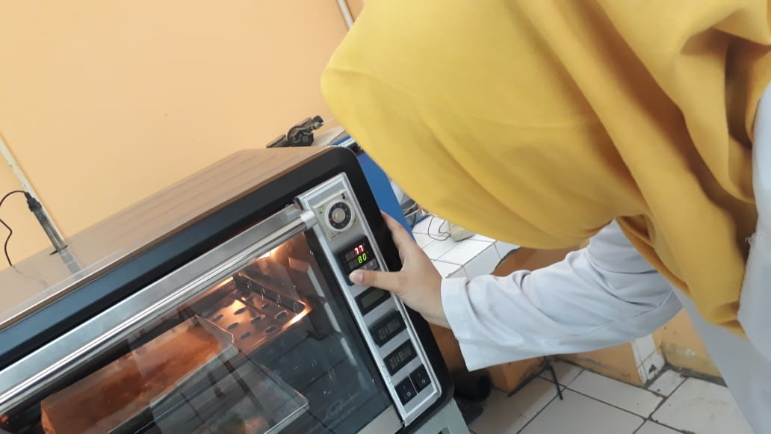

Mengatur Temperatur *Setting Point*

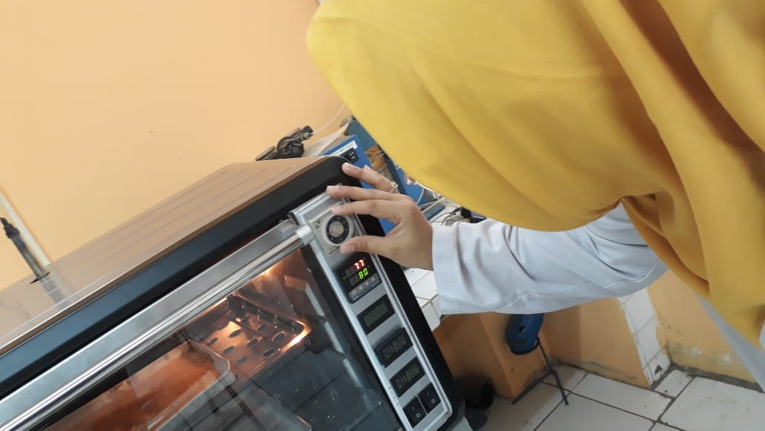

Mengatur Waktu Pengeringan

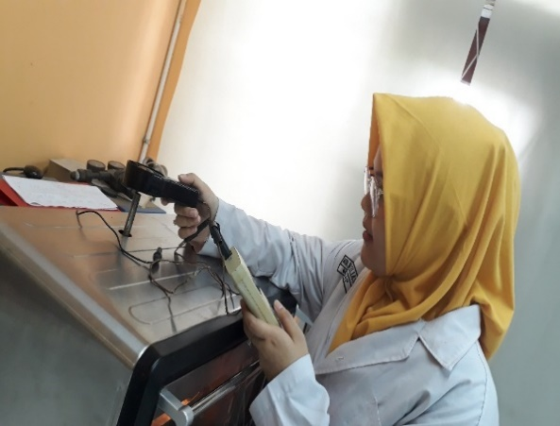

Mengukur Laju Alir Udara Keluar

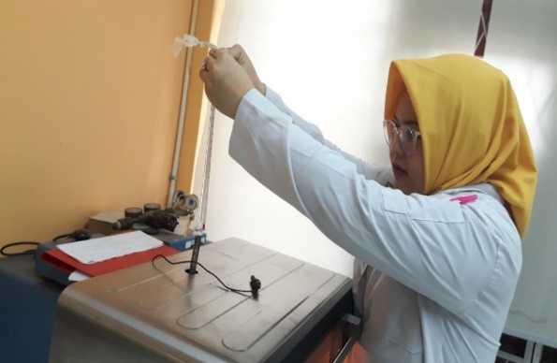

Mengukur Temperatur Bola Basah dan bola Kering

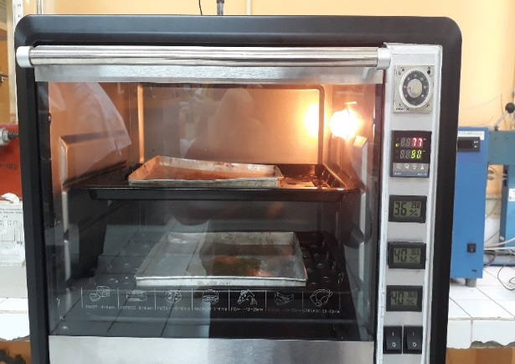

Proses Pengeringan *Hydrogel*

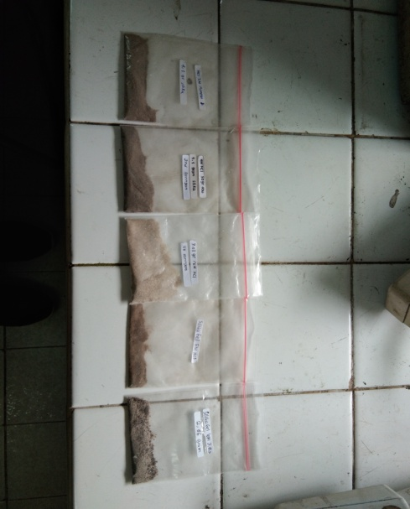

Produk Silika