CHAPTER II

LITERATURE REVIEW

This chapter would discuss the theories related to the focus of this study, such as Kawah Tekurep, Ziarah Kubro, history, design, vlog, vlog as tourism promotion, steps of designing.

2.1 Kawah Tekurep
Kawah Tekurep is a funeral complex that is proof that in the past the Palembang Darussalam Sultanate once existed. This Sultanate was an Islamic empire formed first by a Palembang Javanese noble in 1659. The nobleman was named Sri Susuhunan Abdurrahman. Then on October 7, 1823, the empire was abolished by the Dutch colonial government (bobo.grid.id, 2017).
Kawah Tekurep is located on Jl. Beladak beside the Al-Muhajirin mosque. Kawah Tekurep comes from the word "crater" which means "big cauldron" and tekurep comes from the word "tengkurep" which means "upside down". The name is because the shape of the roof of the tomb is like an inverted crater (jejakpiknik, 2018).
This cemetery was built in 1728 at the behest of Sultan Mahmud Badaruddin I Jaya Wikramo. And then continued the construction of the Central Dome in the cemetery area by Sultan Ahmad Najamuddin I Adi Kesumo. This tomb architecture is a combination of Malay, Indian and Chinese architecture that makes this burial complex show a blend of cultures.
Kawah Tekurep has 4 buildings, 3 of these buildings are only for the sultans, and one building is only for the children of the sultan and his officials. Here are the names of the characters buried in Kawah Tekurep:
First building:
- Sultan Mahmud Badaruddin I
- Ratu Sepuh, sultan's first wife
- Ratu Gading, the sultan's second wife
- Mas Ayu Ratu, the sultan's third wife
- Nyimas Naimah, the sultan's fourth wife
- Imam Sayyid Idrus Al Idrus, sultan's spiritual teacher
Second building:
- Prince Ratu Kamuk
- Ratu Mudo, Prince Kamuk's wife
- Sayyid Yusuf Al Angkawi, priest of the prince's adviser
Third building:
- Sultan Ahmad Najamuddin
- Masayu Dalem, wife of sultan Najamuddin
- Sayyid Abdur Rahman Maulana Tugaah, Sultan sultan
Fourth building:
- Sultan Muhammad Bahauddin
- Ratu Agung, wife of Sultan Bahauddin
- Datuk Murni Hadad, Sultan of Sultan Bahauddin
Towards the holy month of Ramadan, usually held the haul and pilgrimage of the Kubra ulama of Darussalam. This is a large pilgrimage event attended by many people. Not only attended by the people of Palembang, but throughout the archipelago and other countries.

2.2 Ziarah Kubro
The pilgrimage tourists are visiting the tombs of the scholars and founders of the Sultanate of Palembang Darussalam. This tradition is unique because the tombs visited not only one, but some tombs and lasted for three days in a row (kemenpar, 2019).
Kubro Pilgrimage is a tradition of some Yaman Arab descendants living in the city of Palembang, namely visiting the tombs of the scholars one week before the coming of the holy month of Ramadan. This Kubro Pilgrimage lasted for three consecutive days.
In conducting routine pilgrimages every year, the pilgrims carry out activities after the morning prayer until late at night. The tombs visited, among others, are the burial complex of Al-Habib Ahmad bin Syech Shabab, Auliya's funeral and Habaib Telaga Sewidak, the tomb of Babus Salam As-Seggaf, and ends at the Palembang Darussalam Sultanate cemetery in Kawah Tekurep (kumparan, 2019).

2.3 History
History is a narration of the events which have happened among mankind, including an account of the rise and fall of nations, as well as of other great changes which have affected the political and social condition of the human race (John Jacob Anderson, 1821-1906).
History not used is nothing, for all intellectual life is action, like practical life, and if you don't use the stuff well, it might as well be dead (Arnold J. Toynbee, 1889-1975).
The etymological understanding of history comes from the Arabic word sajaratunyang which means tree. In Arabic itself, history is called a date which means time or calendar.
The word History is closer to Greek, which is historia, which means science or smart people. Then in English it turns into a history that means human past. Another word that approaches this reference is geschichte in German, which means it has already happened (Zona referensi, 2019).
Understanding of history according to Moh. Hatta is in his form about the past. History not only gives birth to the criteria of past events, but the understanding of the past that contains various dynamics, may contain the problematic lessons for the next human being (Moh Hatta).

2.4 Design
Etymologically the word ‘design is supposed to be opened from the word designo (Italia) which means picture (Jervis, 1984). This word was given a new meaning in English in the 17th century, which was used to make the School of Design in 1936. While in the world of art in Indonesia, the word design is often matched with: forms, designs, visual systems, forms, paintings , design, design, design, design, sketch of ideas, pictures, clothing, skills, crafts, crafts, presentation techniques, styling, visual communication, floor plans, spatial layout, interior space, good things, problem solving, visual art, form arrangement, form, color, carving, motif, ornament, graphic, decoration (as a noun) or arranging, composing, arranging, planning, decorating, combining, composing, creating, creating, fantasize, reflect, draw, capture images, copy images, paint, install, prepare works (as verbs) and various activities related to the process of remembrance in the broadest sense.
Design is a creative process in solving a problem in terms of the design of an object that is functional or aesthetic. Which in principle looks at the technical aspects, functions, material, without releasing elements of colour, lines, textures, composition balance, and shape (Beta, 2008).

2.5 Vlog
Vlog is short for "video blog" and is pronounced "vlog" (one syllable). A vlog is a blog, or web log, that includes video clips. It may be entirely video-based or may include both video and written commentary. Several types of vlogs are available on the web, including instructional videos, travel updates, and personal commentaries.
People who create vlogs are known as "vloggers." Some vloggers post videos for fun, while others run vlogs for the purpose of generating revenue through advertisements. While it's possible to set up a vlog website, many vloggers post their vlogs on Youtube since it makes their videos easier to find. Additionally, YouTube offers free video hosting, which means vloggers can post unlimited videos without paying web hosting fees.
In order to create a vlog, all you need is a video camera, an Internet connection, and a good idea. While a simple cell phone video camera can get the job done, a standalone HD video camera will produce much higher quality videos. You can publish videos as often as you like, though if you decide to maintain a blog, it helps to post them at consistent intervals, such as once a day or once a week. This helps your viewers know when new videos will be available, which makes them more likely to continue visiting your vlog (Christenssion, 2011).

2.5.1 Characteristics of Vlog
If the blog contains a lot of content in the form of text and also images. However, the vlog contains conversations videos from vloggers who record their blogging activities. So, it's very easy to recognize vlog videos and not vlogs
- Video of the other camera / recording device.
- Video vlog displays conversations, whether monologue, dialog, etc. from author, artist or video maker.
- If the video has been edited, as long as there is still talk (voice) author, there is still a face shape, or does not display the face of the artist, recorder or author. The video can also still be called a vlog.
- Basically, the video blog / vlog contains the author's talk, as a substitute for text media that generally appears on content or blog posts.

2.6 Vlog as Tourism Promotion
Vlog is the main tool for tourism marketing. Statistics are very supportive. In the 2011 Google survey, 66% of people reported watching videos online when thinking of traveling. 64% of those surveyed used online videos to help choose goals, and 57% watched videos to help choose accommodation for their trips. According to the report, travelers watch a combination of professionally made videos and user video contributions, but the number one preferred video source (62%) comes from corporate industries such as hotels, airlines, cruises, tours, etc. And that's not even the best part: from travelers who report watching videos online when planning, 45% of travelers and 72% of business travelers say they are asked to order as a direct result (One Production, 2018). According to Mill & Morrison (2009, in Hasan, Theseus, 2015, p. 4), promotion in tourism helps attract the attention of potential tourists, modifies existing buyer behavior and influences them to visit destinations.
Promotion of tourism means trying to encourage actual and potential customers to travel to a destination through information dissemination. Promotion is one of the most effective marketing mix elements used in marketing tourism products. Promotional goals that are consistent with the general marketing plan are to identify the target groups who will carry out promotions, to find out effective advertising, sales support and public relations programs that will be planned, and to choose the best method to be used to control and assess promotional operations. (Baldemoro 2013, in Hasan, 2015, p. 3).
Video is an efficient medium for promoting something, even tourism because tourists usually look for videos that give them information about where they want to go. Efforts to further promote traditional Palembang food can be achieved through promotional videos.

2.7 Steps of Designing Vlog
the steps of designing a vlog are same as the steps of designing a video, which distinguishes it from the vlog posted on youtube. so, on this occasion the writer will describe the steps of designing video.
Gives the steps of designing a video as in chart 2.1. Based on the chart, there are three steps to design a video such as Pre-production, Production, and Post-production. The pre-production stage consists of outline, script, storyboard, and budgeting. While the production stages consist of shooting. The post-production stage consists of gather raw material, capturing, compositing, editing, and output (Gora, 2019).
STEPS OF DESIGNING VIDEO
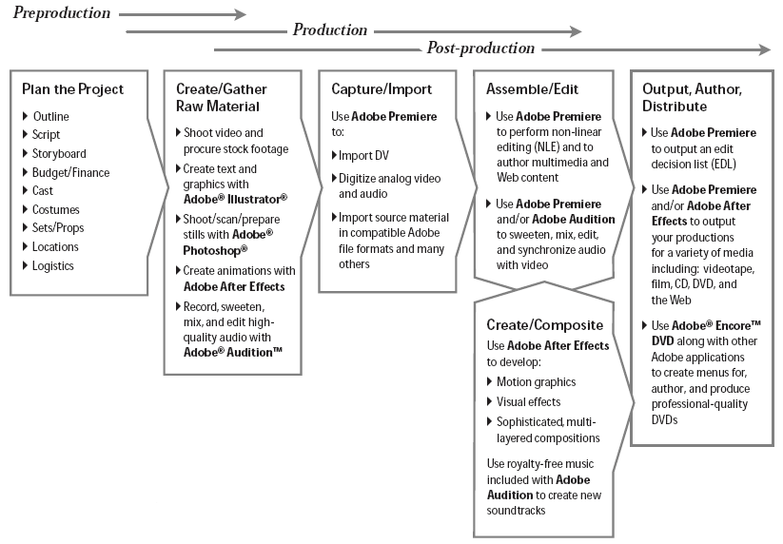
Figure 2. 1 The steps of designing a video according to Gora (2019)

2.7.1 Pre-production
Preproduction is the planning stage. In general, it is the preparation stage before starting the production process (shooting a film or video). With the birth of digital video technology and nonlinear editing methods, the video production process has become easier. When we will start a project, sometimes we already have the stock shoot / footage video that we need, for that we have to review all the needs in accordance with the story we will make. That is, we must prepare existing video footage, photography, charts and graphs, illustration images, or animations. But there are also many videographers who start from scratch or from scratch. In essence, the pre-production goal is to prepare everything so that the production process can run according to the concept and produce a digital video work in accordance with expectations.
- Outline
To make it easier to create a video project, we must make a market plan as the basis for implementation. Outlines are elaborated by making work points that work to help us identify what materials must be made, obtained, or arranged so that our work can work. Outlines can be arranged with co-workers or with our clients, so that we can produce a vision and the same perception about the steps to implement the project that will be made.
- Script
Using the outline is actually enough to start the production stage, but in various video project models, such as television advertising, company profile, soap operas, television dramas, storytelling and animated films, we still need a formal scenario that contains dialogue, narration, notes about location settings, action, lighting, camera angles and movements, atmospheric sound, and so on.
- Storyboard
If it is not enough with outlines and scenarios, then we can also include storyboards in our production process planning series. Storyboard is a sketch of a picture / sketch like a comic picture that describes the events in the film. In the picture also contains notes about the scene, sound, angle and movement of the camera, etc. The use of storyboards will clearly facilitate implementation in the production process later.

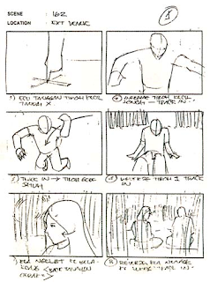
Figure 2. 2 The example of storyboard
- Budgeting
When we are working on a professional or personal project, it is highly recommended to plan a production cost budget. In a professional project, a budget plan is useful for securing company finances. Without a planned budget, and only rely on speculation, the loss percentage will be large. The budget plan includes salary for us, colleagues, actors and other talents (effect specialists, graphics designers, musicians, narrators, and animal trainers).

2.7.2 Production
"Quiet on the set! Action! and Roll 'em! ", these words are often heard when shooting takes place, in essence recording live events, animated scenes and sound on the film, videotape or DV to produce footage / clip is called" production "or the production process. During the production process, our attention will be focused on lighting, blocking (where and how our actors or subjects move), and shooting (how the camera moves and from what angle our scene is seen). There are many good references to learn more about the production process. Making animation / motion graphics can also be categorized in the production process, because it aims to produce footage that will later be compiled and edited in the post-production process.

2.7.3 Post-production
After the production process, footage or a collection of video clips will be produced. To build and deliver stories, you must edit and arrange the clips and of course add visual effects, images, titles and soundtracks. The above process is called postproduction or post-production. The following is an application from Adobe specifically designed for post-production processes:
• Edius Pro 7, a real-time editing application for professionals in the field of digital video production.
• Edius After Effect, a special application for Motion Graphics and Visual Effects.
• Edius Audition ™, a professional application for digital audio processing.
In addition to the above applications, there is also one professional graphic applications that also play an important role in producing high-quality graphic elements, these applications are Edius pro 7. In another chapter, we will also discuss the integration method of various Adobe products for post-production needs.

